(Confidential)
Scope of disclosure | TSCC, TSDV, SWC
Period of confidentiality | Until 2021-12-05
Head of Information Owner | Head of Engineer Department
Handling restriction | N.A

Development Tools Investigate Report

Development of Skerlet Linux for next generation MFP platform

Toshiba Software Development (Vietnam) Co., Ltd

Document ID: TSDV-SKERLET-InvestigateReport_DevelopmentTools
Total: 133 Page No. 1

Revision History

Rev. No.  (X.YY) | Date  (YYYY-MM-DD) | Section No. Changed | Change Description | Author | Reviewed by | Approved by
0.01 | 2012-12-05 | All | Create new | CongVT
0.02 | 2013-02-19 | 5, 6 ,7 | Add report for tools | DuyNV
0.03 | 2013-02-25 | All | Add Using on Cubox status | DuyNV
0.04 | 2013-03-12 | 6,9 | Add Investigation report for Kgtp | DuyNV
0.05 | 2013-03-12 | All | Update all sections | CongVT | CanDD
0.06 | 2013-03-13 | All | Update after peer review | CongVT
0.07 | 2013-03-13 | All | Refine Document | CongVT
0.08 | 2013-03-15 | All | Fix after V&V review | DuyNV
1.00 | 2013-03-18 | Revision History | Update revision to 1.00 | DuyNV | CanDD | AnhPT
1.01 | 2013-03-20 | 2.2 | Insert section LTTV – Linux Trace Toolkit Viewer  Insert section Eclipse LTTng plugin | CongVT  DuyNV | CanDD

Contents
1. Introduction 8
1.1. Purpose 8
1.2. Hardware and Software Requirements 8
1.2.1. Hardware Requirements 8
1.2.2. Software Requirements 8
1.3. Definitions, Acronyms, Abbreviations 8
1.4. References 8
2. Tracing Tools 9
2.1. Ftrace 9
2.1.1. Overview 9
2.1.2. Getting started 10
2.1.3. Function tracer 17
2.1.4. Function Graph tracer 18
2.1.5. Irqsoff latency tracer 19
2.1.6. Wakeup tracer 21
2.1.7. Tracer options 22
2.1.8. Dynamic Ftrace 23
2.1.9. Trace event – nop tracer 25
2.1.10. Trace marker 27
2.1.11. Ftrace dump on OOPS 29
2.1.12. Trace-cmd – front-end tool of Ftrace 29
2.1.13. Kernelshark 33
2.1.14. Benchmark on target board 35
2.1.15. Conclusion 38
2.2. LTTng 39
2.2.1. Overview 39
2.2.2. History 39
2.2.3. Why LTTng 2.0? 39
2.2.4. Getting started 40
2.2.5. Using LTTng 47
2.2.6. LTTV – Linux Trace Toolkit Viewer 53
2.2.7. Eclipse LTTng plugin 54
2.2.8. Benchmark 65
2.2.9. Conclusion 67
3. Profiling Tools 68
3.1. Oprofile 68
3.1.1. Overview 68
3.1.2. Why Oprofile 69
3.1.3. Get started 70
3.1.4. Analyze performance bottlenecks 74
3.1.5. Benchmark on target board 77
3.1.6. Conclussion 79
3.2. Perf 80
3.2.1. Overview 80
3.2.2. Perf commands 81
3.2.3. Using Perf 82
3.2.4. Benchmark on target board 87
3.2.5. Conclusion 89
4. Memory leak detection tools 90
4.1. Valgrind 90
4.1.1. Overview 90
4.1.2. Valgrind's memcheck feature. 90
4.1.3. Installation 90
4.1.4. How to use 90
4.1.5. Usage of Valgrind memcheck in development 92
4.1.6. Using Valgrind on Cubox 97
4.2. Mpatrol 98
4.2.1. Overview 98
4.2.2. Feature 98
4.2.3. Installation 98
4.2.4. How to use 99
4.2.5. Using Mpatrol in development 99
4.2.6. Using Maptrol on Cubox 103
4.3. Efence 103
4.3.1. Overview 103
4.3.2. Feature 103
4.3.3. Installation 103
4.3.4. How to use 103
4.3.5. Using Efence on Cubox 104
4.4. Mtrace 105
4.4.1. Overview 105
4.4.2. How to use 105
4.5. Gperftools 105
4.5.1. Overview 105
4.5.2. How to use 105
4.6. Conclusion 107
5. Debugging tools 107
5.1. Kgdb 107
5.1.1. Overview 107
5.1.2. Build kernel 3.7.1 with KGDB 107
5.1.3. Connect two machine Virtual Box via serial port 112
5.1.4. Using KGDB on target board (CuBox) 118
5.1.5. Conclusion 124
5.2. Kgtp 125
5.2.1. Overview 125
5.2.2. Preparatory work before use KGTP 125
5.2.3. Install Kgtp 128
5.2.4. Use Kgtp 129
6. Comparing tools 131
6.1. Ftrace vs LTTng 131
6.2. Oprofile vs Perf 132
6.3. Memory leak tools 132

List of Figures
Figure 2.1.2-1 Select kernel hacking 11
Figure 2.1.2-2 Select Tracer options 11
Figure 2.1.2-3 Enable Graph tracer 12
Figure 2.1.13-1Kernel shark graph information 33
Figure 2.1.14-1Benchmark for ftrace 36
Figure 2.1.14-2 IO benchmark of ftrace 38
Figure 2.2.7-1 Choose tracing module 55
Figure 2.2.7-2 Create tracing project 56
Figure 2.2.7-3 Project name 57
Figure 2.2.7-4 Project appear 57
Figure 2.2.7-5 Import tracing to project 58
Figure 2.2.7-6 Select file to import 59
Figure 2.2.7-7 Select trace type 60
Figure 2.2.7-8 Open trace 61
Figure 2.2.7-9 Event view 61
Figure 2.2.7-10 Searching 62
Figure 2.2.7-11 Filltering 62
Figure 2.2.7-12 Histogram view 63
Figure 2.2.7-13 Statistics 64
Figure 2.2.8-1Benchmark of LTTng 65
Figure 2.2.8-2 IO benchmark LTTng 66
Figure 3.1.3-1 Choose General setup 70
Figure 3.1.3-2 Select Opfile system profiling 71
Figure 3.1.5-1Benchmark of Oprofile 77
Figure 3.1.5-2 IO benchmark Oprofile 78
Figure 3.2.4-1 Benchmark of Perf 87
Figure 3.2.4-2 IO benchmark of Perf 88
Figure 5.1.2-1 Debian 6 in Virtual box 107
Figure 5.1.2-2Make menuconfig 108
Figure 5.1.2-3 Select kernel hacking 108
Figure 5.1.2-4 Kernel debugging option 109
Figure 5.1.2-5 Compile with debug info 109
Figure 5.1.2-6 Compile with frame pointers 110
Figure 5.1.2-7 Enable KGDB 110
Figure 5.1.2-8 Select Serial port option 111
Figure 5.1.2-9 Select kenel has built 112
Figure 5.1.3-1 Clone Virtual machine 113
Figure 5.1.3-2 Full Clone 113
Figure 5.1.3-3 Clone progress 114
Figure 5.1.3-4 Enable Serial port on debug machine 115
Figure 5.1.3-5 Enable Serial port in remote machine 116
Figure 5.1.3-6 Add parameter for boot up 116
Figure 5.1.3-7 Waiting for remote 117
Figure 5.1.3-8 Connect to debug machine 117
Figure 5.1.3-9 Connect success 118
Figure 5.1.4-1 Enable KGDB 119
Figure 5.1.4-2 KGDB over serial 119
Figure 5.2.2-1 Select general setup 125
Figure 5.2.2-2 Enable Kprobes 126
Figure 5.2.2-3 Select kernel hacking 126
Figure 5.2.2-4 Enable debug file system 127
Figure 5.2.2-5 Compile kernel with debug info 127

List of tables
Table 1 Definition 8
Table 2References 8
Table 3 Result data benchmark of Ftrace 35
Table 4 Result data 37
Table 5 Result data benchmark of LTTng 65
Table 6 Result data of LTTng 65
Table 7 Result data benchmark of Oprofile 77
Table 8 Result data iozone of Oprofile 78
Table 9 Commands of Perf 81
Table 10 Benchmark result data of Perf 87
Table 11 IO result data of Perf 87
Table 12 Memcheck options 91
Table 13 Compare Tracing tools 131
Table 14 Compare Profiling tools 132
Table 15 Compare memory leak tools 132

Introduction

Purpose
This investigation report describle how to use some development tools (ftrace, LTTng, Oprofile, Perf, Valgrind, Efence, Mpatrol, kgdb), also evaluating those tools. Comparation and conclusion what is the advantage or disadvantage of those tools.

Hardware and Software Requirements

Hardware Requirements
- CuBox board
Cubox is a equipment use to evaluation development tools
- x86 PC
Use to compile, run tools and kernel before using on Cubox

Software Requirements
- Linux OS
Build kernel and tools base on Linux OS environment
- Linux kernel source code (include ftrace and kgdb)
- LTTng source code
- Oprofile source code
- Perf source code
- Valgrind source code
- Efence source code
- Mpatrol source code

Definitions, Acronyms, Abbreviations
Table 1 Definition
ID No | Acronyms | Definition
1 | TSDV | Toshiba Software Development Vietnam
2 | SWC | Corporation Software Engineering Center
3 | TSCC | Toshiba Software Consulting Corporation
4 | IO | Input Output
5 | TEC | Toshiba Engineering Center
6 | MFP | Multi Function Printer

References
Table 2References
ID No | Reference | Version Number | Document Name/Source & Location reference | Brief Description | Remarks
1 | The statement of work of TEC |  | 201212-Skerlet-SOW-1-TEC.ppt | Described as an initial draft

Tracing Tools

Ftrace

Overview
Ftrace is an internal tracer designed to help out developers and designers of systems to find what is going on inside the kernel. It can be used for debugging or analyzing latencies and performance issues that take place outside of user-space.
Although ftrace is the function tracer, it also includes an infrastructure that allows for other types of tracing. Some of tracers that are currently in ftrace include a tracer to trace context switches, the time it takes for a high priority task to
run after it was woken up, the time interrupts are disabled, and more (ftrace allows for tracer plugins, which means that the list of tracers can always grow).

Getting started

Getting Linux kernel source code
Clone Linux kernel source code from git server

$ git clone gitosis@debian.tsdv.com.vn:kernel/linux-tec

Enable Ftrace
The kernel should be reconfigured and rebuilt to enable the support of Ftrace. For the purpose of debugging, the kernel configuration parameters that should be enabled are:
CONFIG_FUNCTION_TRACER
CONFIG_FUNCTION_GRAPH_TRACER
CONFIG_STACK_TRACER
CONFIG_DYNAMIC_FTRACE
You can insert into .config file in Linux kernel directory or using “menuconfig”.

Example: Enable Ftrace support using menuconfig flowing steps below:

Step 1: cd to Linux kernel directory

$ cd /path/to/linux-tec

Step 2: Create kernel configuration file using “menuconfig”

$ ARCH=arm CROSS_COMPILE=arm-poky-linux-gnueabi- make menuconfig

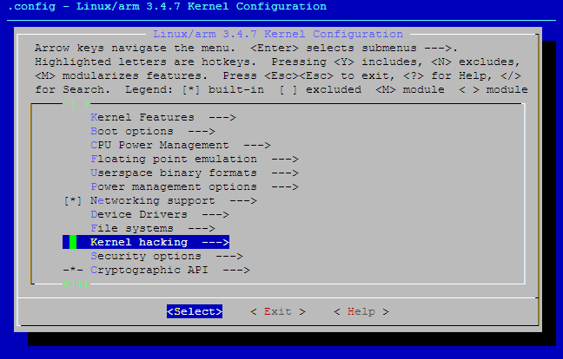
Figure 2.1.2-1 Select kernel hacking

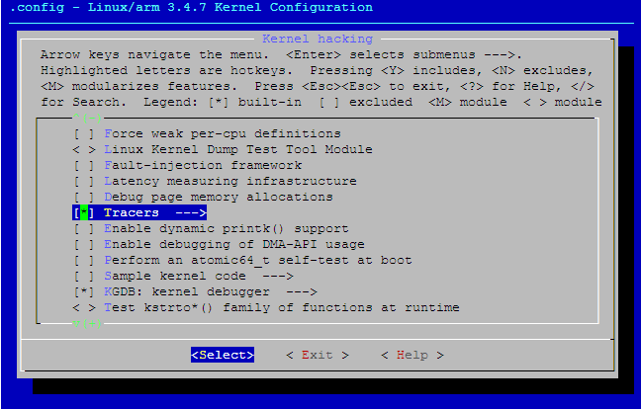
Figure 2.1.2-2 Select Tracer options

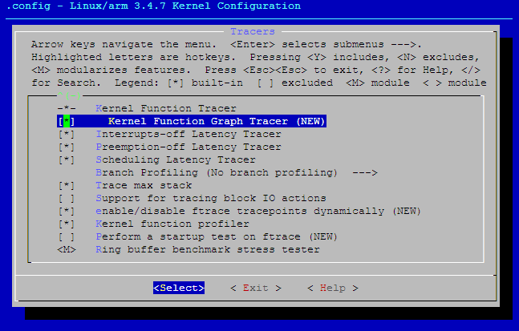
Figure 2.1.2-3 Enable Graph tracer

Ftrace file system
Ftrace uses the debugfs file system to hold the control files as well as the files to display output. In most common, debugfs is default mounted to /sys/kernel/debug directory.
NOTE: You can mount to a specified directory for convenience:

# mkdir /tmp/debug
# mount -t debugfs nodev /tmp/debug

After mounting the debugfs, you can see a directory called "tracing". This directory contains the control and output files of ftrace. Here is a list of some of the key files:
current_tracer | This is used to set or display the current tracer that is configured.
available_tracers | This holds the different types of tracers that have been compiled into the kernel. The tracers listed here can be configured by echoing their name into current_tracer.
tracing_enabled | This sets or displays whether the current_tracer is activated and tracing or not. Echo 0 into this file to disable the tracer or 1 to enable it.
trace | This file holds the output of the trace in a human readable format (described below).
latency_trace | This file shows the same trace but the information is organized more to display possible latencies in the system (described below).
trace_pipe | The output is the same as the "trace" file but this file is meant to be streamed with live tracing. Reads from this file will block until new data is retrieved. Unlike the "trace" and "latency_trace" files, this file is a consumer. This means reading from this file causes sequential reads to display more current data. Once data is read from this file, it is consumed, and will not be read again with a sequential read. The "trace" and "latency_trace" files are static, and if the tracer is not adding more data, they will display the same information every time they are read.
iter_ctrl | This file lets the user control the amount of data that is displayed in one of the above output files.
trace_max_latency | Some of the tracers record the max latency. For example, the time interrupts are disabled. This time is saved in this file. The max trace will also be stored, and displayed by either "trace" or "latency_trace". A new max trace will only be recorded if the latency is greater than the value in this file. (in microseconds)
trace_entries | This sets or displays the number of trace entries each CPU buffer can hold. The tracer buffers are the same size for each CPU. The displayed number is the size of the CPU buffer and not total size. The trace buffers are allocated in pages (blocks of memory that the kernel uses for allocation, usually 4 KB in size). Since each entry is smaller than a page, if the last allocated page has room for more entries than were requested, the rest of the page is used to allocate entries.  This can only be updated when the current_tracer is set to "none".  NOTE: It is planned on changing the allocated buffers from being the number of possible CPUS to the number of online CPUS.
tracing_cpumask | This is a mask that lets the user only trace on specified CPUS. The format is a hex string representing the CPUS.
set_ftrace_filter | When dynamic ftrace is configured in (see the section below "Dynamic Ftrace"), the code is dynamically modified (code text rewrite) to disable calling of the function profiler (mcount). This let tracing be configured in with practically no overhead in performance. This also has a side effect of enabling or disabling specific functions to be traced. Echoing names of functions into this file will limit the trace to only those functions.
set_ftrace_notrace | This has an effect opposite to that of set_ftrace_filter. Any function that is added here will not be traced. If a function exists in both set_ftrace_filter and set_ftrace_notrace, the function will _not_ be traced.
available_filter_functions | When a function is encountered the first time by the dynamic tracer, it is recorded and later the call is converted into a nop. This file lists the functions that have been recorded by the dynamic tracer and these functions can be used to set the ftrace filter by the above "set_ftrace_filter" file.

Using Ftrace
This section will describe overview of using Ftrace
Choosing the tracers
Here is the list of tracers that may be configured to:
nop | This is the tracer by default which traces no function. But it can still be useful to trace events (see Trace event)
function | Function tracer that uses mcount to trace all functions.
sched_switch | Traces the context switches between tasks.
irqsoff | Traces the areas that disable interrupts and saves the trace with the longest max latency. See tracing_max_latency. When a new max is recorded, it replaces the old trace. It is best to view this trace via the latency_trace file.
preemptoff | Similar to irqsoff but traces and records the amount of time for which preemption is disabled.
preemptirqsoff | Similar to irqsoff and preemptoff, but traces and records the largest time for which irqs and/or preemption is disabled.
wakeup | Traces and records the max latency that it takes for the highest priority task to get scheduled after it has been woken up.
none | This is not a tracer. To remove all tracers from tracing simply echo "none" into current_tracer.
To find out which tracers are available, simply cat the available_tracers file in the tracing directory:

# cat available_tracers
function_graph wakeup_rt wakeup preemptirqsoff preemptoff irqsoff function nop

To enable, for example, the function tracer, just echo "function" into the current_tracer file.

# echo function > current_tracer
# cat current_tracer
Function

NOTE: ftrace can handle only one tracer at the same time
Using tracers
At this point ftrace is ready to trace the function, to start just echo "1" into tracing_on file:

# echo 1 > tracing_on

To stop tracing, just echo "0" into same file:

# echo 0 > tracing_on

The log of tracing is contained in the trace file, here is an example of the output from a function trace. The header helps to decode the various fields in the trace.

# cat trace
# tracer: function
#
# entries-in-buffer/entries-written: 60124/4080793 #P:1
#
# _-----=> irqs-off
# / _----=> need-resched
# | / _---=> hardirq/softirq
# || / _--=> preempt-depth
# ||| / delay
# TASK-PID CPU# |||| TIMESTAMP FUNCTION
# | | | |||| | |
agetty-1321 [000] .... 510.989633: release_pages <-free_pages_and_swap_cache
agetty-1321 [000] d... 510.989635: add_preempt_count <-release_pages
agetty-1321 [000] ...1 510.989637: sub_preempt_count <-release_pages
agetty-1321 [000] .... 510.989638: free_hot_cold_page_list <-release_pages
agetty-1321 [000] .... 510.989640: free_hot_cold_page <-free_hot_cold_page_list
agetty-1321 [000] .... 510.989641: free_pages_prepare <-free_hot_cold_page
agetty-1321 [000] .... 510.989643: get_pageblock_flags_group <-free_hot_cold_page
agetty-1321 [000] d... 510.989645: free_pcppages_bulk <-free_hot_cold_page
agetty-1321 [000] d... 510.989646: add_preempt_count <-free_pcppages_bulk

This shows that the current tracer is "function" tracing.
The number of trace entries displayed and the total number recorded (60124/4080793).

The next lines after the header are the trace itself. The header explains which is which.
TASK | The name of the process in the trace
PID | The PID of process
CPU# | The CPU which the process was running on
irq-off | 'd' interrupts are disabled, '.' otherwise
nedd-resched | 'N' task need_resched is set, '.' otherwise
hardirq/softirq | 'H' hard irq occurred inside soft irq  'h' hard irq is running  's' soft irq is running  '. ' normal context
preempt-depth | The level of preempt-depth
time | When the latency-format option is enabled, the trace file output includes a timestamp relative to the start of the trace. This differs from the output when latency-format is disabled, which includes an absolute timestamp.
delay | This is just to help catch your eye a bit better. And needs to be fixed to be only relative to the same CPU. The marks are determined by the difference between this current trace and the next trace.  '!' - greater than preempt_mark_thresh (default 100)  '+' - greater than 1 microsecond  ' ' - less than or equal to 1 microsecond.
Tracing specific process
Perhaps you only need to trace a specific process, or set of processes. The file set_ftrace_pid lets you specify specific processes that you want to trace. To just trace the current thread you can do the following:

# echo $$ > set_ftrace_pid

NOTE: you must clear the set_ftrace_pid file if you want to go to back to generic function tracing after performing the above.

# echo -1 > set_ftrace_pid

Sections below will be describes more detail each tracer and usage of those.

Function tracer
Function tracer is one of most powerful tracers of Ftrace, allow traces almost function in kernel. This is profiler that will make all function call a specific function named mcount(). Unfortunately, this could cause a very large overhead. To improve it, should enable Dynamic Ftrace (see Dynamic Ftrace), then the mcount() calls, when not in use, are converted at run time to nops. This allows the function tracer to have zero overhead when not in use.

Setting up function tracer
This tracer is activated by enabling CONFIG_FUNCTION_TRACER in the kernel configuration. To work, it needs the kernel variable ftrace_enabled to be turned on.

# sysctl kernel.ftrace_enabled = 1
# echo function > current_tracer
# cat current_tracer
Function

Using function tracer
To start trace functions, just echo "1" into tracing_on file, then cat the trace file to view log of tracing:

# echo 1 > tracing_on
# cat trace | head -20
# tracer: function
#
# entries-in-buffer/entries-written: 60117/3564326 #P:1
#
# _-----=> irqs-off
# / _----=> need-resched
# | / _---=> hardirq/softirq
# || / _--=> preempt-depth
# ||| / delay
# TASK-PID CPU# |||| TIMESTAMP FUNCTION
# | | | |||| | |
agetty-1321 [000] .... 1404.703156: __rcu_read_unlock <-find_get_page
agetty-1321 [000] .... 1404.703158: add_preempt_count <-generic_file_aio_read
agetty-1321 [000] ...1 1404.703159: sub_preempt_count <-generic_file_aio_read
agetty-1321 [000] .... 1404.703161: mark_page_accessed <-generic_file_aio_read
agetty-1321 [000] .... 1404.703163: file_read_actor <-generic_file_aio_read
agetty-1321 [000] d... 1404.703165: do_page_fault <-do_DataAbort
agetty-1321 [000] .... 1404.703166: down_read_trylock <-do_page_fault
agetty-1321 [000] d... 1404.703168: add_preempt_count <-__down_read_trylock
agetty-1321 [000] ...1 1404.703169: sub_preempt_count <-__down_read_trylock

The header explains the format of the output pretty well.
TASK | The traced task name
PID | Process ID
CPU# | The CPU that the trace was executed on is within the brackets
TIMESTAMP | The time since boot in <secs>.<usecs> format
FUNCTION | Function name with its parent following the "<-" symbol.

Function Graph tracer
This tracer is similar to the function tracer except that it probes a function on its entry and its exit, which gives the tracer the ability to know the depth of functions that are called, and also the duration of each function. The function graph tracer can make following the flow of execution within the kernel much easier to follow with the human eye.

Setting up function graph tracer
This tracer depends of the CONFIG_FUNCTION_GRAPH kernel option.
To using this tracer, need to echo "function_graph" into the current_tracer file

# echo 0 > tracing_on
# echo function_graph > current_tracer
# cat current_tracer
function_graph

Using function graph tracer
To start trace, just echo "1" into tracing_on file, then cat the trace file to view log of tracing:

# echo 1 > tracing_on
# [USE CASES]
# echo 0 > tracing_on | head -20
# cat trace
# tracer: function_graph
#
# CPU DURATION FUNCTION CALLS
# | | | | | | |
0) + 68.268 us | } /* do_mmap_pgoff */
0) | up_write() {
0) 1.866 us | add_preempt_count();
0) 1.932 us | sub_preempt_count();
0) 9.594 us | }
0) + 96.366 us | } /* sys_mmap_pgoff */
0) | sys_read() {
0) 1.896 us | fget_light();
0) | vfs_read() {
0) 1.968 us | rw_verify_area();
0) | do_sync_read() {
0) | generic_file_aio_read() {
0) 1.962 us | generic_segment_checks();
0) 1.866 us | _cond_resched();
0) | find_get_page() {
0) 1.896 us | __rcu_read_lock();

This gives the start and end of a function denoted with the C like annotation of "{" to start a function and "}" at the end. Leaf functions, which do not call other functions, simply end with a ";".

The DURATION column shows the time spent in the corresponding function. The function graph tracer records the time the function was entered and exited and reports the difference as the duration. These numbers only appear with the leaf functions and the "}" symbol. Note that this time also includes the overhead of all functions within a nested function as well as the overhead of the function graph tracer itself. The closest true timings only occur for the leaf functions.

The lonely "+" that is there is an annotation marker. When the duration is greater than 10 microseconds, a "+" is shown. If the duration is greater than 100 microseconds a "!" will be displayed.

Irqsoff latency tracer
The plugin irqsoff is a way to measure times in the kernel that interrupts are disabled. When a new maximum latency is hit, the tracer saves the trace leading up to that latency point so that every time a new maximum is reached, the old saved trace is discarded and the new trace is saved.

Setting up irqsoff tracer
This tracer is activated with CONFIG_IRQSOFF_TRACER.
To using this tracer, need to echo "irqsoff" into the current_tracer file

# echo irqsoff > current_tracer
# cat current_tracer
irqsoff

When the latency-format option is enabled (see Tracer options more detail), the trace file gives somewhat more information to see why a latency happened.

# echo 1 > options/latency-format

Or

# echo latency-format > trace_options

Using irqsoff tracer
To start trace, just echo "1" into tracing_on file, then cat the trace file to view log of tracing:

# echo 1 > tracing_on
# cat trace | head -30
# tracer: irqsoff
#
# irqsoff latency trace v1.1.5 on 3.4.7-dirty
# --------------------------------------------------------------------
# latency: 168 us, #106/106, CPU#0 | (M:preempt VP:0, KP:0, SP:0 HP:0)
# -----------------
# | task: head-1441 (uid:0 nice:0 policy:0 rt_prio:0)
# -----------------
# => started at: __irq_svc
# => ended at: __do_softirq
#
#
# _------=> CPU#
# / _-----=> irqs-off
# | / _----=> need-resched
# || / _---=> hardirq/softirq
# ||| / _--=> preempt-depth
# |||| / delay
# cmd pid ||||| time | caller
# \ / ||||| \ | /
head-1441 0d... 1us+: __irq_svc
head-1441 0d... 2us : asm_do_IRQ <-__irq_svc
head-1441 0d... 3us : handle_IRQ <-asm_do_IRQ
head-1441 0d... 5us+: irq_enter <-handle_IRQ
head-1441 0d... 7us+: rcu_irq_enter <-irq_enter
head-1441 0d... 9us+: rcu_idle_exit_common <-rcu_irq_enter
head-1441 0d... 10us+: add_preempt_count <-irq_enter
head-1441 0d.h. 12us : generic_handle_irq <-handle_IRQ
head-1441 0d.h. 14us : handle_level_irq <-generic_handle_irq
head-1441 0d.h. 15us : add_preempt_count <-handle_level_irq

This shows that the current tracer is "irqsoff" tracing the time for which interrupts were disabled.
It gives the trace version (v1.1.5) and the version of the kernel upon which this was executed on (3.4.7-dirty).
Then it displays the max latency in microseconds (168 us).
The number of trace entries displayed and the total number recorded (both are 106: #106/106).
VP, KP, SP, and HP are always zero and are reserved for later use.

The task is the process that was running when the latency occurred. (pid: 1441).

The start and stop (the functions in which the interrupts were disabled and enabled respectively) that caused the latencies:
__irq_svc is where the interrupts were disabled.
__do_softirq is where they were enabled again.

The next lines after the header are the trace itself. The header explains which is which.
cmd | The name of the process in the trace
PID | The PID of process
CPU# | The CPU which the process was running on
irq-off | 'd' interrupts are disabled, '.' otherwise
nedd-resched | 'N' task need_resched is set, '.' otherwise
hardirq/softirq | 'H' - hard irq occurred inside soft irq  'h' - hard irq is running  's' - soft irq is running  '. ' - normal context
preempt-depth | The level of preempt-depth
time | When the latency-format option is enabled, the trace file output includes a timestamp relative to the start of the trace. This differs from the output when latency-format is disabled, which includes an absolute timestamp.
delay | This is just to help catch your eye a bit better. And needs to be fixed to be only relative to the same CPU. The marks are determined by the difference between this current trace and the next trace.  '!' - greater than preempt_mark_thresh (default 100)  '+' - greater than 1 microsecond  ' ' - less than or equal to 1 microsecond.

For more precise results, you can disable the function tracing, which can bring a large overhead, by turning off the kernel variable ftrace_enabled.

# sysctl kernel.ftrace_enabled = 0

WARNING Before launching each latency tracer, don't forget to reset the tracing_max_latency

# echo 0 > tracing_max_latency

Wakeup tracer
This tracer tracks the latency of the highest priority task to be scheduled in, starting from the point it has woken up.

Setting up wakeup tracer
This tracer is activated by enabling the CONFIG_SCHED_TRACER.
To using this tracer, just need to echo "wakeup" into the current_tracer file

# echo wakeup > current_tracer
# cat current_tracer
wakeup

Using wakeup tracer
To start trace, just echo "1" into tracing_on file, then cat the trace file to view log of tracing:

# echo 1 > tracing_on
[USE CASES]
# chrt –f 5 sleep 2
[END OF USE CASES]
# cat trace
# tracer: wakeup
#
# wakeup latency trace v1.1.5 on 3.4.7-dirty
# --------------------------------------------------------------------
# latency: 98 us, #45/45, CPU#0 | (M:preempt VP:0, KP:0, SP:0 HP:0)
# -----------------
# | task: sleep-1466 (uid:0 nice:0 policy:1 rt_prio:5)
# -----------------
#
# _------=> CPU#
# / _-----=> irqs-off
# | / _----=> need-resched
# || / _---=> hardirq/softirq
# ||| / _--=> preempt-depth
# |||| / delay
# cmd pid ||||| time | caller
# \ / ||||| \ | /
agetty-1203 0d.h3 3us+: 1203:120:R + [000] 1466: 94:S sleep
agetty-1203 0d.h3 11us+: 0
agetty-1203 0d.h2 13us+: check_preempt_curr <-T.1186
agetty-1203 0dNh2 15us+: sub_preempt_count <-try_to_wake_up
agetty-1203 0dNh1 17us+: sub_preempt_count <-try_to_wake_up
…
agetty-1203 0dN.2 83us+: pick_next_task_stop <-__schedule
agetty-1203 0dN.2 84us+: pick_next_task_rt <-__schedule
agetty-1203 0...2 87us+: sub_preempt_count <-__schedule
agetty-1203 0...2 90us : __schedule
agetty-1203 0...2 92us : 1203:120:R ==> [000] 1466: 94:R sleep

The first trace item show that task "agetty" with PID1203 at priority 120. The "R" means that it is in running state. The "+" denote that it is waking up the task follows. The task is being woken up is sleep with the PID of "5". The sleep task is in "sleep" denoted by the "S"
The third trace item is a scheduling event (de-noted with the sched_switch). This even is the scheduling context switch between the current running task (agetty) and the task that was just woken up (sleep). The "==>" also denotes a scheduling switch is occurring, followed by the task that is scheduling, its PID and in brackets, its priority ([94]).
Running this on our system, we see that it took 91 microseconds to perform the task switch.

Tracer options
Some options can be added to the tracer to change its output. The list of all options is contain in the trace_options file

# cat trace_options
print-parent
nosym-offset
nosym-addr
noverbose
noraw
nohex
nobin
noblock
nostacktrace
trace_printk
noftrace_preempt
nobranch
annotate
nouserstacktrace
nosym-userobj
noprintk-msg-only
context-info
latency-format
sleep-time
graph-time
record-cmd
overwrite
nodisable_on_free
irq-info
nodisplay-graph

To enable an option, just echo its name in the trace_options file

# echo sym-addr > trace_options
# cat trace | head -20
# tracer: function
#
# entries-in-buffer/entries-written: 60109/162219537 #P:1
#
# _-----=> irqs-off
# / _----=> need-resched
# | / _---=> hardirq/softirq
# || / _--=> preempt-depth
# ||| / delay
# TASK-PID CPU# |||| TIMESTAMP FUNCTION
# | | | |||| | |
bash-1269 [000] .... 549.367625: mutex_unlock <c055e744> <-anon_vma_clone <c00e9788>
bash-1269 [000] .... 549.367627: kmem_cache_alloc <c00f51ec> <-anon_vma_fork <c00e9870>
bash-1269 [000] .... 549.367628: kmem_cache_alloc <c00f51ec> <-anon_vma_fork <c00e9890>
bash-1269 [000] .... 549.367630: mutex_lock <c055e8c4> <-anon_vma_fork <c00e98cc>
bash-1269 [000] .... 549.367631: mutex_unlock <c055e744> <-anon_vma_fork <c00e9918>
bash-1269 [000] .... 549.367633: __vma_link_rb <c00e44b0> <-dup_mm <c003579c>
bash-1269 [000] .... 549.367635: copy_page_range <c00e0200> <-dup_mm <c00357b8>
bash-1269 [000] .... 549.367636: copy_pte_range <c00dfe08> <-copy_page_range <c00e02c0>

In this example the sym-addr option add the address of the symbol call. To remove an option, just echo its name preceded by no in the same file

# echo nosym-addr > trace_options

Dynamic Ftrace

Setting up dynamic ftrace
It is highly recommended to enable CONFIG_DYNAMIC_FTRACE because of this performance enhancement. In addition, CONFIG_DYNAMIC_FTRACE gives the ability to filter which function should be traced.

Running the function tracer can be overwhelming. The amount of data may be vast, and very hard to get a hold of by the human brain. Ftrace provides a way to limit what functions you see. Two files exist that let you limit what functions are traced:
set_ftrace_filter
set_ftrace_notrace

When any function is listed in the set_ftrace_filter, only those functions will be traced. This will help the performance of the system when the trace is active. Tracing every function incurs a large overhead, but when using the set_ftrace_filter, only those functions listed in that file will have the NOPs changed to call the tracer. Depending on which functions are being traced, just having a couple of hundred functions enabled is hardly noticeable.

NOTE: The functions listed in set_ftrace_notrace take precedence. That is, if a function is listed in both set_ftrace_notrace and set_ftrace_filter, that function will not be traced.

Using dynamic ftrace
Select filter function
A list of functions that can be added to the filter files is shown in the available_filter_functions file. This file contains almost all functions in the kernel.

# cat available_filter_functions
asm_do_IRQ
do_one_initcall
run_init_process
init_post
name_to_dev_t
match_dev_by_uuid
SetRoundingMode
…

To add a filter, just echo his name in set_ftrace_filter

# echo vfs_write > set_ftrace_filter
# cat set_ftrace_filter
vfs_write
# cat trace | head -20
# tracer: function
#
# entries-in-buffer/entries-written: 60177/722328632 #P:1
#
# _-----=> irqs-off
# / _----=> need-resched
# | / _---=> hardirq/softirq
# || / _--=> preempt-depth
# ||| / delay
# TASK-PID CPU# |||| TIMESTAMP FUNCTION
# | | | |||| | |
agetty-1194 [000] .... 1540.181879: vfs_write <-sys_write
agetty-1194 [000] .... 1540.181888: vfs_write <-sys_write
agetty-1194 [000] .... 1540.181891: vfs_write <-sys_write
agetty-1194 [000] .... 1540.181894: vfs_write <-sys_write
agetty-1194 [000] .... 1540.181901: vfs_write <-sys_write
agetty-1194 [000] .... 1540.181905: vfs_write <-sys_write
agetty-1194 [000] .... 1540.181908: vfs_write <-sys_write
agetty-1194 [000] .... 1540.181911: vfs_write <-sys_write
agetty-1194 [000] .... 1540.181944: vfs_write <-sys_write

But adding one by one all the wanted events can be boring fortunately, these files also take wildcards; the following glob expressions are valid:
- value* - Select all functions that begin with value.
- *value* - Select all functions that contain the text value.
- *value - Select all functions that end with value.

To remove a filter or more, use the '! ' symbol:

# echo '!vfs_write' > set_ftrace_filter

Stop the trace on a specific function
Enabling and disabling recording to the trace file can be done using tracing_on file from debugfs. It can also be controlled accurately through tracing_on() and tracing_off() functions from the kernel, which require unfortunately to recompile the kernel. In the special case where you just want to switch tracing on/off in a specific kernel module you don't need to rebuild the whole kernel. Just add tracing_on() and tracing_off() to your module and recompile it. A last method allows stopping the trace at a particular function. This method uses the set_ftrace_filter file.

The format of the command to have the function trace enable or disable the ring buffer is as follows:

# function:command[:count]

This will execute the command at the start of the function. The command is either traceon or traceoff, and an optional count can be added to have the command only execute a given number of times. If the count is left off (including the leading colon) then the command will be executed every time the function is called.

# echo 'vfs_write:traceoff' > set_ftrace_filter
# cat set_ftrace_filter
#### all functions enabled ####
vfs_write:traceoff:unlimited

NOTE:
Notice that functions with commands do not affect the general filters. Even though a command has been added to vfs_write, the filter still allowed all functions to be traced. Commands and filter functions are separate and do not affect each other.

Also note that the option is non-volatile, that is, even if you enable another tracer plugin in current_tracer, the option will still be enabled if you re-enable the function tracer.

Trace event – nop tracer
Using the different previous plugin tracers is not always very practical. Some can bring a large overhead and others do not give enough information to see what happened. Luckily, there is the event tracer. The event tracing is not a plugin. When events are enabled, they will be recorded in any plugin, including the special nop plugin.

Setting up event tracer
We can set events which is traced via the 'set_event' interface.
The events which are available for tracing can be found in the file 'available_events'

# cat available_events
sunrpc:rpc_call_status
sunrpc:rpc_bind_status
sunrpc:rpc_connect_status
sunrpc:rpc_task_begin
sunrpc:rpc_task_run_action
sunrpc:rpc_task_complete
sunrpc:rpc_task_sleep
sunrpc:rpc_task_wakeup
skb:kfree_skb
skb:consume_skb
skb:skb_copy_datagram_iovec
net:net_dev_xmit
net:net_dev_queue
net:netif_receive_skb
net:netif_rx
napi:napi_poll
sock:sock_rcvqueue_full
sock:sock_exceed_buf_limit
udp:udp_fail_queue_rcv_skb
asoc:snd_soc_reg_write
…

To enable a particular event, such as 'sched_wakeup', simply echo it to set_event. For example:

# echo sched_wakeup >> set_event

NOTE: '>>' is necessary, otherwise it will disable all the events.

To disable all events, echo an empty string to the 'set_event' file:

# echo > set_event

To enable all events, echo '*:*' or '*:' to the set_event file

# echo *:* > set_event

The events are organized into subsystems, such as ext4, irq, sched, etc…, and a full event name looks like this: <subsystem>:<event>. The subsystem name is optional, but it is displayed in the available_events file. All of the events in a subsystem can be specified via the syntax "<subsystem>:*"; for example, to enable all irq events, you can use the command:

# echo 'irq:*' > set_event
Via the enable toggle
The events available are also listed in /sys/kernel/debug/tracing/events/ hierarchy of directories.
To enable event 'sched_wakeup':

# echo 1 > events/sched/sched_wakeup/enable

To disable it:

# echo 0 > events/sched/sched_wakeup/enable

To enable all events in sched subsystem:

# echo 1 > events/sched/enable

To enable all events:

# echo 1 > events/enable

When reading one of these 'enable' files, there are four results:
0 all events this file affects are disabled
1 all events this file affects are enabled
X there is a mixture of events enabled and disabled
? this file does not affect any event

Using event tracer
# echo module_load > set_event
# echo 1 > tracing_on
# insmod ~/hello_world.ko
# echo 0 > tracing_on
# cat trace
# tracer: nop
#
# entries-in-buffer/entries-written: 2/2 #P:1
#
# _-----=> irqs-off
# / _----=> need-resched
# | / _---=> hardirq/softirq
# || / _--=> preempt-depth
# ||| / delay
# TASK-PID CPU# |||| TIMESTAMP FUNCTION
# | | | |||| | |
insmod-1411 [000] ...1 5967.632260: module_load: hello_world 0x1000
insmod-1411 [000] .... 5967.632296: : hello_init

In above example, we enabled 'module_load' event, and then install a module (hello_world.ko).
We can see 'hello_world' module loaded into kernel.

Trace marker
To help synchronize between the actions in user space and kernel space, the trace_marker file was created. It provides a way to write into the Ftrace ring buffer from user space. This marker will then appear in the trace to give a location in the trace of where a specific event occurred.

# echo hello world > trace_marker
# cat trace
# trace: nop
#
# TASK-PID CPU# TIMESTAMP FUNCTION
# | | | | |
<...>-3718 [000] 5546.183420: 0: hello world

Staring, stopping, and recording in a program
The tracing_on and trace_marker files work very well to trace the activities of an application if the source of the application is available. If there is a problem within the application and you need to find out what is happening inside the kernel at a particular location of the application, these two files come in handy.

File test_recording.c
/*
* test_recording.c
* Demo recording in a program using ftrace
*/
#include <stdlib.h>
#include <sys/types.h>
#include <sys/stat.h>
#include <fcntl.h>

int trace_fd = -1;
int marker_fd = -1;

int main(int argc, char *argv[])
{
struct timespec req;
/* open tracing_on */
trace_fd = open("/sys/kernel/debug/tracing/tracing_on", O_WRONLY);
if(trace_fd <= 0)
return -1;
/* open trace_marker */
marker_fd = open("/sys/kernel/debug/tracing/trace_marker", O_WRONLY);
if(marker_fd <= 0)
return -1;

req.tv_sec = 0;
req.tv_nsec = 1000;
/* marking */
write(trace_fd, "1", 1); /* Turn on tracing */
write(marker_fd, "Before nanosleep\n", 12);
nanosleep(&req, NULL);
write(marker_fd, "After nanosleep\n", 11);
write(trace_fd, "0", 1); /* Turn off tracing */
return 0;
}

NOTE: No error checking was added due to this being a simple program for example purposes only
Compile source code

$ arm-skerlet-linux-gnueabi-gcc –o test test_recording.c

We can see output after run test program above:

# ./test
# cat /sys/kernel/debug/tracing/trace

# tracer: nop
#
# entries-in-buffer/entries-written: 2/2 #P:1
#
# _-----=> irqs-off
# / _----=> need-resched
# | / _---=> hardirq/softirq
# || / _--=> preempt-depth
# ||| / delay
# TASK-PID CPU# |||| TIMESTAMP FUNCTION
# | | | |||| | |
<...>-1628 [000] ...1 41.784719: tracing_mark_write: Before nanos
<...>-1628 [000] ...1 41.784842: tracing_mark_write: After nanos

Ftrace dump on OOPS
There are times that the kernel will crash and examining the memory and state of the crash is more of a CSI science than a program debugging science.

Having Ftrace configured and enabling ftrace_dump_on_oops in the kernel boot parameters, or by echoing a "1" into/proc/sys/kernel/ftrace_dump_on_oops, will enable Ftrace to dump to the console the entire trace buffer in ASCII format on oops or panic. Having the console output to a serial log makes debugging crashes much easier. You can now trace back the events that led up to the crash.

Dumping to the console may take a long time since the default Ftrace ring buffer is over a megabyte per CPU. To shrink the size of the ring buffer, write the number of kilobytes you want the ring buffer to be to buffer_size_kb.

Note that the value is per CPU, not the total size of the ring buffer.

# echo 50 > buffer_size_kb

The above will shrink the Ftrace ring buffer down to 50 kilobytes per CPU.

To choose a particular location for the kernel dump, the kernel may call ftrace_dump() directly. Note, this may permanently disable Ftrace and a reboot may be necessary to enable it again. This is because ftrace_dump() reads the buffer. The buffer is made to be written to in all contexts (interrupt, NMI, scheduling) but the reading of the buffer requires locking. To be able to perform ftrace_dump() the locking is disabled and the buffer may end up being corrupted after the output.

Trace-cmd – front-end tool of Ftrace
Trace-cmd is a user-space front-end command-line tool for Ftrace. You can download it from the git repository at git://git.kernel.org/pub/scm/linux/kernel/git/rostedt/trace-cmd.git

Installing trace-cmd
On x86 Skerlet PC
1) Clone source code

$ git clone git://git.kernel.org/pub/scm/linux/kernel/git/rostedt/trace-cmd.git

2) Compile source code

$ cd trace-cmd
$ make

3) Install binary into root filesystem

$ sudo make install
On target board (CuBox)
To porting trace-cmd onto target board (CuBox), can using cross-compiler or using bitbake. In this document we only present using cross-compiler to porting trace-cmd onto target board (CuBox).

1) Clone source code

$ git clone git://git.kernel.org/pub/scm/linux/kernel/git/rostedt/trace-cmd.git

2) Compile source code

$ cd trace-cmd
$ ARCH=arm CROSS_COMPILE=arm-skerlet-linux-gnueabi- make

3) Plugin SD card which store rootfs of target board (CuBox), and then install trace-cmd binary into that

$ df
/dev/sdb1 … /media/rootfs
$ make install DEST_DIR=/media/rootfs

4) Booting target board with rootfs which is installed with trace-cmd

How it work
A simple use case of trace-cmd is to record a trace and then report it.

# trace-cmd record –e ext4 ls
# trace-cmd report
version = 6
[…]
CPU 0 is empty
CPU 2 is empty
CPU 3 is empty
cpus=4
ls-2337 [001] 689472.109840: ext4_ext_map_blocks_enter: dev 8,1 ino 17301505 lblk 0 len 1 flags 0
ls-2337 [001] 689472.109842: ext4_ext_in_cache: dev 8,1 ino 17301505 lblk 0 ret 1
ls-2337 [001] 689472.109843: ext4_ext_map_blocks_exit: dev 8,1 ino 17301505 lblk 0 pblk 69214240 len 1 ret 1
ls-2337 [001] 689472.109874: ext4_journal_start: dev 8,1 nblocks 2 caller ext4_dirty_inode+0x20
ls-2337 [001] 689472.109875: ext4_mark_inode_dirty: dev 8,1 ino 17301505 caller ext4_dirty_inode+0x30

The above example enables the ext4 tracepoints for Ftrace, runs the ls command and records the Ftrace data into a file named trace.dat. The report command reads the trace.dat file and outputs the tracing data to standard output. Some metadata is also shown before the trace output is displayed: the version of the file, any empty CPU buffers, and the number of CPUs that were recorded.

By default, the record and report options write and read to the trace.dat file. You can use the -o or -i options to pick a different file to write to or read from respectively, but this article will use the default name when referencing the data file created by trace-cmd.

NOTE: There's no need to manually mount the debugfs filesystem before using the tool as trace-cmd will look to see if and where it is mounted. If debugfs is not mounted, it will automatically mount it at/sys/kernel/debug.

Recording a trace
As trace-cmd is a front end to Ftrace, the arguments of record reflect some of the features of Ftrace.
The -e option enables an event. The argument following the -e can be an event name, event subsystem name, or the special name all. The all name will make trace-cmd enable all events that the system supports.

# trace-cmd record –e all

If a subsystem name is specified, then all events under that subsystem will be enabled during the trace.
For example, specifying sched will enable all the events within the sched subsystem. If the subsystem name is left off, then all events with the given name will be enabled.

# trace-cmd record –e sched

Or

# trace-cmd record –e sched:*

To enable a single event, the event name can be used by itself, or the subsystem:event format can be used. Currently this would not be an issue because, as of this writing, all events have unique names. If more than one event or subsystem is to be traced, then multiple -e options may be specified.

# trace-cmd record –e sched:sched_wakeup

Or

# trace-cmd record –e sched:sched_wakeup –e sched:sched_switch

Ftrace also has special plugin tracers that do not simply trace specific events. These tracers include the function, function graph, and latency tracers. Through the debugfs tracing directory, these plugins are enabled by echoing the type of tracer into the current_tracer file. With trace-cmd record, they are enabled with the -p option. Using the tracer plugin name as the argument for –p enables that plugin. You can still specify one or more events with a plugin, but you may only specify a single plugin, or no plugin at all.

# trace-cmd record –p function_graph ls
# trace-cmd report

When the record is finished, trace-cmd examines the kernel buffers and outputs some statistics, which may be a little confusing. Here's an example:

Kernel buffer statistics:
Note: "entries" are the entries left in the kernel ring buffer and are not
recorded in the trace data. They should all be zero.

CPU: 0
entries: 0
overrun: 19035
commit overrun: 0
bytes: 2560
oldest event ts: 4.001007
now ts: 693942.219951

As the output explains, the entries field is not the number of entries that were traced, but the number of entries left in the kernel buffer. If entries were dropped because trace-cmd could not read the buffer faster than it was being written to, and the writer overflowed the buffer, then either the overrun or commit overrun values would be something other than zero. The overrun value is the number of entries that were dropped due to the buffer filling up, and the writer deleting the older entries.

The commit overrun is much less likely to occur. Writes to the buffer is a three step process. First the writer reserves space in the ring buffer, then it writes to it, then it commits the change. Writing to the buffer does not disable interrupts. If a write is preempted by an interrupt, and the interrupt performs a large amount of tracing where it fills the buffer up to the point of the space that was reserved for the write it preempted, then it must drop events because it cannot touch the reserved space until it is committed. These dropped events are the commit overrun. This is highly unlikely to happen unless you have a small buffer.

Filtering while recording
Ftrace allows you to filter what functions will be traced by the function tracer. Also, you can graph a single function, or a select set of functions, with the function graph tracer. These features are not lost when using trace-cmd.

# trace-cmd record -p function -l 'sched_*' -n 'sched_slice'

NOTE: The above does not specify a command to execute, so trace-cmd will record until Ctrl^C is hit.
The -l option is the same as echoing its argument into set_ftrace_filter, and the -n option is the same as echoing its argument into set_ftrace_notrace. You can have more than one -l or -n option on the command line.
NOTE: Those options are only useful with the function and function_graph plugins

Here is nice way to find what interrupts have the highest latency:

CPU 1 is empty
CPU 2 is empty
CPU 3 is empty
cpus=4
<idle>-0 [000] 698094.402384: funcgraph_entry: | do_IRQ() {
<idle>-0 [000] 698094.402388: irq_handler_entry: irq=40 name=eth0
<idle>-0 [000] 698094.402412: funcgraph_exit: + 26.209 us | }
[…]
<idle>-0 [000] 698100.192862: funcgraph_entry: | do_IRQ() {
<idle>-0 [000] 698100.192864: irq_handler_entry: irq=18 name=ata_piix
<idle>-0 [000] 698100.192872: irq_handler_entry: irq=18 name=ata_piix
<idle>-0 [000] 698100.192890: funcgraph_exit: + 26.839 us | }
<idle>-0 [000] 698100.225152: funcgraph_entry: | do_IRQ() {
<idle>-0 [000] 698100.225154: irq_handler_entry: irq=18 name=ata_piix
<idle>-0 [000] 698100.225158: irq_handler_entry: irq=18 name=ata_piix
<idle>-0 [000] 698100.225221: funcgraph_exit: + 68.116 us | }
<idle>-0 [000] 698100.225497: funcgraph_entry: | do_IRQ() {
<idle>-0 [000] 698100.225498: irq_handler_entry: irq=18 name=ata_piix
<idle>-0 [000] 698100.225505: irq_handler_entry: irq=18 name=ata_piix
<idle>-0 [000] 698100.225553: funcgraph_exit: + 55.453 us | }

Kernelshark

Overview
KernelShark is a front end reader of trace-cmd(1) output. "trace-cmd record" and "trace-cmd extract" create a trace.dat (trace-cmd.dat(5)) file. KernelShark can read this file and produce a graph and list view of its data

The application has two main viewing areas split by a paned divider. The top half is a graphical display of the data and the bottom half is a list view of each event. Underneath the menu bar is the graph information area:
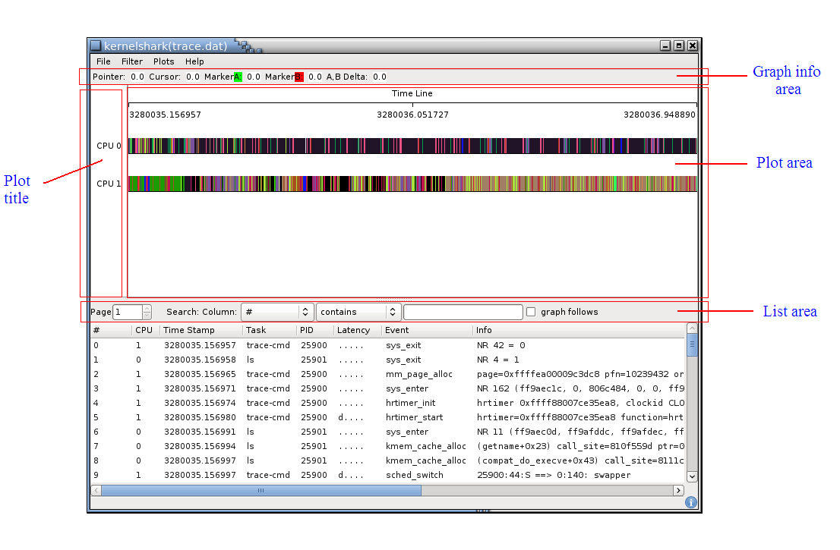
Figure 2.1.13-4Kernel shark graph information
Graph Info Area
The graph information line displays the timestamp of various locations. The Pointer: shows the timestamp of where the mouse pointer is. The Cursor: is the timestamp of the cursor location. To select a cursor location, double click on the graph. Marker A is set with a left mouse click and Marker B is set with a with a left mouse click while holding down the shift key.

Plot area
The plot area contains the data of the given plot, where plots can be per CPU or per task. The top of the plot area shows a timeline. The numbers in the timeline are seconds. The time in the timeline is taken from the timestamps within the trace.dat file which are architecture dependent. The time usually is the timestamp from when the system started.

List Area
The list area contains the Page of the list. The list can hold a maximum of 1 million entries per page. If the trace data contains more than a million entries, then the list will have more than one page.
The list area also contains a search field to search for elements in the list.

NOTE: You can find more information in here

Installing KernelShark in Skerlet
KernelShark is front-end reader of trace-cmd utility, we need to get trace-cmd source code to compile KernelShark

# git clone git://git.kernel.org/pub/scm/linux/kernel/git/rostedt/trace-cmd.git

Before compile KernelShark, we need install some packge that is dependency of trace-cmd

# apt-get install libgtk2.0-dev
# apt-get install libxml2-dev

NOTE: Maybe hasn’t libxml-2.0.pc file, you need to get that from internet and then put into /usr/lib/pkgconfig directory

# wget https://ggobi-documentation.googlecode.com/files/libxml-2.0.pc
# mv libxml-2.0.pc /usr/lib/pkgconfig/

Compile source code

# make
# make gui
# make install
# make install_gui

Using KernelShark
Recording a program which is need to trace

# trace-cmd record ls

Read traced data by KernelShark

# kernelshark

Or specifiy path of trace.dat

# kernelshark –i trace.dat

Benchmark on target board

Hackbench
As every measuring tool, Ftrace brings an overhead for every function call by the kernel. To get a good idea of the overhead, hackbench is useful utility.
You can get source code from here, and then compile:

$ gcc –g –Wall –O2 – hackbench hackbench.c –lpthread

Running hackbench utility on target board (CuBox):

$ cd /sys/kernel/debug/tracing
$ echo 0 > tracing_on
$ echo function > tracing_on
$ ~/hackbench 5 ; 200 tasks
$ ~/hackbench 10 ; 400 tasks
$ ~/hackbench 15 ; 600 tasks
$ ~/hackbench 20 ; 800 tasks

After run hackbench on target board with some test cases:
None: Disable ftrace in kernel
Tracing_off: Enable ftrace in kernel but turn off this
Nop: Using nop tracer
Function: Using function tracer
Function_graph: Using function_graph tracer
Irqsoff: Using irqsoff tracer
Wakeup: Using wakeup tracer
We obtain result below:
Table 3 Result data benchmark of Ftrace
Tracer | Number tasks
Tracer | 200 | 400 | 600 | 800
None | 1.922 | 3.919 | 5.746 | 7.689
tracing_off | 2.662 | 5.346 | 8.064 | 10.618
Nop | 2.680 | 5.366 | 8.083 | 10.780
Function | 31.006 | 61.724 | 92.765 | 122.300
function_graph | 79.544 | 159.127 | 235.983 | 314.644
Irqsoff | 14.204 | 28.601 | 43.034 | 56.954
Wakeup | 4.799 | 9.610 | 14.491 | 19.249

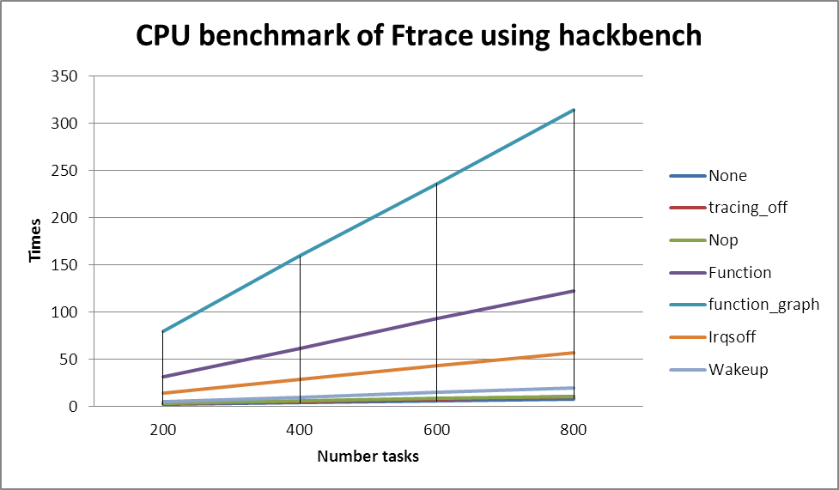
Figure 2.1.14-5Benchmark for ftrace

As we can see, almost tracers will cause high overhead, function and function_graph tracer cause very high overhead.

Iozone
Iozone also is useful benchmark utility, generates and measures a variety of file operations, and measure speed of those operations.
Get source code of iozone package:

$ wget http://www.iozone.org/src/current/iozone3_414.tar

Create a patch file to cross compile iozone source code

File cross_compile_iozone.diff
diff -Naur iozone3_414.org//src/current/makefile iozone3_414/src/current/makefile
--- iozone3_414.org//src/current/makefile 2013-03-14 06:44:12.000000000 +0000
+++ iozone3_414/src/current/makefile 2013-03-14 06:45:55.000000000 +0000
@@ -9,9 +9,9 @@
# convex, FreeBSD, OpenBSD, OSFV3, OSFV4, OSFV5, SCO
# SCO_Unixware_gcc,NetBSD,TRU64, Mac OS X

-CC = cc
+CC = arm-skerlet-linux-gnueabi-gcc
C89 = c89
-GCC = gcc
+GCC = arm-skerlet-linux-gnueabi-gcc
CCS = /usr/ccs/bin/cc
NACC = /opt/ansic/bin/cc
CFLAGS =

Apply above patch

$ cd iozone3_414
$ patch –p1 < cross_compile_iozone.diff

Compile source code

$ make

After compile successfully, you can see some binary file which is need to porting onto target board (CuBox)

$ ls
fileop
iozone
pit_server
$ scp fileop iozone pit_server root@CUBOX_IP_ADDR:/usr/bin

Running iozne on target board:

$ iozone –R –b result.xls –u 1 –l 1 –r 4k –s 10m –F /home/f1

We obtain result:
Table 4 Result data
Tracer | None | tracing_off | nop | function | function_graph | irqsoff | wakeup
Initial write | 112081.38 | 70790.078 | 84989.141 | 6930.1655 | 1422.108765 | 19992.188 | 43331.258
Rewrite | 278471.19 | 223137.42 | 223864.33 | 12048.464 | 8895.553711 | 51977.309 | 120665.21
Read | 190846.03 | 201690.13 | 201428.11 | 67791.672 | 32741.49414 | 142247.67 | 170652.03
Re-read | 191034.48 | 202195.27 | 201972.77 | 68220.234 | 13809.50977 | 142206.7 | 170734.8
Reverse read | 83146.563 | 186980.94 | 83719.656 | 56568.641 | 26445.79883 | 111276.41 | 153213.41
Stride read | 179268.59 | 183828.58 | 188287.55 | 26035.961 | 27781.92969 | 112557.2 | 155505
Random Read | 180841.63 | 188159.69 | 186005.97 | 59547.387 | 21683.57227 | 114179.92 | 101733.61
Mixed workload | 180781.5 | 188398.22 | 188349.48 | 59339.242 | 27919.41797 | 114202.7 | 155812.45
Random write | 251776.05 | 208376.41 | 209082.42 | 9118.1797 | 3979.408203 | 50781.273 | 115280.46
Pwrite | 113019.27 | 85433.594 | 85167.953 | 4113.5186 | 1437.131836 | 27281.363 | 43086.914
Pread | 188024.61 | 196119.19 | 174060.22 | 62142.707 | 29635.38086 | 110899.45 | 161979.61

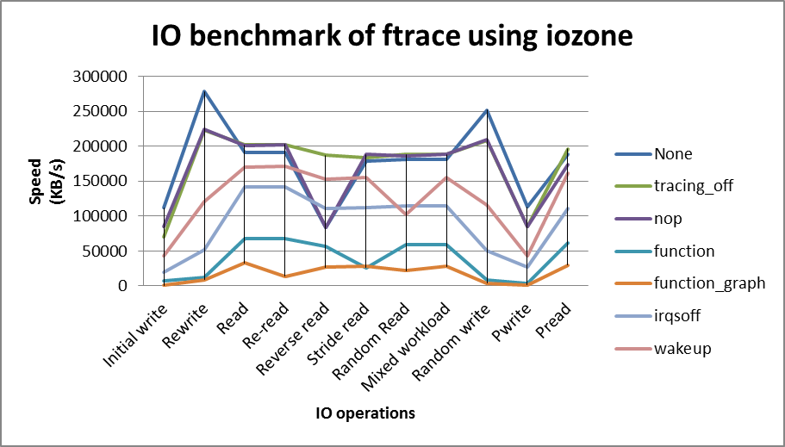
Figure 2.1.14-6 IO benchmark of ftrace

We can see, when using function and function_graph tracer, speed of file operations is too much lower than others.

Conclusion
Ftrace has been designed with function tracing as primary purpose; it also supports tracepoint instrumentation and dynamic probing. It has efficient mechanisms to quickly collect data and to filter out information that is not interesting to the user. Ftrace targets a kernel developer audience, including console output integration that allows dumping tracing buffers upon a kernel crash. Its event headers are fixed by the ABI, with extensible event payload definitions. Its ring buffer is heavily optimized for performance, but it allows only a single user to trace at any given time. Its tracing infrastructure resides at kernel-level only. Therefore, tracing user space requires a round-trip to the kernel, which causes a performance hit.

In development environments, Ftrace is suited for kernel developers who want to debug bugs and latency issues occurring at kernel-level. One of the major Ftrace strengths over Perf is its low overhead. It is therefore well-suited for tracing high-throughput data coming from frequently hit tracepoints or from function entry/exit instrumentation on busy systems.

LTTng

Overview
The LTTng project aims at providing highly efficient tracing tools for Linux. Its tracers help tracking down performance issues and debugging problems involving multiple concurrent processes and threads. Tracing across multiple systems is also possible.

Apart from LTTng's kernel tracer and user-space tracer, viewing and analysis tools are part of the project. The LTTV viewer permits to analyze and show traces, both in text format and graphically.

LTTng's performance relies on techniques such as User-space RCU, lockless algorithms, per-CPU data structures and cache impact minimization.

History
The recently released Linux Trace Toolkit next generation (LTTng) 2.0 tracer is the result of a two-year development cycle involving a team of dedicated developers. Unlike its predecessor, LTTng 0.x, it can be installed on a vanilla or distribution kernel without any patches. It also performs combined tracing of both the kernel and user space, and has many more features that will be detailed in this article and its successor.

Why LTTng 2.0?
The main motivation behind LTTng 2.0 is that we identified a strong demand for user-space tracing, and we noticed that targeting a user base broader than developers required a lot of work focusing on usability. Moving forward toward these goals led us to the unification of the tracer control and user interface (UI) for both kernel and user-space tracing.

Some might wonder why we did not go down the Perf or Ftrace path for our development. Perf does not meet our performance needs, and is in many ways designed specifically for the Linux kernel (e.g. the trace format is kernel-specific). As for Ftrace, its performance is similar to that of LTTng, but its main focus is on simplicity for kernel debugging use-cases, which means a single user, single tracing session, and single set of buffers. It also has a trace format specifically tuned for the Linux kernel, which does not meet our requirements.

Getting started

Install LTTng onUbuntu 12.04
Add LTTng stable PPA

$ sudo apt-add-repository ppa:lttng/ppa
$ sudo apt-get update

Install LTTng

$ sudo apt-get install lttng-tools lttng-modules-dkms babeltrace

Once the modules are installed correctly, you can start tracing right away. No need to reboot!

Install LTTng on Skerlet
TBD
1) Get source code from LTTng home page

$ wget https://lttng.org/files/urcu/userspace-rcu-0.7.5.tar.bz2
$ wget https://lttng.org/files/lttng-tools/lttng-tools-2.0.5.tar.bz2
$ wget https://lttng.org/files/lttng-modules/lttng-modules-2.0.6.tar.bz2
$ wget https://lttng.org/files/lttng-ust/lttng-ust-2.0.6.tar.bz2

2) Compile and install userspace-rcu lib

$ cd userspace-rcu-0.7.5/
$ ./configure
$ make
$ sudo make install

3) Compile and install lttng-ust lib

$ cd lttng-ust-2.0.6/
$ ./configure
$ make
$ sudo make install

4) Compile and install lttng-tools

$ cd lttng-tools-2.0.5/
$ ./configure
$ make
$ sudo make install

5) Compile lttng-modules
TBD
NOTE: Currently, we have not build lttng-modules successfully with Skerlet kernel version 2.6.32 yet, because lttng-modules 2.0.6 requires at least Linux 2.6.38

Install LTTng on target board (CuBox)
Get source code from LTTng home page

$ wget https://lttng.org/files/urcu/userspace-rcu-0.7.5.tar.bz2
$ wget https://lttng.org/files/lttng-tools/lttng-tools-2.0.5.tar.bz2
$ wget https://lttng.org/files/lttng-modules/lttng-modules-2.0.6.tar.bz2
$ wget https://lttng.org/files/lttng-ust/lttng-ust-2.0.6.tar.bz2

LTTng Basic
LTTng commands and options
This program follow the usual GNU command line syntax with long options starting with two dashes. Below is a summary of the available options:
-h, --help
Show summary of possible options and commands.
-v, --verbose
Increase verbosity. Three levels of verbosity are available which are triggered by putting additional v to the option (-vv or -vvv)
-q, --quiet
Suppress all messages (even errors).
-g, --group NAME
Set unix tracing group name. (default: tracing)
-n, --no-sessiond
Don't automatically spawn a session daemon.
--sessiond-path
Set session daemon full binary path.
--list-options
Simple listing of lttng options.
--list-commands
Simple listing of lttng commands.

Below is a summary of the available commands:
add-context
Add context to event(s) and/or channel(s)

A context is basically extra information appended to a channel or event. For instance, you could ask the tracer to add the PID information within the "sched_switch" kernel event. You can also add performance monitoring unit counters (perf PMU) using the perf kernel API

For example, this command will add the context information 'prio' and two perf counters (hardware branch misses and cache misses), to all events in the trace data output:

# lttng add-context -k -t prio -t perf:branch-misses -t perf:cache-misses

Please take a look at the help (-h/--help) for a detailed list of available contexts.

If no channel and no event is given (-c/-e), the context is added to all channels (which applies automatically to all events in that channel). Otherwise the context will be added only to the channel (-c) and/or event (-e) indicated.

If -s, --session is omitted, the session name is taken from the .lttngrc file.

OPTIONS:
-h, --help
Show summary of possible options and commands.

-s, --session NAME
Apply on session name.

-c, --channel NAME
Apply on channel name.

-e, --event NAME
Apply on event name.

-k, --kernel
Apply for the kernel tracer

-u, --userspace
Apply for the user-space tracer

-t, --type TYPE
Context type. You can repeat this option on the command line. Please use "lttng add-context -h" to list all available types.
calibrate
Quantify LTTng overhead.

The LTTng calibrate command can be used to find out the combined average overhead of the LTTng tracer and the instrumentation mechanisms used. This overhead can be calibrated in terms of time or using any of the PMU performance counter available on the system.

You can see this section which explain how to use calibrate

create [OPTIONS] [NAME]
Create tracing session.

A tracing session contains channel(s) which contains event(s). It is domain agnostic meaning that you can enable channels and events for either the user-space tracer and/or the kernel tracer. It acts like a container aggregating multiple tracing sources.

On creation, a .lttngrc file is created in your $HOME directory containing the current session name. If NAME is omitted, a session name is automatically created having this form: 'auto-yyyymmdd-hhmmss'.

If no -o, --output is specified, the traces will be written in $HOME/lttng-traces.

OPTIONS:

-h, --help
Show summary of possible options and commands.

--list-options
Simple listing of options

-o, --output PATH
Specify output path for traces

destroy [OPTIONS] [NAME]
Teardown tracing session.

Free memory on the session daemon and tracer side. It's gone!

If NAME is omitted, the session name is taken from the .lttngrc file.

OPTIONS:

-h, --help
Show summary of possible options and commands.

--list-options
Simple listing of options

enable-event NAME[,NAME2,...] [-k|-u] [OPTIONS]
Enable tracing event

A tracing event is always assigned to a channel. If -c, --channel is omitted, a default channel named 'channel0' is created and the event is added to it. For the user-space tracer, using -a, --all is the same as using the wildcard "*".

If -s, --session is omitted, the session name is taken from the .lttngrc file.

disable-channel NAME[,NAME2,...] [-k|-u] [OPTIONS]
Disable tracing channel

Disabling a channel makes all event(s) in that channel to stop tracing. You can enable it back by calling lttng enable-channel NAME again.

If -s, --session is omitted, the session name is taken from the .lttngrc file.

disable-event NAME[,NAME2,...] [-k|-u] [OPTIONS]
Disable tracing event

The event, once disabled, can be re-enabled by calling lttng enable-event NAME again.

list [-k|-u] [SESSION [SESSION_OPTIONS]]
List tracing session information.

set-session NAME
Set current session name

Will change the session name in the .lttngrc file.

start [OPTIONS] [NAME]
Start tracing

It will start tracing for all tracers for a specific tracing session.

If NAME is omitted, the session name is taken from the .lttngrc file.

stop [OPTIONS] [NAME]
Stop tracing

It will stop tracing for all tracers for a specific tracing session.

If NAME is omitted, the session name is taken from the .lttngrc file.

view [SESSION_NAME] [OPTIONS]
View traces of a tracing session

By default, the babeltrace viewer will be used for text viewing.

Kernel Tracing
First make sure you have lttng-modules (the kernel modules) and lttng-tools installed.

You can start the session daemon by invoking the command "lttng-sessiond", or let the lttng command line tool do it for you. The session daemon loads the LTTng tracer modules for you if those modules can be found on your system. If they are not found, the kernel tracing feature will be unavailable.

List available kernel events:

# lttng list -k

1) Create a tracing session. The .lttng directory will be created with .lttngrc file in $HOME containing the session name (here 'mysession') you are working on.

# lttng create mysession

2) If you have multiple sessions, you can change the current session by using

# lttng set-session myothersession

3) Enable tracepoint event(s). Here for example, we want only 'sched_switch' and 'sched_wakeup' events for the kernel (-k/--kernel).

# lttng enable-event sched_switch,sched_wakeup -k

or enable ALL tracepoint events:

# lttng enable-event -a -k --tracepoint

4) Enable all system call event(s).

# lttng enable-event -a -k --syscall

5) Enable kprobes and/or the function tracer with lttng.
This is a new feature made possible by the new LTTng 2.0 kernel tracer. You can enable a dynamic probe and data will be output in the trace along side with your tracing data.

# lttng enable-event [aname] -k --probe [symbol]+0x0

or

# lttng enable-event [aname] -k --probe 0xffff7260695

Either an <address> or a <symbol+offset> can be used for probes.

You can also enable function tracer, which uses the Ftrace API. Again, data will be output in the trace

# lttng enable-event aname -k --function <symbol_name>

6) Enable context information for an event:
This is also a new feature which allows you to add context information to an event. For example, you can add the PID along with the event information:

# lttng add-context -k -e sched_switch -t pid

At this point, you will have to look at 'lttng add-context --help' for all possible context type.

You can on the same line activate multiple context:

# lttng add-context -k -e sched_switch -t pid -t nice -t tid

7) Enable perf counter for an event
Again, a new powerful feature is the possibility to add perf counter data to the trace on a per event basis. Let say we want to get the CPU cycles at each event:

# lttng add-context -k -e sched_switch -t perf:cpu-cycles

You'll have to use the add-context help for all possible perf counter values.

8) Start tracing:

# lttng start

Tracing is in progress at this point and traces will be written in $HOME/lttng-traces/mysession-<date>-<time>

NOTE: It will start tracing for all domain(s).

9) Stop tracing:

# lttng stop

NOTE: At this point, you can restart the trace (lttng start). You can also read the trace since the buffers are flushed on stop command.

10) Destroy your session after you are done with tracing

# lttng destroy

User-space tracing
Like kernel tracing, you can start the session daemon by invoking the command "lttng-sessiond", or let the lttng command line tool do it for you.

NOTE: You do not need root credentials in order to tracer user-space applications. However, if you run the session daemon under non-root user rights, only applications of that user will be traced.

So, after instrumenting you applications with LTTng-ust 2.0 (http://lttng.org/lttng2.0), upon startup, it will automatically register to the session daemon. If there is none running, it will simply wait on a separate thread for a session daemon to appear and then register.

Start your instrumented application at any time but at least before starting tracing .

List available registered applications:

# lttng list -u

1) Create a tracing session. The .lttng directory will be created with a .lttngrc file in $HOME containing the session name (here 'mysession') you are working on.

$ lttng create mysession

If you have multiple sessions, you can change the current session by using:

$ lttng set-session myothersession

2) Enable all tracepoints for the global UST domain ("-u" alone).

$ lttng enable-event -a –u

or enable a single tracepoint event

$ lttng enable-event ust_tests_hello:tptest -u

3) This is also a new feature which allows you to add context information to an event. For example, you can add the PID along with the event information:

$ lttng add-context -t pid -e ust_tests_hello:tptest -u

At this point, you will have to look at 'lttng add-context --help' for all possible context type.

You can on the same line activate multiple context:

$ lttng add-context -u -e ust_tests_hello:tptest -t pid -t nice -t tid

4) Start tracing:

$ lttng start

Tracing is in progress at this point and traces will be written in
$HOME/lttng-traces/mysession-<date>-<time>/ust/<procname>-<pid>-<date>-<time>

NOTE: It will start tracing for all domain(s).

5) Stop tracing:

$ lttng stop

NOTE: At this point, you can restart the trace (lttng start). You can also read the trace since the buffers are flushed on stop command.

6) Destroy your session after you are done with tracing

$ lttng destroy

7) Read a trace

$ lttng view

The tool "Babeltrace" can be used to dump your binary trace into a human-readable text format.

# babeltrace $HOME/lttng-traces/mysession-<date>-<time> | less

Using LTTng

Kernel activity overview with tracepoints
Tracing the kernel activity can be done by enabling all tracepoints and then starting a trace session. This sequence of commands will show a human-readable text log of the system activity (run as root or a user in the tracing group):

# lttng create
# lttng enable-event --kernel --all
# lttng start
# sleep 2 # let the system generate some activity
# lttng stop
# lttng view
# lttng destroy

Here is an example of the event text output (with annotation), generated by using:

# lttng view -e "babeltrace -n all"

To show all field name:

timestamp = 15:38:02.730821891, # Event timestamp
delta = +0.000000140, # Timestamp delta from previous event
name = sched_wakeup, # Event name
stream.packet.context = { # Stream-specific context information
cpu_id = 3 # CPU which has written this event
},
event.fields = { # Event payload
comm = "kworker/3:2",
tid = 6017,
prop = 120,
success = 1,
target_cppu = 3
}

You can specify tracepoints can be traced with command:

# lttng enable-event --kernel irq_handler_entry,irq_handler_exit

Only "irq_handler_entry" and "irq_handler_exit" will be trace. Output look like:

# lttng view | head
[15:57:34.914931871] (+?.?????????) irq_handler_entry: { cpu_id = 0 }, { irq = 42, name = "i915" }
[15:57:34.914937399] (+0.000005528) irq_handler_exit: { cpu_id = 0 }, { irq = 42, ret = 1 }
…

NOTE: To get the list of available tracepoints:

# lttng list –k
Kernel events:
-------------
timer_init (loglevel: TRACE_EMERG (0)) (type: tracepoint)
timer_start (loglevel: TRACE_EMERG (0)) (type: tracepoint)
…

Dynamic probe
This second example shows how to plant a dynamic probe (kprobe) in the kernel and gather information from the probe:

# lttng create
# lttng enable-event --kernel sys_open --probe sys_open+0x0
# lttng enable-event --kernel sys_close --probe sys_close+0x0
# lttng start
# sleep 2 # let the system generate some activity
# lttng stop
# lttng view
# lttng destroy

Example event generated:

timetamp = 16:19:17.100535152, # Event timestamp
delta = +0.481156709, # Timestamp delta from previous event
name = sys_open, # event name
stream.packet.context = { # Stream-specific context information
cpu_id = 0 # CPU which has written this event
},
event.fields = {
ip = 0xC1143C20 # Instruction pointer where probe was planted
}
All instrumentation sources can be combined and collected within a trace session.

User space tracing
LTTng 2.0 offers fast user-space tracing support with the "lttng-ust" (LTTng User-space Tracer) library.

The "hello" program is distributed with lttng-ust source code. Base on this program, we will create a test program which demonstrating how to create a tracepoint to trace user application.

File ust_test_hello.h

#undef TRACEPOINT_PROVIDER
#define TRACEPOINT_PROVIDER ust_tests_hello

#if !defined(_TRACEPOINT_UST_TESTS_HELLO_H) || defined(TRACEPOINT_HEADER_MULTI_READ)
#define _TRACEPOINT_UST_TESTS_HELLO_H

#ifdef __cplusplus
extern "C" {
#endif

#include <lttng/tracepoint.h>
#include <stdbool.h>

TRACEPOINT_EVENT(ust_tests_hello, tptest,
TP_ARGS(int, anint, int, netint, long *, values,
char *, text, size_t, textlen,
double, doublearg, float, floatarg,
bool, boolarg),
TP_FIELDS(
ctf_integer(int, intfield, anint)
ctf_integer_hex(int, intfield2, anint)
ctf_integer(long, longfield, anint)
ctf_integer_network(int, netintfield, netint)
ctf_integer_network_hex(int, netintfieldhex, netint)
ctf_array(long, arrfield1, values, 3)
ctf_array_text(char, arrfield2, text, 10)
ctf_sequence(char, seqfield1, text,
size_t, textlen)
ctf_sequence_text(char, seqfield2, text,
size_t, textlen)
ctf_string(stringfield, text)
ctf_float(float, floatfield, floatarg)
ctf_float(double, doublefield, doublearg)
ctf_integer(bool, boolfield, boolarg)
)
)

TRACEPOINT_EVENT(ust_tests_hello, tptest_sighandler,
TP_ARGS(),
TP_FIELDS()
)

#endif /* _TRACEPOINT_UST_TESTS_HELLO_H */

#undef TRACEPOINT_INCLUDE_FILE
#define TRACEPOINT_INCLUDE_FILE ./ust_tests_hello.h

/* This part must be outside ifdef protection */
#include <lttng/tracepoint-event.h>

#ifdef __cplusplus
}
#endif

First, we define a tracepoint provider:

#define TRACEPOINT_PROVIDER ust_tests_hello

NOTE: Have to define tracepoint provider before include tracepoint.h

Then we declare 2 tracepoint event using TRACEPOINT_EVENT macro. TRACEPOINT_EVENT macro contain 4 fields:
- Provider name (need to same as TRACEPOINT_PROVIDER) is ut_test_hello
- Tracepoint name (in this ex: tptest and tptest_sighandler)
- TP_ARGS contains the arguments passed for the tracepoint
- TP_FIELDS describes how to write the fields of the trace event, also it will determine output format of tracepoint argument.

NOTE: You can see lttng-ust man page for more detail

File hello.c

#include <stdio.h>
#include <unistd.h>
#include <sys/mman.h>
#include <stdarg.h>
#include <sys/types.h>
#include <sys/stat.h>
#include <fcntl.h>
#include <signal.h>
#include <string.h>
#include <arpa/inet.h>
#include <stdlib.h>
#include <stdbool.h>

#define TRACEPOINT_DEFINE
#include "ust_tests_hello.h"

#define NR_SAMPLES
void inthandler(int sig)
{
printf("in SIGUSR1 handler\n");
tracepoint(ust_tests_hello, tptest_sighandler);
}

int init_int_handler(void)
{
int result;
struct sigaction act;

memset(&act, 0, sizeof(act));
result = sigemptyset(&act.sa_mask);
if (result == -1) {
perror("sigemptyset");
return -1;
}

act.sa_handler = inthandler;
act.sa_flags = SA_RESTART;

/* Only defer ourselves. Also, try to restart interrupted
* syscalls to disturb the traced program as little as possible.
*/
result = sigaction(SIGUSR1, &act, NULL);
if (result == -1) {
perror("sigaction");
return -1;
}

return 0;
}

int main(int argc, char **argv)
{
int i, netint;
long values[] = { 1, 2, 3 };
char text[10] = "test";
double dbl = 2.0;
float flt = 2222.0;
int delay = 0;
bool mybool = 123; /* should print "1" */

init_int_handler();

if (argc == 2)
delay = atoi(argv[1]);

fprintf(stderr, "Hello, World!\n");

sleep(delay);

fprintf(stderr, "Tracing... ");
for (i = 0; i < NR_SAMPLES; i++) {
netint = htonl(i);
tracepoint(ust_tests_hello, tptest, i, netint, values,
text, strlen(text), dbl, flt, mybool);
}
/* send SIGUSR1 */
kill(get_pid(), SIGUSR1);

fprintf(stderr, " done.\n");
return 0;
}

We will using tracepoint() function to trace argument passed to tracepoint event

tracepoint(ust_test_hello, /* tracepoint provider */
tptest, /* tracepoint name */
args… /* arguments */
)

You must be link to –ldl and -llttng-ust when compile source code:

# gcc –o hello hello.c –llttng-ust –ldl

After compile, run hello program and obverse result

$ lttng create
$ lttng enable-event --userspace --all
$ lttng start
$ cd hello/
$ ./hello # Very, very high-throughput test application
$ lttng stop
$ lttng view
$ lttng destroy

Output from lttng view

# gcc –o hello hello.c –llttng-ust

We can see fields of tracepoint are printed out

[…]
[20:01:43.148603230] (+0.000000238) ust_tests_hello:tptest: { cpu_id = 0 }, { intfield = 9, intfield2 = 0x9, longfield = 9, netintfield = 9, netintfieldhex = 0x9, arrfield1 = [ [0] = 1, [1] = 2, [2] = 3 ], arrfield2 = "test", _seqfield1_length = 4, seqfield1 = [ [0] = 116, [1] = 101, [2] = 115, [3] = 116 ], _seqfield2_length = 4, seqfield2 = "test", stringfield = "test", floatfield = 2222, doublefield = 2, boolfield = 1 }
[20:01:43.148694151] (+0.000000208) ust_tests_hello:tptest_sighandler: { cpu_id = 0 }, { }

Calibrate function
It is important to measure the overhead produced by kretprobes, reading the performance monitoring unit (PMU), and tracing with LTTng to understand how much of the total count can be attributed to the tracing itself. LTTng has a "calibrate" command to trigger calibration functions which, when instrumented, collect the base cost of the instrumentation.
This sequence of commands will gather a trace executing a kretprobe hooked on an empty function that gathers the LLC-misses information (see lttng add-context --help to get a list of the available PMU counters).

# lttng create calibrate-session
# lttng enable-event calibrate --kernel --function lttng_calibrate_kretprobe
# lttng add-context --kernel -t perf:LLC-load-misses -t perf:LLC-store-misses \
-t perf:LLC-prefetch-misses
# lttng start
# for a in $(seq 1 10); do \
lttng calibrate --kernel --function;
# done
# lttng stop
# lttng view
# lttng destroy

Here is some sample output:

[…]
[11:43:14.240518268] (+0.000007059) calibrate_return: { cpu_id = 1 }, { perf_LLC_prefetch_misses = 3, perf_LLC_store_misses = 3, perf_LLC_load_misses = 3 }, { ip = 0xF934C450, parent_ip = 0xF934C47D }
[11:43:14.242055786] (+0.001537518) calibrate_entry: { cpu_id = 1 }, { perf_LLC_prefetch_misses = 3, perf_LLC_store_misses = 3, perf_LLC_load_misses = 3 }, { ip = 0xF934C450, parent_ip = 0xF934C47D }
[11:43:14.242059083] (+0.000003297) calibrate_return: { cpu_id = 1 }, { perf_LLC_prefetch_misses = 3, perf_LLC_store_misses = 3, perf_LLC_load_misses = 3 }, { ip = 0xF934C450, parent_ip = 0xF934C47D }
[…]

LTTV – Linux Trace Toolkit Viewer

Installing LTTV
1) Get source code

$ git clone git://git.lttng.org/lttv.git

2) Compile source code and install

$ ./bootstrap
$ ./configure
$ make
$ sudo make install

Using LTTV
TBD
NOTE: It does not yet support the CTF format, which is used by the LTTng 2.0 kernel and userspace tracers (see http://lttng.org/lttv).

Eclipse LTTng plugin
The LTTng plug-in for Eclipse provides an Eclipse integration for the control of the LTTng tracer as well as fetching and visualization of the traces produced. It also provides the foundation for user-defined analysis tools.

The LTTng Eclipse plug-in provides the following views:

- Project - an extension to the standard Eclipse Project view tailored for tracing projects
- Control - to control the tracer and configure the tracepoints
- Events - a versatile view that presents the raw events in tabular format with support for searching, filtering and bookmarking
- Statistics - a view that that provides simple statistics on event occurrences by type
- Histogram - a view that displays the event density with respect to time in traces
These views can be extended or tailored for specific trace types (e.g. kernel, HW, user app).

NOTE: You can see here to get a lot of useful information.

Installing Eclipse LTTng plugin
Add PPA of Eclipse LTTng plugin

$ sudo apt-add-repository ppa:lttng/eclipse
$ sudo apt-get update

NOTE: You can add repository of Eclipse LTTng plugin manualy by append two line below into /etc/apt/sources.list

deb http://ppa.launchpad.net/lttng/eclipse/ubuntu precise main
deb-src http://ppa.launchpad.net/lttng/eclipse/ubuntu precise main

Install Eclipse LTTng plugin

$ sudo apt-get install eclipse-lttng

Using Eclipse LTTng plugin
After installing Eclipse and the plugins via one of the previous methods, opening a LTTng trace is a couple clicks away.
1) Open Tracing Perspective
Go to Window → Open Perspective → Other, and select the Tracing

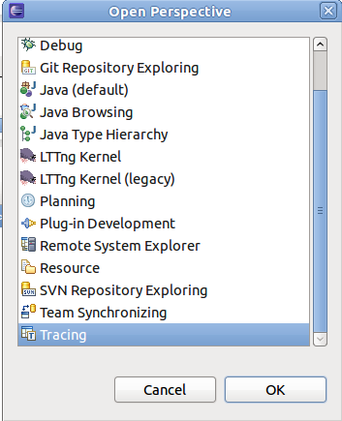
Figure 2.2.7-7 Choose tracing module

2) Create Tracing project
A new Tracing project can be created using the New Tracing Project wizard. To create a new Tracing select File → New → Project... from the main menu bar
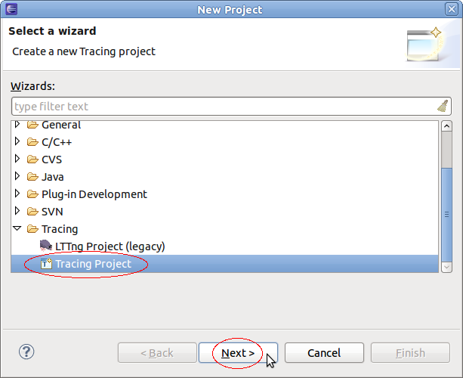
Figure 2.2.7-8 Create tracing project

In the list of project categories, expand category Tracing and select Tracing Project and the click on Next →. A second page of the wizard will show. Now enter a name in the field Project Name, select a location if required and the press on Finish.

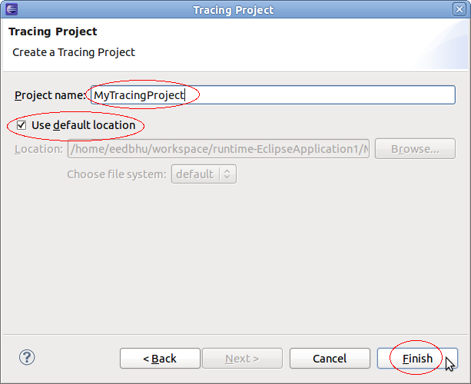
Figure 2.2.7-9 Project name

A new project will appear in the Project Explorer view.

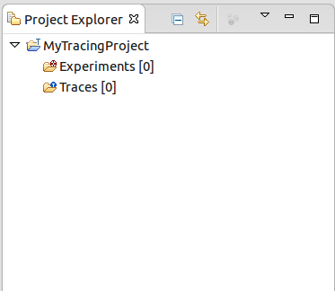
Figure 2.2.7-10 Project appear

Tracing projects have two sub-folders: Traces which holds the individual traces, and Experiments which holds sets of traces that we want to correlate.

3) Importing Traces in a Project
After tracing with LTTng, we can import data which is result of tracing by LTTng

# lttng create
# lttng enable-event –a –k
# lttng start
# sleep 1
# lttng stop
# lttng destroy

NOTE: At this point tracing data is located at /root/lttng-traces/auto-20161125-162222 directory.

The Traces folder holds the set of traces available for experiments. To import a trace to the traces folder, select the Traces folder and click the right mouse button. Then select Import... menu item in the context-sensitive menu.
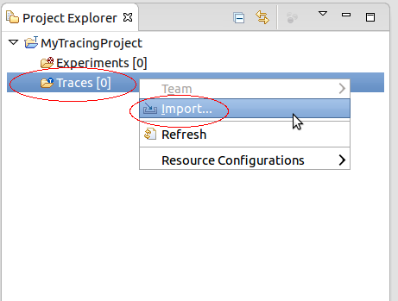
Figure 2.2.7-11 Import tracing to project
A new display will show for selecting traces to import. By default, it shows the correct destination directory where the traces will be imported to. Now, specify the location of the traces by entering the path directly in the Source Directory or by browsing the file system (click on button browse). Then select the traces to import in the list of files and folders. Optionally, select the Trace Type from the drop-down menu, select or deselect the checkboxes for Overwrite existing trace without warning and Create links into workspace. When all options are configured, click on Finish.

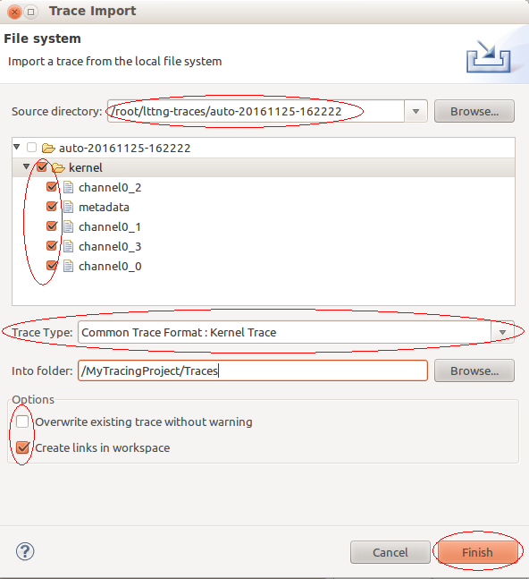
Figure 2.2.7-12 Select file to import

4) Selecting trace type
If no trace type was selected a trace type as to be associated to a trace before it can be opened. To select a trace type select the relevant trace and click the right mouse button. In the context-sensitive menu, select Select Trace Type... menu item. A sub-menu will show will all available trace type categories. From the relevant category select the required trace type. The examples, below show how to select the Common Trace Format types LTTng Kernel and Generic CTF trace.
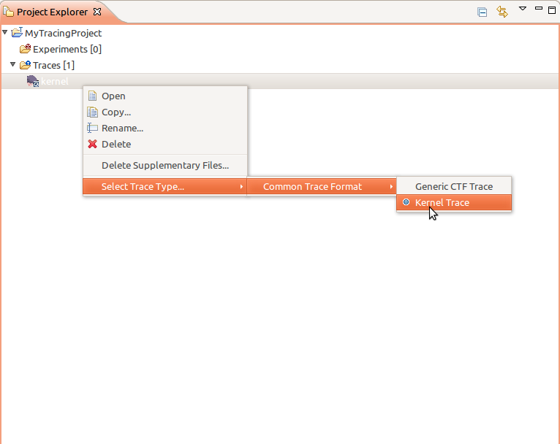
Figure 2.2.7-13 Select trace type

5) Open a trace
A trace or experiment can be open by double-clicking the left mouse button on the trace or experiment in the Project Explorer view. Alternatively, select the trace or experiment in the in the Project Explorer view and click the right mouse button. Then select Open menu item of the context-sensitive menu.
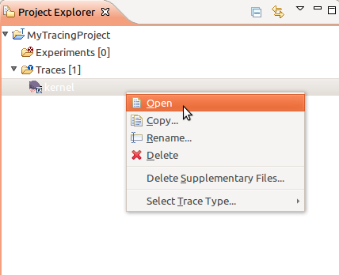
Figure 2.2.7-14 Open trace

Event view
The Events view shows the basic trace data in chronological order in a tabular format.

When opened, the Events view displays the events of the currently selected trace or experiment.

The header displays the current trace (or experiment) name.

Being part of the Tracing and Monitoring Framework, the default table displays the following fields:
- Timestamp: the event timestamp
- Source: the source of the event
- Type: the event type and localization
- Reference: the event reference
- Content: the raw event content
The first row of the table is the header row a.k.a. the Search and Filter row.

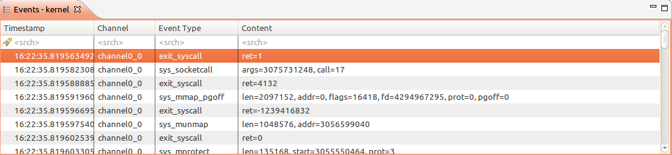
Figure 2.2.7-15 Event view

Searching and Filtering
Searching and filtering of events in the table can be performed by entering matching conditions in one or multiple columns in the header row (the first row below the column header).
To toggle between searching and filtering, click on the 'search' () or 'filter' () icon in the header row's left margin, or right-click on the header row and select Show Filter Bar or Show Search Bar in the context menu.
To apply a matching condition to a specific column, click on the column's header row cell, type in a regular expression and press the ENTER key. You can also enter a simple text string and it will be automatically be replaced with a 'contains' regular expression.
When matching conditions are applied to two or more columns, all conditions must be met for the event to match (i.e. 'and' behavior).
To clear all matching conditions in the header row, press the DEL key.

Searching

When a searching condition is applied to the header row, the table will select the next matching event starting from the top currently displayed event. Wrapping will occur if there is no match until the end of the trace.

All matching events will have a 'search match' icon in their left margin. Non-matching events will be dimmed.

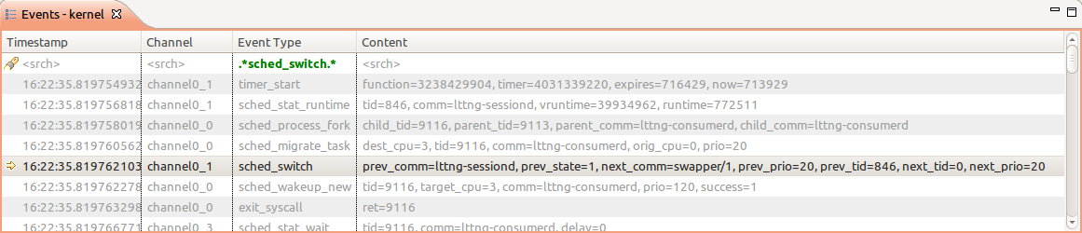
Figure 2.2.7-16 Searching

Pressing the ENTER key will search and select the next matching event. Pressing the SHIFT-ENTER key will search and select the previous matching event. Wrapping will occur in both directions.
Press ESC to cancel an ongoing search.
Press DEL to clear the header row and reset all events to normal.

Filtering

When a filtering condition is entered in the head row, the table will clear all events and fill itself with matching events as they are found from the beginning of the trace.
A status row will be displayed before and after the matching events, dynamically showing how many matching events were found and how many events were processed so far. Once the filtering is completed, the status row icon in the left margin will change from a 'stop' to a 'filter' icon.

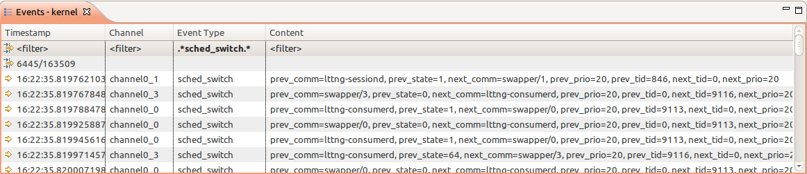
Figure 2.2.7-17 Filltering

Press ESC to stop an ongoing filtering. In this case the status row icon will remain as a 'stop' icon to indicate that not all events were processed.
Press DEL or right-click on the table and select Clear Filters from the context menu to clear the header row and remove the filtering. All trace events will be now shown in the table. Note that the currently selected event will remain selected even after the filter is removed.
You can also search on the subset of filtered events by toggling the header row to the Search Bar while a filter is applied. Searching and filtering conditions are independent of each other.

Histogram view
The Histogram View displays the trace events distribution with respect to time. When streaming a trace, this view is dynamically updated as the events are received.

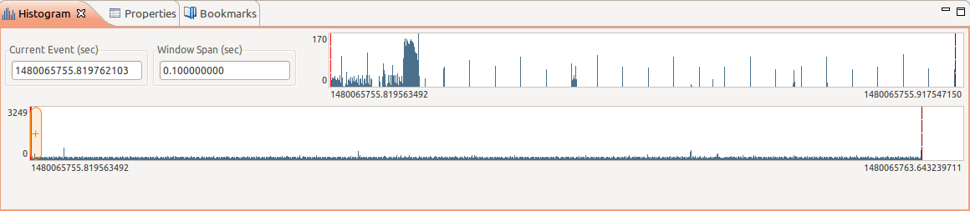
Figure 2.2.7-18 Histogram view

On the top left, there are two data controls:
Current Event (sec) : Displays the timestamp of the currently selected event
Window Span (sec) : Displays the current time range window size

Both control can be used to modify their respective value. After validation, the other controls and views will be synchronized and updated accordingly.

In each histogram, the following keys are handled:
Left : Moves the current event to the previous non-empty bar
Right : Moves the current event to the next non-empty bar
Home : Displays the current event to the first histogram bar
End : Displays the current event to the last non-empty histogram bar

Statistic view
The Statistics View displays the various event counters that are collected when analyzing a trace. The data is organized per trace. To open the Statistics View, select Windows → Show View → Other... → Tracing → Statistics. A new view will open with the name Statistics. This view shows 2 columns: Level and Number of Events. After parsing a trace the view will display the number of events per event type. The cells where the number of events are printed also contain a colored bar that indicates the percentage of the event count in relation to the total number of events. The statistics is collected for the whole trace. This view is part of the Tracing and Monitoring Framework (TMF) and is generic. It will work for any trace type extensions. For the LTTng 2.0 integration the Statistics view will display statistics as shown below:
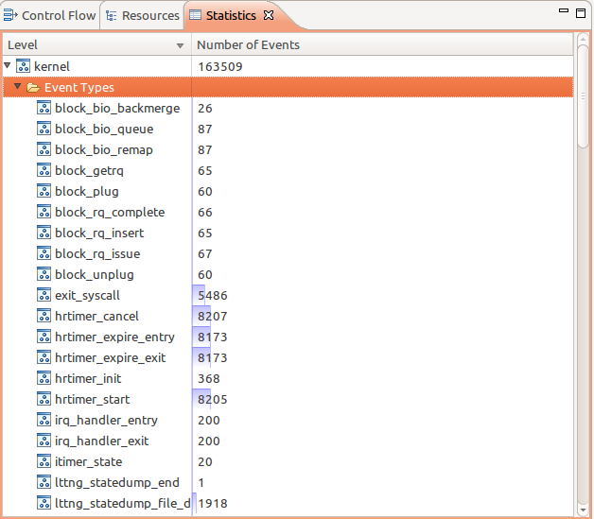
Figure 2.2.7-19 Statistics

Benchmark
TBD
NOTE: Because we haven’t installed successfully LTTng2.0 onto CuBox also x86 Skerlet PC yet, so we have implemented benchmark for LTTng in Ubuntu 12.04.

Running hackbench with some test cases:
None: Disable LTTng
Tracing with LTTng: Enable tracing hackbench by LTTng

Table 5 Result data benchmark of LTTng
 | Number tasks
 | 200 | 400 | 600 | 800
None | 0.127 | 0.256 | 0.381 | 0.507
Tracing with LTTng | 0.129 | 0.256 | 0.383 | 0.512

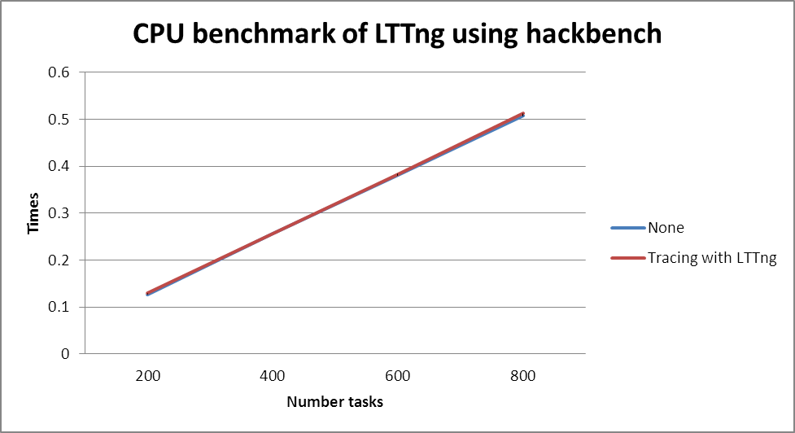
Figure 2.2.8-20Benchmark of LTTng

Similar benchmark with hackbench, implement benchmark for LTTng with iozone:

# iozone -R -b result.xls -l 1 -u 1 -r 4k -s 10m -F /home/f1

We obtain result:

Table 6 Result data of LTTng
 | None | Tracing with LTTng
Initial write | 561776.4 | 706748.625
Rewrite | 1081767 | 911202.1875
Read | 2184802 | 2144479
Re-read | 2175433 | 2178250
Reverse Read | 1612621 | 1623605.25
Stride read | 1638924 | 1610838.125
Random read | 1646584 | 1639964.125
Mixed workload | 1644474 | 1622293.5
Random write | 888196.8 | 1151336.875
Pwrite | 893074.8 | 601080.9375
Pread | 1902604 | 1839391.375

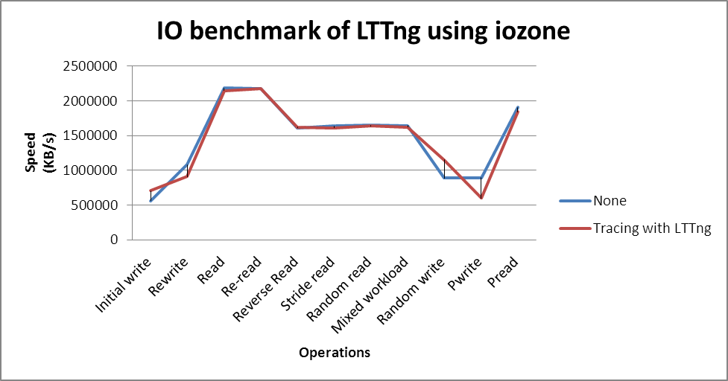
Figure 2.2.8-21 IO benchmark LTTng

As we can see, LTTng take low overhead, that warrant performance for system need to high performance.

Conclusion
The targeted LTTng audience includes anyone responsible for production systems, system administrators, and application developers. LTTng focuses on providing a system-wide view (across software stack layers) with detailed combined application and system-level execution traces, without adding too much overhead to the traced system.

One downside of LTTng 2.0 is that it is not provided by the upstream kernel: it requires that either the distribution, or the end user, install separate packages. LTTng 2.0 is also not geared toward kernel development: it currently does not support integration with kernel crash dump tools, nor does it support kernel early boot tracing.

LTTng is best suited to finding performance slowdowns or latency issues (e.g. long delays) in production or while doing development when the cause is either unknown or comes from the interaction between various software/hardware components. It can also be used to monitor production systems and desktops (in flight recorder mode) and trigger an execution trace snapshot when an error occurs, which provides detailed reports to system administrators and developers. (Note: flight recorder support was available in LTTng 0.x, but is not fully supported by the LTTng 2.0 tracing session daemon. Stay tuned for the 2.1 release currently in preparation.)

Profiling Tools

Oprofile

Overview
OProﬁle is a low-overhead, system-wide sampling proﬁ ler for Linux which aids developers in ﬁnding where and why the processor spends time in particular sections of code.

"Legacy" OProfile consists of the opcontrol shell script, the oprofiled daemon, and several post-processing tools (e.g., opreport). The opcontrol script is used for configuring, starting, and stopping a profiling session. An OProfile kernel driver (usually built as a kernel module) is used for collecting samples, which are then recorded into sample files by oprofiled. Using OProfile in "legacy mode" requires root user authority since the profiling is done on a system-wide basis, which may (if misused) cause adverse effects to the system.

This section gives a brief description of the available OProfile utilities and their purpose.

ophelp
This utility lists the available events and short descriptions.
operf
This is the recommended program for collecting profile data.
opcontrol
Used for controlling OProfile data collection in legacy mode.
agent libraries
Used by virtual machines (like the Java VM) to record information about JITed code being profiled.
opreport
This is the main tool for retrieving useful profile data.
opannotate
This utility can be used to produce annotated source, assembly or mixed source/assembly. Source level annotation is available only if the application was compiled with debugging symbols.
opgprof
This utility can output gprof-style data files for a binary, for use with gprof -p.
oparchive
This utility can be used to collect executables, debuginfo, and sample files and copy the files into an archive. The archive is self-contained and can be moved to another machine for further analysis.
opimport
This utility converts sample database files from a foreign binary format (abi) to the native format. This is useful only when moving sample files between hosts, for analysis on platforms other than the one used for collection.

Why Oprofile
OProfile is useful in a number of situations. You might want to use OProfile when you :
- Need low overhead
- Cannot use highly intrusive profiling methods
- Need to profile interrupt handlers
- Need to profile an application and its shared libraries
- Need to profile dynamically compiled code of supported virtual machines
- Want to examine hardware effects such as cache misses
- Want detailed source annotation
- Want instruction-level profiles
- Want call-graph profiles
OProfile might not be a complete solution when you:
- Require call graph profiles on platforms other than x86, ARM, and PowerPC
- Require 100% instruction-accurate profiles
- Need function call counts or an interstitial profiling API
- Cannot tolerate any disturbance to the system whatsoever
- Need to profile interpreted or dynamically compiled code of non-supported virtual machines

Get started

Install Oprofile on x86-PC
Download source code

$ wget http://ncu.dl.sourceforge.net/project/oprofile/oprofile/oprofile-0.9.8/oprofile-0.9.8.tar.gz

Create a user with name oprofile

$ sudo adduser oprofile

Compile Oprofile source code

$ ./configure
$ make
$ sudo make install

Install Oprofile on target board (CuBox)
Enable kernel profiling support by setting CONFIG_OPROFILE=y

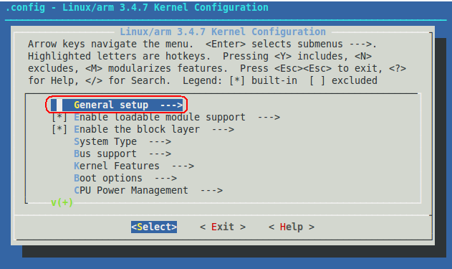
Figure 3.1.3-22 Choose General setup

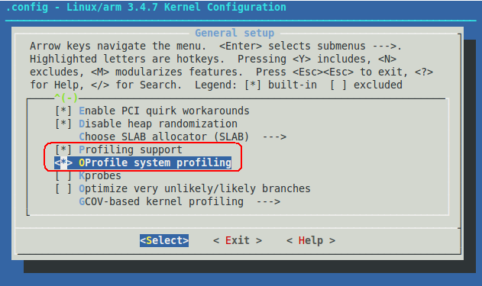
Figure 3.1.3-23 Select Opfile system profiling

Get source code from Oprofile home page

$ wget http://ncu.dl.sourceforge.net/project/oprofile/oprofile/oprofile-0.9.8/oprofile-0.9.8.tar.gz

Compile Oprofile source code

$ ./configure –-host=arm-skerlet-linux-gnueabi
$ make

Using opcontrol
1) Decide if you want to profile with or without the Linux Kernel:
Profile with the Linux Kernel:

# opcontrol --vmlinux=/tmp/vmlinux

Or profile without the Linux Kernel:

# opcontrol --no-vmlinux

2) Reset collected data from previous session

# opcontrol -reset

3) Start the OProfile daemon

# opcontrol –start
Using 2.6+ OProfile kernel interface.
Reading module info.
Using log file /var/lib/oprofile/samples/oprofiled.log
Daemon started.
Profiler running.

4) Start your application you want to profile right after the previous step

# ./test # test program

5) Stop the OProfile daemon

# opcontrol –stop

6) Flush the collected data to /var/lib/oprofile/samples

# opcontrol –dump

7) Shutdown oprofile deamon

# opcontrol –shutdown

8) Read collected data
To read collected data can using either opreport or opannotate.

Using opreport

# opreport –l
samples % image name symbol name
929 86.4186 no-vmlinux /no-vmlinux
41 3.8140 hello slow_multiply
18 1.6744 [vdso] (tgid:7860 range:0xb777f000-0xb777ffff) [vdso] (tgid:7860 range:0xb777f000-0xb777ffff)
14 1.3023 libc-2.15.so puts
12 1.1163 libc-2.15.so _IO_file_write@@GLIBC_2.1
12 1.1163 libc-2.15.so new_do_write
10 0.9302 libc-2.15.so _IO_file_xsputn@@GLIBC_2.1
9 0.8372 libc-2.15.so _IO_file_overflow@@GLIBC_2.1
5 0.4651 libc-2.15.so _IO_do_write@@GLIBC_2.1
5 0.4651 libc-2.15.so __i686.get_pc_thunk.bx
4 0.3721 hello main
4 0.3721 libc-2.15.so __overflow
3 0.2791 libc-2.15.so __write_nocancel
3 0.2791 libc-2.15.so write
2 0.1860 libc-2.15.so __GI_strlen
1 0.0930 hello fast_multiply
1 0.0930 ld-2.15.so _dl_fini
1 0.0930 ld-2.15.so _dl_relocate_object
1 0.0930 ld-2.15.so _dl_sysdep_read_whole_file

Or using opannotate

# opannotate –s ./hello
/*
* Total samples for file : "/home/congvt/tmp/src/hello/hello.c"
*
* 46 4.2791
*/

:#include <stdlib.h>
:#include <stdio.h>
:
:int fast_multiply(x, y)
:{ /* fast_multiply total: 1 0.0930 */
: return x * y;
1 0.0930 :}
:
:int slow_multiply(x, y)
:{ /* slow_multiply total: 41 3.8140 */
: int i, j, z;
:
: printf("%s\n", __func__);
32 2.9767 : for (i = 0, z = 0; i < x; i++)
6 0.5581 : z = z + y;
2 0.1860 : return z;
1 0.0930 :}
:
:int main()
:{ /* main total: 4 0.3721 */
: int i,j;
: int x,y;
:
: printf("%s\n", __func__);
: for (i = 0; i < 200; i ++) {
1 0.0930 : for (j = 0; j < 30 ; j++) {
1 0.0930 : x = fast_multiply(i, j);
2 0.1860 : y = slow_multiply(i, j);
: }
: }
: return 0;
:}

Using operf
Operf only profile program using default event for your system (some cycles-based event).

1) First, we need to profile program:

# operf ./test

2) Reading collected data:

# opreport –l ./test

Analyze performance bottlenecks
Opannotate utility is useful to detect performance bottlenecks of program. We will analyze example below to see.
The example is trivial and uses two functions -- slow_multiply() and fast_multiply() -- to multiply two numbers:

/*
* test.c: test program using to analyze performance bottneleck with
* opannatate utility
*/
#include <stdlib.h>
#include <stdio.h>

int fast_multiply(x, y)
{
return x * y;
}

int slow_multiply(x, y)
{
int i, j, z;

for (i = 0, z = 0; i < x; i++)
z = z + y;
return z;
}

int main()
{
int i,j;
int x,y;

for (i = 0; i < 200; i ++) {
for (j = 0; j < 30 ; j++) {
x = fast_multiply(i, j);
y = slow_multiply(i, j);
}
}
return 0;
}

Profile this code and analyze it with opannotate, which allows you to view the source code with OProfile annotation. You must first compile the source with debug information, which opannotate requires to add its annotation.

# gcc –g –o test test.c

Use operf utility to profile the code, and then analyze result by using opannotate

# operf ./test

Finally, use the opannotate tool to generate source code with the --source option or the assembly code with the –-assembly option. Whether you use one or both of these options depends on the level of detail you want to profile. For this example, use the --source option to identify where most of the processor cycles are occurring.

# opannotate –-source ./test
…
/*
* Command line: opannotate -s ./test
*
* Interpretation of command line:
* Output annotated source file with samples
* Output all files
*
* CPU: Intel Sandy Bridge microarchitecture, speed 3.3e+06 MHz (estimated)
* Counted CPU_CLK_UNHALTED events (Clock cycles when not halted) with a unit mask of 0x00 (No unit mask) count 100000
*/
/*
* Total samples for file : "/home/congvt/tmp/src/oprofile-test/test.c"
*
* 50 84.7458
*/

:#include <stdlib.h>
:#include <stdio.h>
:
:int fast_multiply(x, y)
:{ /* fast_multiply total: 1 1.6949 */
: return x * y;
1 1.6949 :}
:
:int slow_multiply(x, y)
:{ /* slow_multiply total: 49 83.0508 */
: int i, j, z;
:
40 67.7966 : for (i = 0, z = 0; i < x; i++)
8 13.5593 : z = z + y;
1 1.6949 : return z;
:}
:
:int main()
:{
: int i,j;
: int x,y;
:
: for (i = 0; i < 200; i ++) {
: for (j = 0; j < 30 ; j++) {
: x = fast_multiply(i, j);
: y = slow_multiply(i, j);
: }
: }
: return 0;
:}

The following lines from above list show the number of CYCLES used in both multiplication functions:

:{ /* fast_multiply total: 1 1.6949 */

:{ /* slow_multiply total: 49 83.0508 */

As you can see, fast_mulitply() only used 1 samples, while slow_multiply() used 49 samples. While this is a trivial example and would not likely occur in the real world, it demonstrates how you could profile your code and analyze it for performance bottlenecks.

Benchmark on target board
We use hackbench to measure time will be taken in some cases:
None: Run hackbench in normal case
Profiling with Oprofile: Enabe profiling program using Oprofile

# opcontrol –init
# opcontrol –-start
# hackbench 5 ; 200 tasks
# hackbench 10 ; 400 tasks
# hackbench 15 ; 600 tasks
# hackbench 20 ; 800 tasks
# opcontrol –h

After that, we obtain result:

Table 7 Result data benchmark of Oprofile
Test cases | Number tasks
Test cases | 200 | 400 | 600 | 800
None | 1.922 | 3.919 | 5.746 | 7.689
Profiling with Oprofile | 1.975 | 4.002 | 6.071 | 8.111

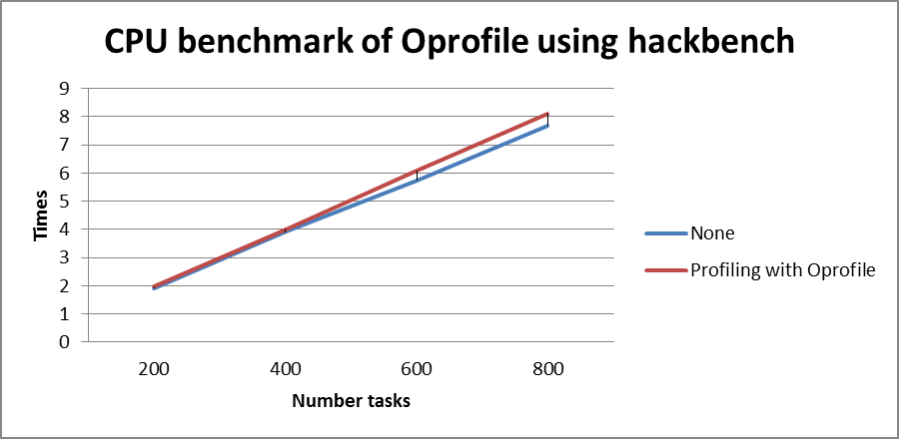
Figure 3.1.5-24Benchmark of Oprofile

When we use Oprofile to profiling , hackbench will take a time more than normal (about 5.5%). Overhead time is not much.

In 2nd benchmark, we also use iozone to evaluate variety file operations in two test case which metioned in above benchmark:

# opcontrol –init
# opcontrol –-start
# iozone -R -b result.xls -l 1 -u 1 -r 4k -s 10m -F /home/f1
# opcontrol –h

Collect output data:

Table 8 Result data iozone of Oprofile
Operations | Test cases
Operations | None | Profiling with Oprofile
Initial write | 112081.375 | 104450.4063
Rewrite | 278471.1875 | 273737.75
Read | 190846.0313 | 107506.7344
Re-read | 191034.4844 | 211570.7656
Reverse read | 83146.5625 | 197466.2969
Stride read | 179268.5938 | 197382.8125
Random Read | 180841.625 | 197817.3594
Mixed workload | 180781.5 | 197931.3125
Random write | 251776.0469 | 254176.4531
Pwrite | 113019.2656 | 50732.02734
Pread | 188024.6094 | 206276.7656

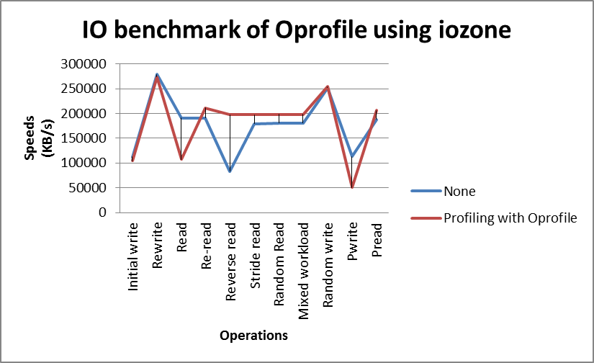
Figure 3.1.5-25 IO benchmark Oprofile

Conclussion
Profiling allows you to learn where your program spent its time and which functions called which other functions while it was executing. This information can show you which pieces of your program are slower than you expected, and might be candidates for rewriting to make your program execute faster. It can also tell you which functions are being called more or less often than you expected. This may help you spot bugs that had otherwise been unnoticed.

OProfile profiles all parts of a running system, from the kernel (including modules and interrupt handlers) to shared libraries and binaries. These features make it ideal for profiling the entire system to determine processing bottlenecks. OProfile is a profiling tool, which means that data from system is collected by sampling program counters over given periods of time. OProfile is useful for collecting summarized information about the execution. OProfile is capable of profiling all running code at a low overhead. It has a typical overhead of between 1% and 15%, depending on the workload. For instance, OProfile consumes roughly 15% of the CPU when running a video decoding application with SDK2/STKPI.

Perf

Overview

What is Perf
Perf, sometimes “Perf events” or Perf tools originally Performance Counters for Linux, is a performance analyzing tool in Linux, available form kernel 2.6.31. User-space controlling utility, called “perf” has git-like interface with subcommands. It is capable of statistical profiling of entire system (both kernel and user code), single CPU or severals threads.

Why Perf
When an application encounters some performance issues, we have to find the code that causes the problem to optimize only what really matters. Want to monitoring performance of software or kernel itself.
To find the code we have to optimize, the profilers are really useful. Gathering statistic on how the code executes. Can be done in two ways:
- Software : low precision
- Hardware : Uses specialized counters on CPU
Perf is a profiler tool for Linux 2.6+ based systems that abstracts away CPU hardware differences in Linux performance measurements and presents a simple command line interface. In 2012 IBM recognized perf (along with OProfile) as one of the two most commonly used performance counter profiling tools on Linux

Installation on Skerlet
First of all, if it is not already done, you have to install the perf tools on your computer. On Debian and Ubuntu you can install "perf" by installing the linux-tools-<your kernel version> package:
You can check your kernel version by:
$ uname –r
Then you can install linux tools for your kernel
$ sudo apt-get install linux-tools-< your kernel version >
If your distro doesn't include "perf" as a package you can build it manually like so:
- apt-get install binutils-dev libdwarf-dev libelf-dev (or equivalent on your distro)
- download a kernel source tree, matching your kernel version, from http://kernel.org
- unpack it
- cd tools/perf
- make
If you want, make install, or just copy the binary somewhere appropriate
This document base on Linux kernel version 3.2.0-23-generic-pae.

Installation on target board (CuBox)
Perf is a tool distribute within kernel source code, so we need to get kernel source code, and cross compile perf then porting to rootfs of target board.

1) Clone kernel source code

$ git clone gitosis@debian.tsdv.com.vn:kernel/linux-tec

2) Compile perf source code

$ cd linux-tec/tools/perf
$ ARCH=arm CROSS_COMPILE=arm-skerlet-linux-gnueabi- make

NOTE: perf is depended on libelf, so need to install elfutils package into sysroot of cross-build SDK before compiling perf.
After build successful, we can see execute file is named perf under perf source code directory.

3) Porting execute file into rootfs of target board
To do that, you can copy binary file of perf from local PC via ethernet

Perf commands
The perf tool offers a rich set of commands to collect and analyze performance and trace data. The command line usage is reminiscent of git in that there is a generic tool.
usage: perf [--version] [--help] COMMAND [ARG]
The most commonly used perf commands are:

Table 9 Commands of Perf
Commands | Description
annotate | Read perf.data (created by perf record) and display annotated code
archive | Create archive with object files with build-ids found in perf.data file
bench | General framework for benchmark suites
buildid-cache | Manage <tt>build-id</tt> cache.
buildid-list | List the buildids in a perf.data file
diff | Read two perf.data files and display the differential profile
inject | Filter to augment the events stream with additional information
kmem | Tool to trace/measure kernel memory(slab) properties
kvm | Tool to trace/measure kvm guest os
list | List all symbolic event types
lock | Analyze lock events
probe | Define new dynamic tracepoints
record | Run a command and record its profile into perf.data
report | Read perf.data (created by perf record) and display the profile
sched | Tool to trace/measure scheduler properties (latencies)
script | Read perf.data (created by perf record) and display trace output
stat | Run a command and gather performance counter statistics
test | Runs sanity tests.
timechart | Tool to visualize total system behavior during a workload
top | System profiling tool.

Certain commands require special support in the kernel and may not be available. To obtain the list of options for each command, simply type the command name followed by -h:
For example :
$ perf_3.2.0-36 stat -h

usage: perf stat [<options>] [<command>]

-e, --event <event> event selector. use 'perf list' to list available events
-i, --no-inherit child tasks do not inherit counters
-p, --pid <n> stat events on existing process id
-t, --tid <n> stat events on existing thread id
-a, --all-cpus system-wide collection from all CPUs
-c, --scale scale/normalize counters
-v, --verbose be more verbose (show counter open errors, etc)
-r, --repeat <n> repeat command and print average + stddev (max: 100)
-n, --null null run - dont start any counters
-B, --big-num print large numbers with thousands' separators

Using Perf
In the model used there are no daemons, instead there is a growing number of sub-commands implemented in a single binary, very much like the git tool, from which code was borrowed, keeping features like the automatic pager. The tools can be used by non root users, with operations being allowed only for threads they have permission to monitor.
That below will be described, in a order that is the most common commands of Perf

List
The perf tool supports a list of measurable events.
$ perf_3.2.0-36 list
List of pre-defined events (to be used in -e):
cpu-cycles OR cycles [Hardware event]
stalled-cycles-frontend OR idle-cycles-frontend [Hardware event]
stalled-cycles-backend OR idle-cycles-backend [Hardware event]
instructions [Hardware event]
cache-references [Hardware event]
cache-misses [Hardware event]
branch-instructions OR branches [Hardware event]
branch-misses [Hardware event]
bus-cycles [Hardware event]

cpu-clock [Software event]
task-clock [Software event]
page-faults OR faults [Software event]
minor-faults [Software event]
major-faults [Software event]
context-switches OR cs [Software event]
cpu-migrations OR migrations [Software event]
alignment-faults [Software event]
emulation-faults [Software event]

L1-dcache-loads [Hardware cache event]
L1-dcache-load-misses [Hardware cache event]
L1-dcache-stores [Hardware cache event]
L1-dcache-store-misses [Hardware cache event]
L1-dcache-prefetches [Hardware cache event]
L1-dcache-prefetch-misses [Hardware cache event]
L1-icache-loads [Hardware cache event]
L1-icache-load-misses [Hardware cache event]
L1-icache-prefetches [Hardware cache event]
L1-icache-prefetch-misses [Hardware cache event]
LLC-loads [Hardware cache event]
LLC-load-misses [Hardware cache event]
LLC-stores [Hardware cache event]
LLC-store-misses [Hardware cache event]
LLC-prefetches [Hardware cache event]
LLC-prefetch-misses [Hardware cache event]
dTLB-loads [Hardware cache event]
dTLB-load-misses [Hardware cache event]
dTLB-stores [Hardware cache event]
dTLB-store-misses [Hardware cache event]
dTLB-prefetches [Hardware cache event]
dTLB-prefetch-misses [Hardware cache event]
iTLB-loads [Hardware cache event]
iTLB-load-misses [Hardware cache event]
branch-loads [Hardware cache event]
branch-load-misses [Hardware cache event]
node-loads [Hardware cache event]
node-load-misses [Hardware cache event]
node-stores [Hardware cache event]
node-store-misses [Hardware cache event]
node-prefetches [Hardware cache event]
node-prefetch-misses [Hardware cache event]

rNNN (see 'perf list --help' on how to encode it) [Raw hardware event descriptor]

mem:<addr>[:access] [Hardware breakpoint]

Stat
To count the number of events that took place while some workload runs the stat tool can be used.
Multiple events can be speciﬁed, as in the default case:
$ perf_3.2.0-36 stat sleep 1

Performance counter stats for 'sleep 1':

0.746095 task-clock # 0.001 CPUs utilized
2 context-switches # 0.003 M/sec
0 CPU-migrations # 0.000 M/sec
154 page-faults # 0.206 M/sec
1,174,836 cycles # 1.575 GHz
789,255 stalled-cycles-frontend # 67.18% frontend cycles idle
621,324 stalled-cycles-backend # 52.89% backend cycles idle
706,541 instructions # 0.60 insns per cycle
# 1.12 stalled cycles per insn
120,799 branches # 161.908 M/sec
<not counted> branch-misses

1.034528203 seconds time elapsed
The -repeat option can be used to print the average and standard deviation found after running the speciﬁed workload multiple times.
if you see some zeroes here it probably means your processor isn't fully supported by the kernel's perf events subsystem.

Top
This command provides snapshots of system activity according to a speciﬁed event, or cycles if none is speciﬁed. It will decay the percentages over time, allowing to see transitioning shift on symbols sampling. Perf top shows the functions where most of the time is spent. By default, perf top operates in processor-wide mode, monitoring all online CPUs at both user and kernel levels. It is possible to monitor only a subset of the CPUS using the -C option
This tool is usually the ﬁrst one used to get a quick glimpse of what is happening on the system
$ perf_3.2.0-36 top

PerfTop: 42 irqs/sec kernel:52.4% exact: 0.0% [1000Hz cycles], (all, 4 CPUs)
-------------------------------------------------------------------------------

24.13% perf_3.2.0-36 [.] 0x386a4
17.76% [kernel] [k] kallsyms_expand_symbol
6.65% [kernel] [k] memcpy
5.34% [kernel] [k] vsnprintf
5.23% [kernel] [k] string.isra.2
4.21% [kernel] [k] put_cpu_partial
4.00% [kernel] [k] module_get_kallsym
3.99% libc-2.15.so [.] __strchr_sse2_bsf
3.98% libc-2.15.so [.] __memcpy_ia32
3.89% libc-2.15.so [.] _IO_getdelim
2.91% [kernel] [k] intel_idle
2.66% libc-2.15.so [.] __strcmp_sse4_2
1.51% libc-2.15.so [.] __memchr_ia32
1.33% [kernel] [k] strlen
1.33% [kernel] [k] strcmp
1.33% libc-2.15.so [.] __i686.get_pc_thunk.cx
1.33% libc-2.15.so [.] __strstr_sse42
1.33% libc-2.15.so [.] __strlen_sse2_bsf
1.28% [kernel] [k] update_page_reclaim_stat
1.20% libc-2.15.so [.] _IO_feof
1.18% [kernel] [k] format_decode

Record
The perf tool can be used to collect profiles on per-thread, per-process and per-cpu basis. The recording session can be for an existing process or thread, when the pid/tid must be speciﬁed so that samples can start to be taken for the desired entities. This generates an output file calledperf.data. That file can then be analyzed, possibly an another machine, using the perf report and perf annotate commands
he perf_events interface allows two modes to express the sampling period:
- the number of occurrences of the event (period)
- the average rate of samples/sec (frequency)
The perf tool defaults to the average rate. It is set to 1000Hz, or 1000 samples/sec. That means that the kernel is dynamically adjusting the sampling period to achieve the target average rate. The adjustment in period is reported in the raw profile data. In contrast, with the other mode, the sampling period is set by the user and does not vary between samples. There is currently no support for sampling period randomization.
$ perf_3.2.0-36 record sleep 1

[ perf record: Woken up 1 times to write data ]
[ perf record: Captured and wrote 0.010 MB perf.data (~429 samples) ]

Report
Samples collected by perf record are saved into a binary file called, by default, perf.data. The perf report command reads this file and generates a concise execution profile. By default, samples are sorted by functions with the most samples first. It is possible to customize the sorting order and therefore to view the data differently. With perf.data is generated by record command above we can see the result of report command.
$ perf_3.2.0-36 report

# Events: 11 cycles
#
# Overhead Command Shared Object Symbol
# ........ ....... ................. ......................
#
90.16% sleep [kernel.kallsyms] [k] __flush_itimer_signals
7.89% sleep [kernel.kallsyms] [k] sysenter_exit
1.85% sleep [kernel.kallsyms] [k] pgd_free
0.10% sleep [kernel.kallsyms] [k] native_write_msr_safe

#
# (For a higher level overview, try: perf report --sort comm,dso)
#
The column Overhead indicates the percentage of the overall samples collected in the corresponding function. The second column reports the process from which the samples were collected. In per-thread/per-process mode, this is always the name of the monitored command. But in cpu-wide mode, the command can vary. The third column shows the name of the ELF image where the samples came from. If a program is dynamically linked, then this may show the name of a shared library. When the samples come from the kernel, then the pseudo ELF image name [kernel.kallsyms] is used. The fourth column indicates the privilege level at which the sample was taken, i.e. when the program was running when it was interrupted:
- [.] : user level
- [k]: kernel level
- [g]: guest kernel level (virtualization)
- [u]: guest os user space
- [H]: hypervisor
The final column shows the symbol name.
Perf can report the function spend a lot of time. Below is an example that Perf can capture the low function in an application
Your code
#include <stdio.h>
void fast_funct()
{
printf(“fast function”);
}

void low_funct()
{
while(1)
printf("Low function\n");

}
int main()
{
printf("Hello, world!\n");
fast_funct();
low_funct();
return 0;
}

Compile and run with Perf record
$ perf_3.2.0-36 record ./a.out
View report
$ perf_3.2.0-36 report
The report on the screen
93.10% a.out [kernel.kallsyms] [k] 0xc1035808
2.20% a.out [vdso] [.] 0xb77d9424
1.22% a.out libc-2.15.so [.] _IO_puts
0.64% a.out libc-2.15.so [.] _IO_file_xsputn@@GLIBC_2.1
0.49% a.out libc-2.15.so [.] _IO_do_write@@GLIBC_2.1
0.43% a.out libc-2.15.so [.] __overflow
0.41% a.out libc-2.15.so [.] new_do_write
0.37% a.out libc-2.15.so [.] _IO_file_write@@GLIBC_2.1
0.33% a.out libc-2.15.so [.] _IO_file_overflow@@GLIBC_2.1
0.32% a.out libc-2.15.so [.] __GI___libc_write
0.18% a.out libc-2.15.so [.] __strlen_ia32
0.18% a.out libc-2.15.so [.] __i686.get_pc_thunk.bx
0.13% a.out a.out [.] low_funct
In abve report, perf show the function is low in application a.out

Annotate
It is possible to drill down to the instruction level with perf annotate. For that, you need to invoke perf annotate with the name of the command to annotate. All the functions with samples will be disassembled and each instruction will have its relative percentage of samples reported:

Sched
Perf sched has five sub-commands currently:
- perf sched record # low-overhead recording of arbitrary workloads
- perf sched latency # output per task latency metrics
- perf sched map # show summary/map of context-switching
- perf sched script # output finegrained trace
- perf sched replay # replay a captured workload using simlated threads

Desktop users would generally use perf sched record to capture a trace (which creates perf.data), and 'perf sched latency' tool to check latencies (which analyzes the trace in perf.data). The other tools too use an already recorded perf.data
Sched latency example usage:
root@thangcv-PC:~# perf_3.2.0-36 sched record sleep 10
[ perf record: Woken up 7 times to write data ]
[ perf record: Captured and wrote 17.118 MB perf.data (~747904 samples) ]

root@thangcv-PC:~# perf_3.2.0-36 sched latency --sort max

---------------------------------------------------------------------------------------------------------------
Task | Runtime ms | Switches | Average delay ms | Maximum delay ms | Maximum delay at |
---------------------------------------------------------------------------------------------------------------
kthreadd:10562 | 4403.496 ms | 62 | avg: 0.233 ms | max: 5.611 ms | max at: 83251.471553 s
compiz:4502 | 730.482 ms | 354 | avg: 0.012 ms | max: 1.529 ms | max at: 83250.666777 s
[…………]
ksoftirqd/1:10 | 314.120 ms | 109 | avg: 0.002 ms | max: 0.004 ms | max at: 83253.444559 s
ksoftirqd/3:19 | 0.000 ms | 3 | avg: 0.002 ms | max: 0.002 ms | max at: 83256.073686 s
-----------------------------------------------------------------------------------------
TOTAL: | 19638.573 ms | 1067 |
---------------------------------------------------
INFO: 1.850% state machine bugs (20 out of 1081)

Benchmark on target board
Similar benchmark for Oprofile, we also use hackbench and iozone to evaluate performance of CPU and IO operations.

When using hackbench:

# perf stat hackbench 5
# perf stat hackbench 10
# perf stat hackbench 15
# perf stat hackbench 20

We obtain result:

Table 10 Benchmark result data of Perf
Test cases | Number tasks
Test cases | 200 | 400 | 600 | 800
None | 1.913 | 3.859 | 5.798 | 7.792
Profiling with perf | 1.947 | 3.877 | 5.827 | 7.8

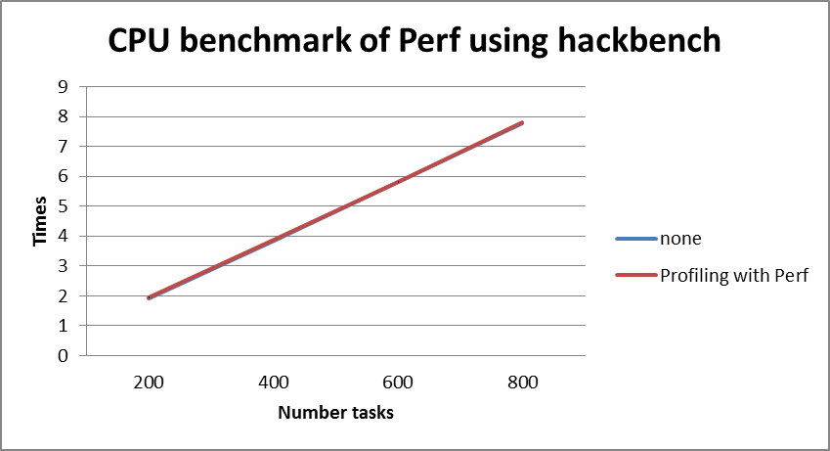
Figure 3.2.4-26 Benchmark of Perf

Using iozone to mesuare speed of IO operations:

# iozone –R –b result.xls –l 1 –u 1 – r 4k –s 10m –F /home/f1

We obtain result:

Table 11 IO result data of Perf
Operations | Test cases
Operations | None | Profiling with Perf
Initial write | 112081.375 | 112731.8125
Rewrite | 278471.1875 | 279489.5938
Read | 190846.0313 | 211496.7969
Re-read | 191034.4844 | 211920.4844
Reverse read | 83146.5625 | 80049.51563
Stride read | 179268.5938 | 198878.0781
Random Read | 180841.625 | 199484.9531
Mixed workload | 180781.5 | 199454.3906
Random write | 251776.0469 | 254776.5469
Pwrite | 113019.2656 | 113135.375
Pread | 188024.6094 | 207258.25

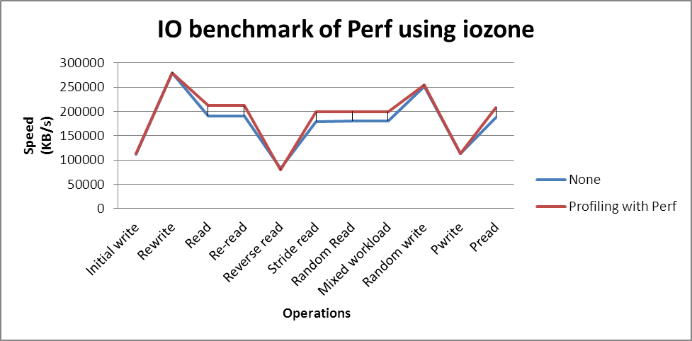
Figure 3.2.4-27 IO benchmark of Perf

In this benchmark, we can see Perf has taken low overhead, about 1.788% with CPU benchmark and smaller than 10.9% with IO bench mark.

Conclusion
Perf provides rich generalized abstractions over hardware specific capabilities. Among others, it provides per task, per CPU and per-workload counters, sampling on top of these and source code event annotation. But Perf’s document is very thin although the tool is simple enough.

Memory leak detection tools

Valgrind

Overview

What is Valgrind
Valgrind is an instrumentation framework for building dynamic analysis tools. There are Valgrind tools that can automatically detect many memory management and threading bugs, and profile your programs in detail
Most popular tool of Valgrind is memcheck

Why is Valgrind
Valgrind is easy to use. Valgrind uses dynamic binary instrumentation, so you don't need to modify, recompile or relink your applications. Just prefix your command line with valgrind and everything works
Valgrind is suitable for any type of software. Valgrind works with programs written in any language

When use Valgrind
It depends on your exact needs. Here are some examples of when people use Valgrind's bug-detecting tools.
- All the time. For small programs with short run-times, when developing you can always run the program under a Valgrind tool (usually Memcheck), knowing that memory bugs will be found immediately.
- In automatic testing. By using Valgrind tools in your automatic unit, integration, system, or regression test, you can be confident no code will be unchecked.
- When a bug occurs. Get instant feedback about what the bug is, where it occurred, and why….

About Valgrind's tools suite
The Valgrind distribution includes the following debugging and profiling tools:
- Memcheck : Memcheck detects memory-management problems, and is aimed primarily at C and C++ programs
- Cachegrind : Cachegrind is a cache profiler. It performs detailed simulation of the I1, D1 and L2 caches in your CPU and so can accurately pinpoint the sources of cache misses in your code
- Callgrind : It provides all the information that Cachegrind does, plus extra information about callgraphs
- Massif : Massif is a heap profiler. It performs detailed heap profiling by taking regular snapshots of a program's heap
- Helgrind : Helgrind is a thread debugger which finds data races in multithreaded programs
- DRD : DRD is a tool for detecting errors in multithreaded C and C++ programs
- Other Tools : Several other Valgrind tools have been created

Valgrind's memcheck feature.
Memcheck is a memory error detector. It can detect the following problems that are common in C and C++ programs
- Illegal read / Illegal write errors
- Use of uninitialised values
- Use of uninitialised or unaddressable values in system calls
- Illegal frees
- When a heap block is freed with an inappropriate deallocation function
- Overlapping source and destination blocks
- Memory leak detection

Installation
# apt-get install valgrind

How to use

Syntax
valgrind [--tool=toolselect] myprog arg1 arg2
For memcheck tool :
valgrind [–tool=memcheck] [memcheck_options] myprog arg1 arg2
- Memcheck is default tool
- myprog - your program that need to be checked with valgrind
- arg1 arg2 - arguments of your program
Memcheck is the most popular tool of Valgrind

Description about options and variables
Table 12 Memcheck options
Memcheck options | Description
--leak-check=<no|summary|yes|full> [default: summary] | When enabled, search for memory leaks when the client program finishes. If set to summary, it says how many leaks occurred. If set to full or yes, it also gives details of each individual leak.
--show-possibly-lost=<yes|no> [default: yes] | When disabled, the memory leak detector will not show "possibly lost" blocks.
--leak-resolution=<low|med|high> [default: high] | When doing leak checking, determines how willing Memcheck is to consider different backtraces to be the same for the purposes of merging multiple leaks into a single leak report. When set to low, only the first two entries need match. When med, four entries have to match. When high, all entries need to match.  For hardcore leak debugging, you probably want to use --leak-resolution=high together with --num-callers=40 or some such large number.  Note that the --leak-resolution setting does not affect Memcheck's ability to find leaks. It only changes how the results are presented.
--show-reachable=<yes|no> [default: no] | When disabled, the memory leak detector only shows "definitely lost" and "possibly lost" blocks. When enabled, the leak detector also shows "reachable" and "indirectly lost" blocks. (In other words, it shows all blocks, except suppressed ones, so --show-all would be a better name for it.)
--undef-value-errors=<yes|no> [default: yes] | Controls whether Memcheck reports uses of undefined value errors. Set this to no if you don't want to see undefined value errors. It also has the side effect of speeding up Memcheck somewhat.
--track-origins=<yes|no> [default: no] | Controls whether Memcheck tracks the origin of uninitialised values. By default, it does not, which means that although it can tell you that an uninitialised value is being used in a dangerous way, it cannot tell you where the uninitialised value came from. This often makes it difficult to track down the root problem.
--partial-loads-ok=<yes|no> [default: no] | Controls how Memcheck handles word-sized, word-aligned loads from addresses for which some bytes are addressable and others are not. When yes, such loads do not produce an address error. Instead, loaded bytes originating from illegal addresses are marked as uninitialised, and those corresponding to legal addresses are handled in the normal way.
--freelist-vol=<number> [default: 20000000] | When the client program releases memory using free (in C) or delete (C++), that memory is not immediately made available for re-allocation. Instead, it is marked inaccessible and placed in a queue of freed blocks. The purpose is to defer as long as possible the point at which freed-up memory comes back into circulation. This increases the chance that Memcheck will be able to detect invalid accesses to blocks for some significant period of time after they have been freed.
--workaround-gcc296-bugs=<yes|no> [default: no] | When enabled, assume that reads and writes some small distance below the stack pointer are due to bugs in GCC 2.96, and does not report them. The "small distance" is 256 bytes by default. Note that GCC 2.96 is the default compiler on some ancient Linux distributions (RedHat 7.X) and so you may need to use this option. Do not use it if you do not have to, as it can cause real errors to be overlooked. A better alternative is to use a more recent GCC in which this bug is fixed.
--ignore-ranges=0xPP-0xQQ[,0xRR-0xSS] | Any ranges listed in this option (and multiple ranges can be specified, separated by commas) will be ignored by Memcheck's addressability checking.
--malloc-fill=<hexnumber> | Fills blocks allocated by malloc, new, etc, but not by calloc, with the specified byte. This can be useful when trying to shake out obscure memory corruption problems. The allocated area is still regarded by Memcheck as undefined -- this option only affects its contents. Note that --malloc-fill does not affect a block of memory when it is used as argument to client requests VALGRIND_MEMPOOL_ALLOC or VALGRIND_MALLOCLIKE_BLOCK.
--free-fill=<hexnumber> | Fills blocks freed by free, delete, etc, with the specified byte value. This can be useful when trying to shake out obscure memory corruption problems. The freed area is still regarded by Memcheck as not valid for access -- this option only affects its contents. Note that --free-fill does not affect a block of memory when it is used as argument to client requests VALGRIND_MEMPOOL_FREE or VALGRIND_FREELIKE_BLOCK.

Usage of Valgrind memcheck in development
In development we can use Valgrind to profiling and debugging our program. Memcheck is a memory error detector. It helps you make your programs, particularly those written in C and C++, more correct.
This tool can detect the following memory related problems :
- Use of uninitialized memory
- Reading/writing memory after it has been freed
- Reading/writing off the end of malloc’d blocks
- Memory leaks
- Mismatched use of malloc/new/new[] vs free/delete/delete[]
- Doubly freed memory

Use of uninitialized memory
Your code :
#include <stdio.h>
#include <stdlib.h>

int main(void)
{
char *p;
char c = *p;
printf("\n [%c]\n",c);
return 0;
}
In the above code, we try to use an uninitialized pointer ‘p’. Program runs normally but we impossible to tell the value of c. So when use valgrind memcheck it can generate warning of uninitialized variable.
$ valgrind ./uninit
==19509== Memcheck, a memory error detector
==19509== Copyright (C) 2002-2011, and GNU GPL'd, by Julian Seward et al.
==19509== Using Valgrind-3.7.0 and LibVEX; rerun with -h for copyright info
==19509== Command: ./uninit
==19509==
==19509== Use of uninitialised value of size 4
==19509== at 0x80483F1: main (in /home/duynv/valgrind/uninit)
==19509==

[�]
==19509==
==19509== HEAP SUMMARY:
==19509== in use at exit: 0 bytes in 0 blocks
==19509== total heap usage: 0 allocs, 0 frees, 0 bytes allocated
==19509==
==19509== All heap blocks were freed -- no leaks are possible
==19509==
==19509== For counts of detected and suppressed errors, rerun with: -v
==19509== Use --track-origins=yes to see where uninitialised values come from
==19509== ERROR SUMMARY: 1 errors from 1 contexts (suppressed: 0 from 0)

Reading/writing memory after it has been freed
Your code :
#include <stdio.h>
#include <stdlib.h>

int main(void)
{
char *p = malloc(1);
*p = 'a';
char c = *p;
printf("\n [%c]\n",c);
free(p);
c = *p;
printf("\n [%c]\n",c);
return 0;
}
In the above piece of code, we have freed a pointer ‘p’ and then again we have tried to access the value help by the pointer. Program runs with no error but we can not control the value of c after pointer p has freed. Valgrind memcheck can generate a warning about this scenario
$ valgrind ./freed
==21290== Memcheck, a memory error detector
==21290== Copyright (C) 2002-2011, and GNU GPL'd, by Julian Seward et al.
==21290== Using Valgrind-3.7.0 and LibVEX; rerun with -h for copyright info
==21290== Command: ./freed
==21290==

[a]
==21290== Invalid read of size 1
==21290== at 0x8048495: main (in /home/duynv/valgrind/freed)
==21290== Address 0x41f6028 is 0 bytes inside a block of size 1 free'd
==21290== at 0x402B06C: free (in /usr/lib/valgrind/vgpreload_memcheck-x86-linux.so)
==21290== by 0x8048490: main (in /home/duynv/valgrind/freed)
==21290==

[a]
==21290==
==21290== HEAP SUMMARY:
==21290== in use at exit: 0 bytes in 0 blocks
==21290== total heap usage: 1 allocs, 1 frees, 1 bytes allocated
==21290==
==21290== All heap blocks were freed -- no leaks are possible
==21290==
==21290== For counts of detected and suppressed errors, rerun with: -v
==21290== ERROR SUMMARY: 1 errors from 1 contexts (suppressed: 0 from 0)
As seen in the output above, the tool detects the invalid read and prints the warning ‘Invalid read of size 1′.

Reading/writing off the end of malloc’d blocks
Your code :
#include <stdio.h>
#include <stdlib.h>

int main(void)
{
char *p = malloc(1);
*p = 'a';
*(p+1) = 'b';
char c = *(p+1);
printf("\n [%c]\n",c);
free(p);
return 0;
}
In the above piece of code, we have allocated 1 byte for ‘p’ but we access the the address p+1 while reading the value into ‘c’ and assign value for ‘p+1’. Program runs with no error but we can not control the value of c. If other program access to p+1 address and change value of this address, value of c changes also. Valgrind memcheck can generate warning about this scenario.
$ valgrind ./readoff
==21437== Memcheck, a memory error detector
==21437== Copyright (C) 2002-2011, and GNU GPL'd, by Julian Seward et al.
==21437== Using Valgrind-3.7.0 and LibVEX; rerun with -h for copyright info
==21437== Command: ./readoff
==21437==
==21437== Invalid write of size 1
==21437== at 0x804846B: main (in /home/duynv/valgrind/readoff)
==21437== Address 0x41f6029 is 0 bytes after a block of size 1 alloc'd
==21437== at 0x402BE68: malloc (in /usr/lib/valgrind/vgpreload_memcheck-x86-linux.so)
==21437== by 0x8048458: main (in /home/duynv/valgrind/readoff)
==21437==
==21437== Invalid read of size 1
==21437== at 0x8048472: main (in /home/duynv/valgrind/readoff)
==21437== Address 0x41f6029 is 0 bytes after a block of size 1 alloc'd
==21437== at 0x402BE68: malloc (in /usr/lib/valgrind/vgpreload_memcheck-x86-linux.so)
==21437== by 0x8048458: main (in /home/duynv/valgrind/readoff)
==21437==

[b]
==21437==
==21437== HEAP SUMMARY:
==21437== in use at exit: 0 bytes in 0 blocks
==21437== total heap usage: 1 allocs, 1 frees, 1 bytes allocated
==21437==
==21437== All heap blocks were freed -- no leaks are possible
==21437==
==21437== For counts of detected and suppressed errors, rerun with: -v
==21437== ERROR SUMMARY: 2 errors from 2 contexts (suppressed: 0 from 0)
This tool detects the invalid read and write in this case.

Memory leaks
Your code :
#include <stdio.h>
#include <stdlib.h>

int main(void)
{
char *p = malloc(1);
*p = 'a';
char c = *p;
printf("\n [%c]\n",c);
return 0;
}
In this code, we have malloced one byte but haven’t freed it. Program runs normally but one byte of RAM has leaked. Using Valgrind memcheck we can see what happens.
$ valgrind ./leak
==21719== Memcheck, a memory error detector
==21719== Copyright (C) 2002-2011, and GNU GPL'd, by Julian Seward et al.
==21719== Using Valgrind-3.7.0 and LibVEX; rerun with -h for copyright info
==21719== Command: ./leak
==21719==

[a]
==21719==
==21719== HEAP SUMMARY:
==21719== in use at exit: 1 bytes in 1 blocks
==21719== total heap usage: 1 allocs, 0 frees, 1 bytes allocated
==21719==
==21719== LEAK SUMMARY:
==21719== definitely lost: 1 bytes in 1 blocks
==21719== indirectly lost: 0 bytes in 0 blocks
==21719== possibly lost: 0 bytes in 0 blocks
==21719== still reachable: 0 bytes in 0 blocks
==21719== suppressed: 0 bytes in 0 blocks
==21719== Rerun with --leak-check=full to see details of leaked memory
==21719==
==21719== For counts of detected and suppressed errors, rerun with: -v
==21719== ERROR SUMMARY: 0 errors from 0 contexts (suppressed: 0 from 0)
There is a message about leak summary show us that one byte in one block has leaked

Mismatched use of malloc/new/new[] vs free/delete/delete[]
Your code :
#include <stdio.h>
#include <stdlib.h>
#include<iostream>

int main(void)
{
char *p = (char*)malloc(1);
*p = 'a';
char c = *p;
printf("\n [%c]\n",c);
delete p;
return 0;
}

In the above code, we have used malloc() to allocate memory but used delete operator to delete the memory. Program runs with no error but valgrind memcheck will show us the mismatch while free
$ valgrind ./mismatch
==2574== Memcheck, a memory error detector
==2574== Copyright (C) 2002-2011, and GNU GPL'd, by Julian Seward et al.
==2574== Using Valgrind-3.7.0 and LibVEX; rerun with -h for copyright info
==2574== Command: ./mismatch
==2574==

[a]
==2574== Mismatched free() / delete / delete []
==2574== at 0x402ACFC: operator delete(void*) (in /usr/lib/valgrind/vgpreload_memcheck-x86-linux.so)
==2574== by 0x80485BF: main (in /home/duynv/valgrind/mismatch)
==2574== Address 0x4327028 is 0 bytes inside a block of size 1 alloc'd
==2574== at 0x402BE68: malloc (in /usr/lib/valgrind/vgpreload_memcheck-x86-linux.so)
==2574== by 0x8048588: main (in /home/duynv/valgrind/mismatch)
==2574==
==2574==
==2574== HEAP SUMMARY:
==2574== in use at exit: 0 bytes in 0 blocks
==2574== total heap usage: 1 allocs, 1 frees, 1 bytes allocated
==2574==
==2574== All heap blocks were freed -- no leaks are possible
==2574==
==2574== For counts of detected and suppressed errors, rerun with: -v
==2574== ERROR SUMMARY: 1 errors from 1 contexts (suppressed: 0 from 0)
We see from the output above, the tool clearly states ‘Mismatched free() / delete / delete []‘

Doubly freed memory
Your code :
#include <stdio.h>
#include <stdlib.h>
int main(void)
{
char *p = (char*)malloc(1);
*p = 'a';
char c = *p;
printf("\n [%c]\n",c);
free(p);
free(p);
return 0;
}
When run program normally will show us error about double freed and Valgrind memcheck generate error also.
$ valgrind ./Dfreed
==3167== Memcheck, a memory error detector
==3167== Copyright (C) 2002-20011, and GNU GPL'd, by Julian Seward et al.
==3167== Using Valgrind-3.6.0.SVN-Debian and LibVEX; rerun with -h for copyright info
==3167== Command: ./Dfreed
==3167==

[a]
==3167== Invalid free() / delete / delete[]
==3167== at 0x4C270BD: free (vg_replace_malloc.c:366)
==3167== by 0x40060A: main (valgrind.c:12)
==3167== Address 0x51b0040 is 0 bytes inside a block of size 1 free'd
==3167== at 0x4C270BD: free (vg_replace_malloc.c:366)
==3167== by 0x4005FE: main (valgrind.c:11)
==3167==
==3167==
==3167== HEAP SUMMARY:
==3167== in use at exit: 0 bytes in 0 blocks
==3167== total heap usage: 1 allocs, 2 frees, 1 bytes allocated
==3167==
==3167== All heap blocks were freed -- no leaks are possible
==3167==
==3167== For counts of detected and suppressed errors, rerun with: -v
==3167== ERROR SUMMARY: 1 errors from 1 contexts (suppressed: 4 from 4)

As seen from the output above, the tool detects that we have called free twice on the same pointer.

Using Valgrind on Cubox

Install Valgrind on Cubox
The first request, you have a kernel image runs on Cubox
Git clone poky-skerlet to local coputer
$ git clone gitosis@debian.tsdv.com.vn:tools/poky-skerlet
Setup cubox environment for compile
$ . ./poky-skerlet/setup.sh ebx
Bitbake Valgrind
$ bitbake valgrind
Move to image directory of Valgrind
$ cd tmp/work/armv7a-vfp-skerlet-linux-gnueabi/valgrind-3.7.0-3-r0/image
And copy usr of to usr/bin on Cubox
$ scp usr/* –r root@<ip of Cubox>:/usr

Run Valgrind on Cubox
Firstly we need to compile c program on Cubox. We use gcc selfbuild and compile program
# arm-skerlet-linux-gnueabi-gcc a.c
Memcheck with valgrind
# valgrind ./a.out
But now, Valgrind has some problems at startup. It not show the memory defect
# valgrind ./a.out
==29706== Memcheck, a memory error detector
==29706== Copyright (C) 2002-2011, and GNU GPL'd, by Julian Seward et al.
==29706== Using Valgrind-3.7.0 and LibVEX; rerun with -h for copyright info
==29706== Command: ./a.out
==29706==
disInstr(arm): unhandled instruction: 0xECECA102
cond=14(0xE) 27:20=206(0xCE) 4:4=0 3:0=2(0x2)
==29706== valgrind: Unrecognised instruction at address 0x4018528.
==29706== at 0x4018528: __sigsetjmp (in /usr/lib/ld-2.16.so)
==29706== by 0x400F5BB: _dl_catch_error (in /usr/lib/ld-2.16.so)
==29706== Your program just tried to execute an instruction that Valgrind
==29706== did not recognise. There are two possible reasons for this.
==29706== 1. Your program has a bug and erroneously jumped to a non-code
==29706== location. If you are running Memcheck and you just saw a
==29706== warning about a bad jump, it's probably your program's fault.
==29706== 2. The instruction is legitimate but Valgrind doesn't handle it,
==29706== i.e. it's Valgrind's fault. If you think this is the case or
==29706== you are not sure, please let us know and we'll try to fix it.
==29706== Either way, Valgrind will now raise a SIGILL signal which will
==29706== probably kill your program.
==29706==
==29706== Process terminating with default action of signal 4 (SIGILL)
==29706== Illegal opcode at address 0x4018528
==29706== at 0x4018528: __sigsetjmp (in /usr/lib/ld-2.16.so)
==29706== by 0x400F5BB: _dl_catch_error (in /usr/lib/ld-2.16.so)
==29706==
==29706== HEAP SUMMARY:
==29706== in use at exit: 0 bytes in 0 blocks
==29706== total heap usage: 0 allocs, 0 frees, 0 bytes allocated
==29706==
==29706== All heap blocks were freed -- no leaks are possible
==29706==
==29706== For counts of detected and suppressed errors, rerun with: -v
==29706== ERROR SUMMARY: 0 errors from 0 contexts (suppressed: 0 from 0)
Illegal instruction
This bug has searched on the internet but for now, it has not the solution to resole.

Mpatrol

Overview

What is Mpatrol
The mpatrol library is a powerful debugging tool that attempts to diagnose run-time errors that are caused by the wrong use of dynamically allocated memory. It acts as a malloc() debugger for debugging dynamic memory allocations, although it can also trace and profile calls to malloc() and free() too. If you don't know what the malloc() function or operator new[] do then this library is probably not for you. You have to have a certain amount of programming expertise and a knowledge of how to run a command line compiler and linker before you should attempt to use this.

Why is Mpatrol
The unfortunate among us who have to work with dinosaurs such as C/C++ (and are developing/maintaining non-trivial programs) need to make constant use of manual dynamic memory allocation/deallocation. In C, the *malloc()/free() family of functions will serve your allocation/deallocation needs.
In C++ you have the new/delete operator, making life a little easier because objects referenced from one object may be deleted automatically when said object is destroyed. I will not comment on this because there are enough excellent tutorials on the subject. The mpatrol library has been designed with the intention of replacing calls to existing C and C++ memory allocation functions as seamlessly as possible. It helps us debugging and know what happens inside the program.

When use Mpatrol
Will you need mpatrol only if you have a memory leak? Not necessarily. Mpatrol will tell you a lot about how your application is working with memory, thus serving as a profiling tool as well.
Essentially, every memory (de-)allocation function (malloc(), calloc(), the new operator, and so forth) is provided by a runtime library. Mpatrol wraps these functions, so when you call them you will call mpatrol's customized versions. For that to work, you need to tell your compiler to use mpatrol functions, not the default ones. In most cases, relinking in a special way will already do the trick.

Feature
Mpatrol supports for many platforms, has ability to read symbols from executable files and share libraries.
Mpatrol has so many features but in the scope of this document we focus to using mpatrol to debug program and detect memory leak.
- Details of memory allocations and free memory are stored internally as a tree structure for speed and also to allow the best fit allocation algorithm to be used
- Contains 19 replacement C dynamic memory allocation functions
- Contains 5 replacement C dynamic memory extension functions
- Contains 6 replacement C dynamic memory alternative functions
- Contains 4 replacement C++ dynamic memory allocation operators
- Contains 10 replacement C memory operation functions
- Contains support for automatically registering any functions whose names begin with `__mp_init_' and `__mp_fini_' to be called when the mpatrol library is initialised and terminated respectively. A function is also provided to register additional functions to be called when the mpatrol library terminates

Installation
To download source of Mpatrol we can use subversion
svn co https://mpatrol.svn.sourceforge.net/svnroot/mpatrol mpatrol
Apter get source code you can go to auto folder to setup and make maptrol
$ cd /mpatrol/trunk/pkg/auto
$ chmod +x setup
$ ./setup
$ chmod +x configure
$ ./configure
$ make
$ sudo make install
When run list above commands you may meet some error. Error about missing some package, you must install those packages on you local. Some missing package i meet:
- Libtool
- Check
- Binutils
After make install you must export library path for maptrol library
export LD_LIBRARY_PATH="/usr/local/lib:${LD_LIBRARY_PATH}"

How to use

Adding mpatrol option
At first, you must add mpatrol library to your code
#include "mpatrol.h"
Then you must add –lmptrol option if you want to use mpatrol to monitor your program
$ gcc -o test1 test1.c -L/usr/local/lib -lmpatrol -lbfd

Syntax
Usage: mpatrol [options] <command> [arguments]

Description about options and variables
The mpatrol command is used to set various mpatrol library options when running command with its arguments. In most cases, command must have been linked with the mpatrol library, unless the --dynamic option is used in which case command need only have been dynamically linked.
All mpatrol library diagnostics are sent to the file mpatrol.%n.log in the current directory by default (where `%n' is the current process id) but this can be changed using the --log-file option
Almost options of mpatrol correspond to their listed mpatrol library option. You can see this at Mpatrol Options
To monitor memory manipulate, we always use some options
--leak-table : pecifies that the leak table should be automatically used and a leak
--check-frees : Checks that no attempt is made to deallocate a NULL pointer.
--check-allocs : Checks that no attempt is made to allocate a block of memory of size zero
--check-memory : Checks that no attempt is made to perform a zero-length memory operation or a memory operation on a NULL pointer

Using Mpatrol in development
In development, Mpatrol can monitor and generate log about error or mismatch of your program when manipulate memory

Mismatch address when malloc and free
Your code
#include <stdio.h>
#include "mpatrol.h"

int main(void)
{
char *p;

if (p = (char *) malloc(16))
free(p + 1);
return EXIT_SUCCESS;
}
Pointer p has malloced but program free pointer p+1. In log file of mpatrol we can see the message of this scenario
$ vim mpatrol.16055.log
……
FREE: free (0x09BE4195) [main|test1.c|35]
0x080485AB main+151
0xB74F6C76 __libc_start_main+230
0x08048481 _start+33

ERROR: [MISMAT]: free: 0x09BE4195 does not match allocation of 0x09BE4194
0x09BE4194 (16 bytes) {malloc:191:0} [main|test1.c|34]
0x08048569 main+85
0xB74F6C76 __libc_start_main+230
0x08048481 _start+33
……
In above log file we can see message about mismatch of address has freed

Realloc after free
Your code
#include "mpatrol.h"

int main(void)
{
char *p;

if (p = (char *) malloc(16))
{
free(p);
p = (char *) realloc(p, 32);
}
return EXIT_SUCCESS;
}
Pointer p has freed but program call command realloc after that. In log file of mpatrol we can see the message of this scenario
$ vim mpatrol.log2
……
REALLOC: realloc (0x089CD194, 32 bytes, 4 bytes) [main|test2.c|37]
0x08048630 main+236
0xB7632C76 __libc_start_main+230
0x080484B1 _start+33

ERROR: [NOTALL]: realloc: 0x089CD194 has not been allocated
……
In above log file we can see message about realloc command, error at realloc command because address has not been allocated

Double freed memory
Your code
#include "mpatrol.h"

int main(void)
{
char *p;

if (p = (char *) malloc(16))
{
free(p);
free(p);
}
return EXIT_SUCCESS;
}
Pointer p has freed but program call command free after that. In log file of mpatrol we can see the message of this scenario
$ vim mpatrol.log3
……
FREE: free (0x088AA194) [main|test3.c|38]
0x080485DC main+200
0xB765FC76 __libc_start_main+230
0x08048481 _start+33

ERROR: [NOTALL]: free: 0x088AA194 has not been allocated
……
In above log file we can see message about free command, error at free command because address has not been allocated

Using memory after free
Your code
#include "mpatrol.h"

int main(void)
{
char *p;

if (p = (char *) malloc(16))
{
free(p);
p[8] = '\0';
}
return EXIT_SUCCESS;
}
Pointer p has freed but program still wite to that address after that. In log file of mpatrol we can see the message of this scenario
$ vim mpatrol.log4
……
WARNING: [FRENUL]: free: attempt to free a NULL pointer

WARNING: [FRENUL]: free: attempt to free a NULL pointer
……
ERROR: [FRECOR]: free memory corruption at 0x09D4119C
0x09D4119C 00555555 55555555 55555555 55555555 .UUUUUUUUUUUUUUU
0x09D411AC 55555555 55555555 55555555 55555555 UUUUUUUUUUUUUUUU
0x09D411BC 55555555 55555555 55555555 55555555 UUUUUUUUUUUUUUUU
0x09D411CC 55555555 55555555 55555555 55555555 UUUUUUUUUUUUUUUU
0x09D411DC 55555555 55555555 55555555 55555555 UUUUUUUUUUUUUUUU
0x09D411EC 55555555 55555555 55555555 55555555 UUUUUUUUUUUUUUUU
0x09D411FC 55555555 55555555 55555555 55555555 UUUUUUUUUUUUUUUU
0x09D4120C 55555555 55555555 55555555 55555555 UUUUUUUUUUUUUUUU
0x09D4121C 55555555 55555555 55555555 55555555 UUUUUUUUUUUUUUUU
0x09D4122C 55555555 55555555 55555555 55555555 UUUUUUUUUUUUUUUU
0x09D4123C 55555555 55555555 55555555 55555555 UUUUUUUUUUUUUUUU
0x09D4124C 55555555 55555555 55555555 55555555 UUUUUUUUUUUUUUUU
0x09D4125C 55555555 55555555 55555555 55555555 UUUUUUUUUUUUUUUU
0x09D4126C 55555555 55555555 55555555 55555555 UUUUUUUUUUUUUUUU
0x09D4127C 55555555 55555555 55555555 55555555 UUUUUUUUUUUUUUUU
0x09D4128C 55555555 55555555 55555555 55555555 UUUUUUUUUUUUUUUU
In above log file we can see message about using memory, when pointer free, it become a NULL pointer but program still use and write value. Mpatrol will generate warning and error message.

Mismatch use of malloc/new/new[] vs free/delete/delete[]
Your code
#include "mpatrol.h"

int main(void)
{
char *p;

p = new char[16];
delete p;
return EXIT_SUCCESS;
}
Allocates a block of 16 bytes using C++ operator new[] and then attempts to free it using C++ operator delete. It not match. Need to use delete[] insted
$ vim mpatrol.log4
……
FREE: operator delete (0x09B2D194) [int main()|test7.c|35]
0x08048A58 _ZdlPv+79
0x0804892D main+89
0xB7512C76 __libc_start_main+230
0x08048841 _start+33

ERROR: [INCOMP]: operator delete: 0x09B2D194 was allocated with operator new[]
0x09B2D194 (16 bytes) {operator new[]:275:0} [int main()|test7.c|34]
0x080489AD _ZnajPKcS0_m+79
0x08048901 main+45
0xB7512C76 __libc_start_main+230
0x08048841 _start+33
……
In above log file we can see message about error when pointer delete and the message about mismatch between new[] and delete

Using realloc after new[]
Your code
#include "mpatrol.h"

int main(void)
{
char *p;

p = new char[16];
p = (char *) realloc(p, 32);
delete[] p;
return EXIT_SUCCESS;
}
Allocates a block of 16 bytes using C++ operator new[] and then attempts to resize it using realloc()
$ vim mpatrol.log5
……
REALLOC: realloc (0x083CD194, 32 bytes, 4 bytes) [int main()|mpatrol.c|10]
0x08048989 main+133
0xB7405C76 __libc_start_main+230
0x08048871 _start+33

ERROR: [INCOMP]: realloc: 0x083CD194 was allocated with operator new[]
0x083CD194 (16 bytes) {operator new[]:275:0} [int main()|mpatrol.c|9]
0x08048A3D _ZnajPKcS0_m+79
0x08048931 main+45
0xB7405C76 __libc_start_main+230
0x08048871 _start+33
……
In above log file we can see message about error when pointer realloc

Using Maptrol on Cubox
Currently, git server has not included Mpatrol source code.
Cross compile with cross build SDK
Get source code
$wget ftp://193.105.142.100/pub/FreeBSD/ports/local-distfiles/gahr/mpatrol-1.5.1.tar.gz
Unzip mpatrol
$ tar zxvf mpatrol-1.5.1.tar.gz
Move to auto folder
$ cd /mpatrol-1.5.1/pkg/auto
Run setup and configure with host=arm -skerlet-linux –gnueabi then run make. Local computer has crashed.
Both version 1.5.1 and 1.4.8 have been not working. When Mpatrol was compiling an error about doc folder appeared. If that error has been fixed and run make command again, the local computer has been crashed.

Efence

Overview

What is eFence
Electric Fence (or eFence) is a memory debugger written by Bruce Perens. It consists of a library which programmers can link into their code to override the C standard library memory management functions. eFence triggers a program crash when the memory error occurs, so a debugger can be used to inspect the code that caused the error.

When use eFence
Electric Fence is intended to find two common types of programming bugs:
- Overrunning the end (or beginning) of a dynamically allocated buffer
- Using a dynamically allocated buffer after returning it to the heap
In both cases, Electric Fence causes the errant program to abort immediately via a segmentation fault. Normally, these two errors would cause heap corruption, which would manifest itself only much later, usually in unrelated ways. Thus, Electric Fence helps programmers find the precise location of memory programming errors.

Feature
Efence basically works by replacing the malloc system call with a modified malloc that surrounds any new memory regions with protected areas. If a process attempts to write into such a protected area, it will cause a segmentation violation

Installation
Electric fence can be download at
http://linux.softpedia.com/get/Programming/Debuggers/Electric-Fence-3305.shtml
Or you can get package with apt-get command
$ sudo apt-get install electric-fence
After install you can use efence to monitor you program by add –lefence when compile

How to use
When you add option –lefence to compile, message of efence will appear even you run binary file
$ gcc -o test test.c –lefence
Efence can capture and generate notice when program uses memory not safe. We can use combine with gdb to find the point unsafe in code

Software that overruns the boundaries of a malloc() memory allocation
Your code
#include <stdio.h>
#include <string.h>
#include <stdlib.h>
int main()
{
char *arr; int i;
arr = (char *)malloc(sizeof(char)*5);
strcpy(arr,"amee is my name");
return 0;
}
This program don’t has a warning message when run normal, but when compile with efence a message will be appear.

Software that touches a memory allocation that has been released by free()
Your code
#include <stdio.h>
#include <stdlib.h>

int main(void)
{
char *p = malloc(1);
*p = 'a';
char c = *p;
printf("\n [%c]\n",c);
free(p);
c = *p;
printf("\n [%c]\n",c);
return 0;
}
In this code, program using address of pointer p after free. In this case, we can’t control the value of c. efence will notice us about this scenario
In other case, efence can not capture, example: memory leak, when program malloc but not free…

Using Efence on Cubox

Install Efence on Cubox
The first request, you have a kernel image runs on Cubox
Git clone poky-skerlet to local coputer
$ git clone gitosis@debian.tsdv.com.vn:tools/poky-skerlet
Setup cubox environment for compile
$ . ./poky-skerlet/setup.sh ebx
Bitbake Valgrind
$ bitbake electric-fence
Move to image directory of Valgrind and copy usr of to usr/bin on Cubox
$ cd tmp/work/armv7a-vfp-skerlet-linux-gnueabi/ electric-fence-git-r0/image

$ scp usr/* –r root@<ip of Cubox>:/usr

Run Efence on Cubox
We need to compile c program with efence option on Cubox.
# arm-skerlet-linux-gnueabi-gcc -lefence a.c
Run binary was compiled file and see the log on the screen. But now efence on Cubox not generate notice like in x86 version.Souce code is downloaded from skerlet and compiled by hand is not working too. Defence has debugged don’t know exactly what happened. When malloc funcfion in efence.c file was disabled it can generate message about Electric Fence. Efence functions relatesmprotect function on Cubox. It has run an example of mprotect to check operator of mprotect function.So the problem could not analysis.

Mtrace

Overview
Mtrace is the memory debugger. The function mtrace installs handlers for malloc, realloc and free; the function muntrace disables these handlers. To use it, the program is modified to call mtrace() and muntrace() to start and stop tracing of allocations. A log file is created, which can then be scanned by the 'mtrace' Perl script. The 'mtrace' program lists only unbalanced allocations. If source is available it can show the source line where the problem occurred. mtrace can be used on both C and C++ programs

How to use
On C and C++ program, sometimes program allocate memory but doesn’t free the memory before exiting.
For example:
#include <stdlib.h>
int main(void) {
int * a;
a = malloc(sizeof(int)); /* allocate memory and assign it to the pointer */
return 0; /* we exited the program without freeing memory */
/* we should have released the allocated memory with the statement“free(a)” */
}
Mtrace can detect and generate report about memory problem. Below is steps to using Mtrace
Export MALLOC_TRACE= /path/to/program/MallocTraceOutputFile.txt
Include mcheck.h in the source code
#include <mcheck.h>
Include mcheck.h in the source code
#include <mcheck.h>
Call the function mtrace() before you start allocating memory. It is usually easiest to call mtrace() at the very beginning of the main() function:
mtrace();
To delineate the end of the code that should be traced, call the function muntrace(). This is usually done at the end of the main() function:
muntrace();
Compile and run the program as usual. Note that you need to compile with the -g option to get useful output. In GCC on Linux, this can be done using the following commands for a C program:
$gcc yourProgram.c -g
$./a.out
If the mtrace command reports “No Memory Leaks”, then all memory that was allocated in the last execution of that program was also released, which is the way it should be. If, on the other hand, mtrace gives output such as that below, it means the programmer still has some work to do.
Memory not freed:
-----------------
Address Size Caller
0x08049910 0x4 at /home/sureshsathiah/tips/leak.c:9

Gperftools

Overview
Perftools is a collection of a high-performance multi-threaded malloc() implementation, plus some pretty nifty performance analysis tools. These tools are for use by developers so that they can create more robust applications. Especially of use to those developing multi-threaded applications in C++ with templates. Includes TCMalloc, heap-checker, heap-profiler and cpu-profiler.

How to use

TCMalloc
TCMalloc is faster than the glibc 2.3 malloc (available as a separate library called ptmalloc2) and other mallocs that I have tested. ptmalloc2 takes approximately 300 nanoseconds to execute a malloc/free pair on a 2.8 GHz P4 (for small objects). The TCMalloc implementation takes approximately 50 nanoseconds for the same operation pair. Speed is important for a malloc implementation because if malloc is not fast enough, application writers are inclined to write their own custom free lists on top of malloc. This can lead to extra complexity, and more memory usage unless the application writer is very careful to appropriately size the free lists and scavenge idle objects out of the free list.
TCMalloc also reduces lock contention for multi-threaded programs. For small objects, there is virtually zero contention. For large objects, TCMalloc tries to use fine grained and efficient spinlocks. ptmalloc2 also reduces lock contention by using per-thread arenas but there is a big problem with ptmalloc2's use of per-thread arenas. In ptmalloc2 memory can never move from one arena to another. This can lead to huge amounts of wasted space. For example, in one Google application, the first phase would allocate approximately 300MB of memory for its URL canonicalization data structures. When the first phase finished, a second phase would be started in the same address space. If this second phase was assigned a different arena than the one used by the first phase, this phase would not reuse any of the memory left after the first phase and would add another 300MB to the address space. Similar memory blowup problems were also noticed in other applications.
To use TCMalloc, just link TCMalloc into your application via the "-ltcmalloc" linker flag. You can use TCMalloc in applications you didn't compile yourself, by using LD_PRELOAD:
$ LD_PRELOAD="/usr/lib/libtcmalloc.so"
TCMalloc includes a heap checker and heap profiler as well.
TCMalloc assigns each thread a thread-local cache. Small allocations are satisfied from the thread-local cache. Objects are moved from central data structures into a thread-local cache as needed, and periodic garbage collections are used to migrate memory back from a thread-local cache into the central data structures. TCMalloc treats objects with size <= 32K ("small" objects) differently from larger objects. Large objects are allocated directly from the central heap using a page-level allocator (a page is a 4K aligned region of memory). I.e., a large object is always page-aligned and occupies an integral number of pages. A run of pages can be carved up into a sequence of small objects, each equally sized. For example a run of one page (4K) can be carved up into 32 objects of size 128 bytes each.

Heap checker
To use the Heap Leak Checker you have to
- Link the library with –ltcmalloc
- Set $HEAPCHECK to the desired mode
minimal, normal, strict, draconian, asis, local
- Output can be analyzed with pprof

Heap profiler
To use the Heap Profiler you have to
- Link the library with –ltcmalloc
- Set $HEAPPROFILE to the path where to save the profile
- Surround the code to be profiled with
HeapProfilerStart(“prefix name”)
HeapProfilerStop()
- Output can be analyzed with pprof

Cpu profiler
To use the CPU Profiler you have to
- link the library with –lprofiler.
- Set $CPUPROFILE to the path where to save the profile.
- Surround the code to be profiled with
ProfilerStart(“profile name”)
ProfilerStop()
- Output can be analyzed with pprof
Pprof
Analyzes profiles generated by
- Heap Leak Checker – call graph of reported leaks
- CPU Profiler – Weighted call graph with timing information
- Heap Profiler – weighed directed graph of memory allocations
Text, postscript (gv), dot, pdf, gif, sourcecode listings, & disassembly

Conclusion
In above is tools use for detect memory problems. Tools help developer detect problems about memory and resolve errors. Each tool has specific property to tracing and debuggin memory. Some tools detect common memory problems, some tools tracing how the application using memory, those tools forcus on check the way to use malloc and delete function. The other forcus on the heap memory problems. Although the approachs are different but tools help programmer tracing and managerment memories are used by application

Debugging tools

Kgdb

Overview

What is kgdb
Kgdb is a source level debugger for linux kernel. It is used along with gdb to debug a linux kernel. The expectation is that gdb can be used to "break in" to the kernel to inspect memory, variables and look through a cal stack information similar to what an application developer would use gdb for. It is possible to place breakpoints in kernel code and perform some limited execution stepping.

When use KGDB
When we build our own kernel, we need to confirm that our kernel run correctly. Our kernel just oopsed. The drivers we develop are not working as well as it should, or is not working at all. When we get those troubles we need to debug kernel and Kgdb is a useful kernel debugger.

Why is KGDB
Kgdb is intergrated into kernel. Kernel developers can debug a kernel similar to application programs with use of KGDB. It makes it possible to place breakpoints in kernel code, step through the code and observe variables.

Build kernel 3.7.1 with KGDB
In this investigation, we base on Debian 6 System install on Virtual box.
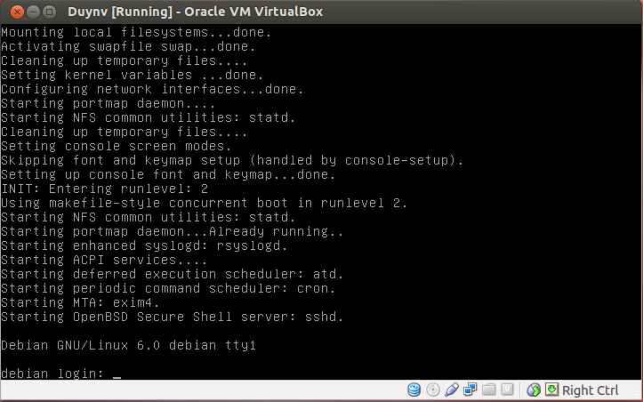
Figure 5.1.2-28 Debian 6 in Virtual box
We use Linux kernel 3.7.1 download form
http://www.kernel.org/pub/linux/kernel/v3.x/
Extract kernel
Make menuconfig to edit configuration file and enable KGDB in kernel setting
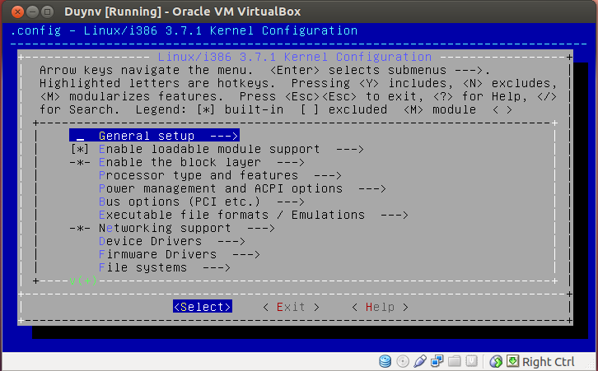
Figure 5.1.2-29Make menuconfig
There are some essential options for kgdb. Please enter the `Kernel hacking’ entry.
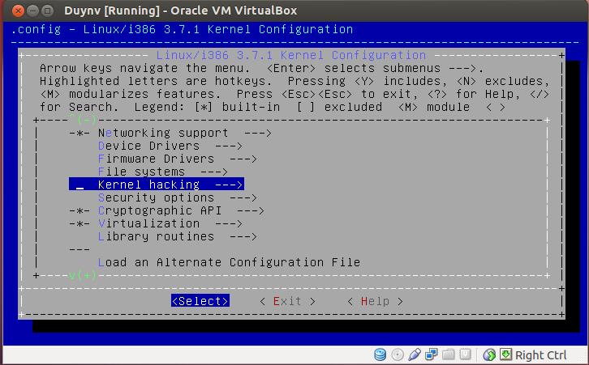
Figure 5.1.2-30 Select kernel hacking
Select option `Kernel debugging’.
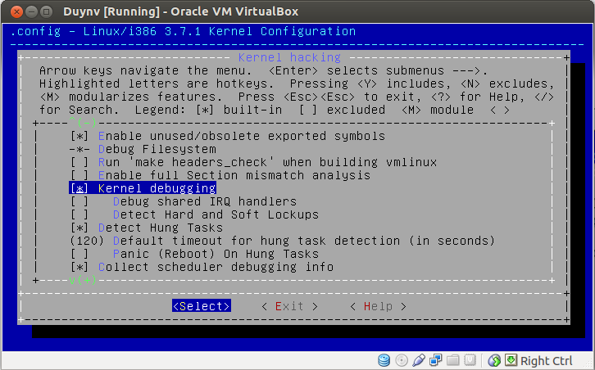
Figure 5.1.2-31 Kernel debugging option
Select option `Compile the kernel with debug info’.
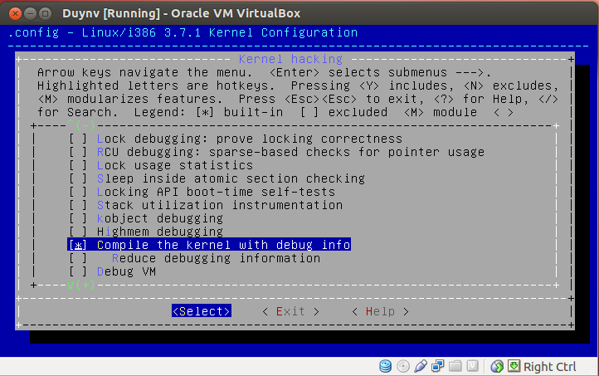
Figure 5.1.2-32 Compile with debug info
Select option `Compile the kernel with frame pointers’.
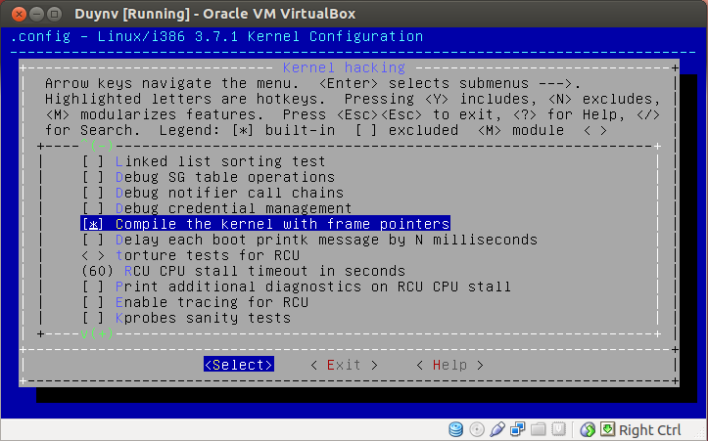
Figure 5.1.2-33 Compile with frame pointers
Select option `KGDB: kernel debugger’, and enter the `KGDB: kernel debugger’ entry.
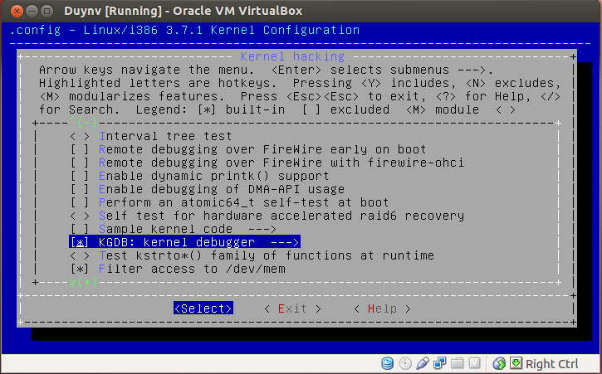
Figure 5.1.2-34 Enable KGDB
Because we want to use serial port rs232 in kgdb, please select option `KGDB: use kgdb over the serial console’.
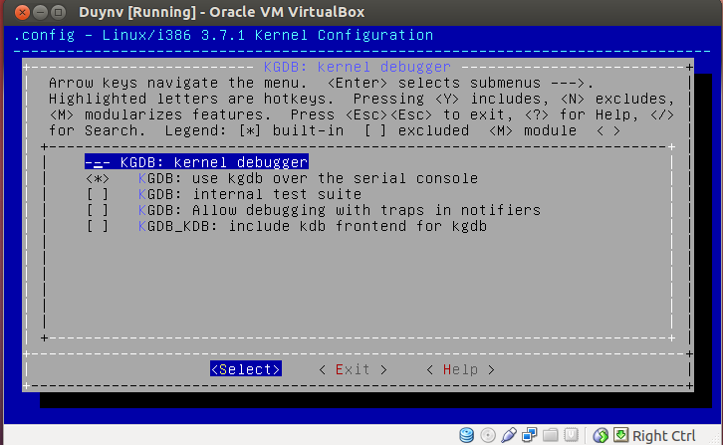
Figure 5.1.2-35 Select Serial port option
After that it will generate .config file then we run make all to make linux image
root@debian:/home/duynv/linux-3.7.1# make all
Make modules_install’, it will install modules to /lib/modules/3.7.1/
root@debian:/home/duynv/linux-3.7.1# make module_install
If we not run this command, sometimes we get error with modules.dep file
Make install : it will move linux images to /boot and edit boot manager configuration in some distributions
root@debian:/home/duynv/linux-3.7.1# make install
After run this command, in /boot folder we can see two files System.map-3.7.1 and vmlinuz-3.7.1
We need to make initrd.img file by initramfs command
root@debian:/home/duynv/linux-3.7.1# initramfs /boot/initrd.img-3.7.1 3.7.1
To edit boot managerment configruration we use update-grub command
root@debian:/home/duynv/linux-3.7.1# update-grub
When we finish all above steps we have created a kernel with kgbd build in. We can reboot system.
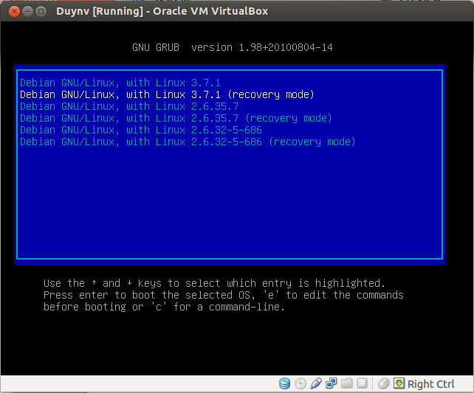
Figure 5.1.2-36 Select kenel has built

Connect two machine Virtual Box via serial port
Finish 7.2 we have a machine with our own kernel. To debug we need to create anoter machine. Because we need two machines, in Virtual Box we can clone our machine to another machine.
Firstly, we run Virtual Box and click in Snapshots button. Then we can sheet a sheep button, click that button or press Ctrl+ Shift+C.
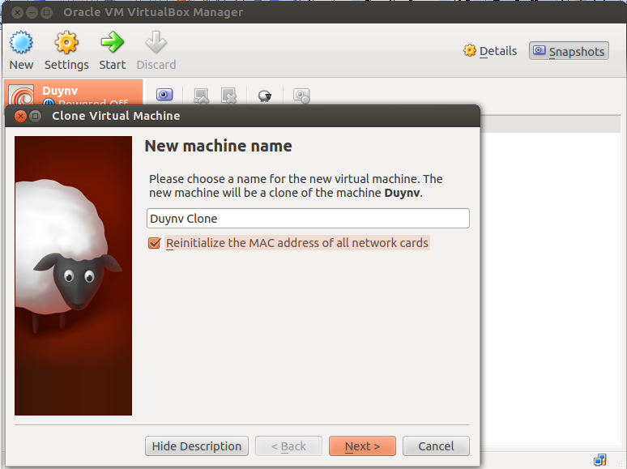
Figure 5.1.3-37 Clone Virtual machine
Check reinitialize the MAC address and press Next
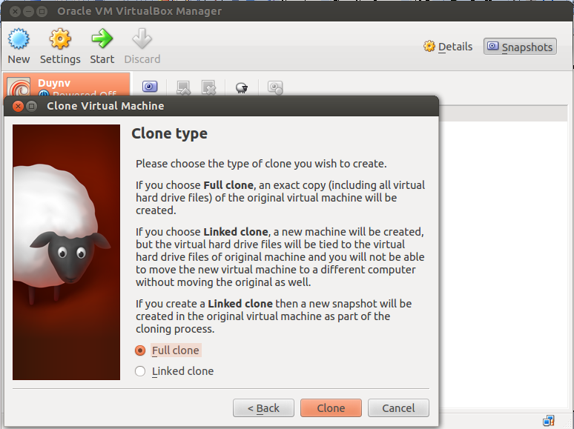
Figure 5.1.3-38 Full Clone
Choose Full clone to create new machine. Click Clone button and wait.
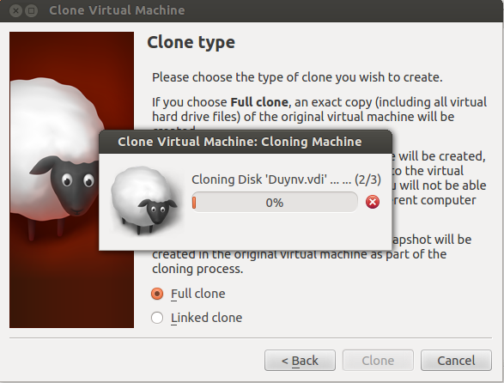
Figure 5.1.3-39 Clone progress
After clone, we have two machines with our kernel has been built. We enable serial port on two machines with the same name, select port mode Host Pipe. In machine we use to debug kernel we select Create Pipe option
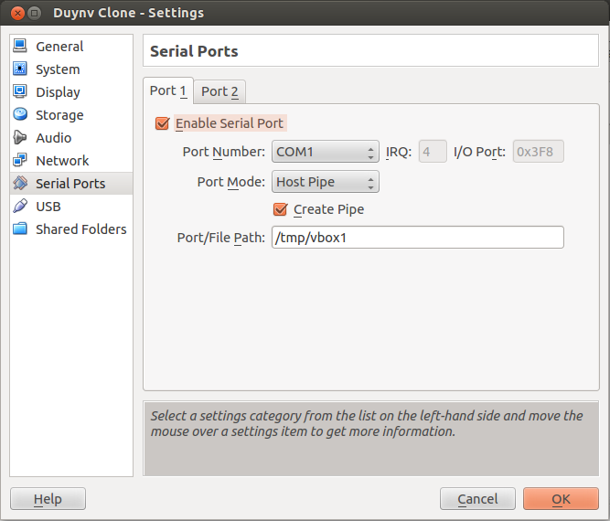
Figure 5.1.3-40 Enable Serial port on debug machine
On remote machine we don’t select Create Pipe option
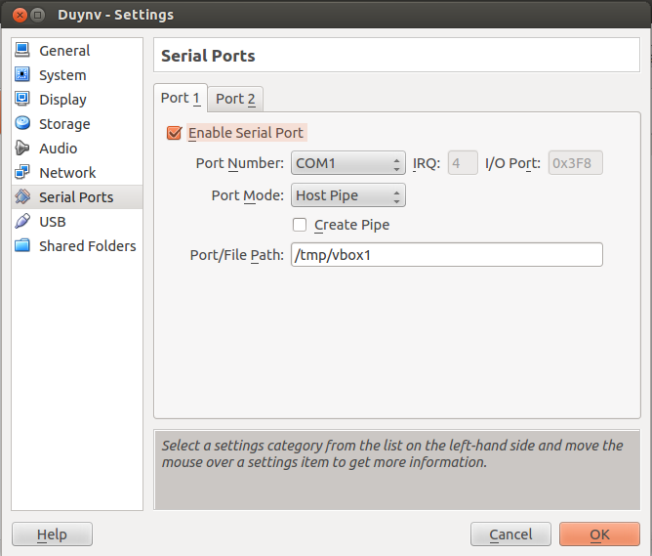
Figure 5.1.3-41 Enable Serial port in remote machine
In debug machine, we edit file grub.cfg to allow connect via ttyS0 and waiting connenction form remote gdb when boot up
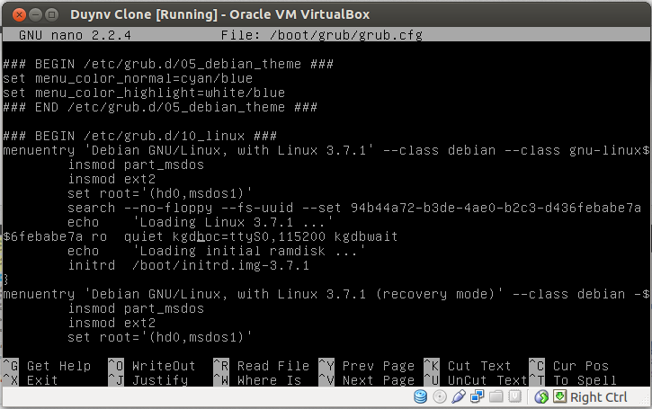
Figure 5.1.3-42 Add parameter for boot up
We add “kgdboc=ttyS0,115200 kgdbwait” to boot options
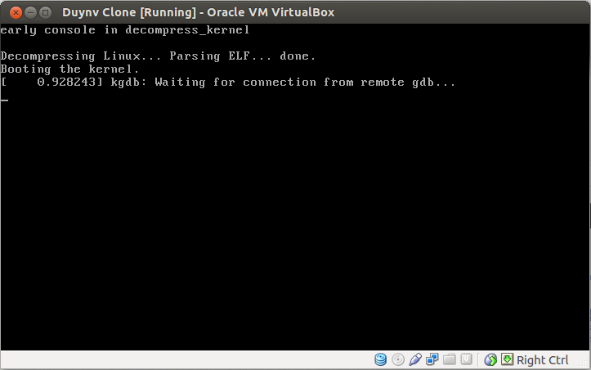
Figure 5.1.3-43 Waiting for remote
From remote machine, we run gdb with vmlinux file and debug target machine
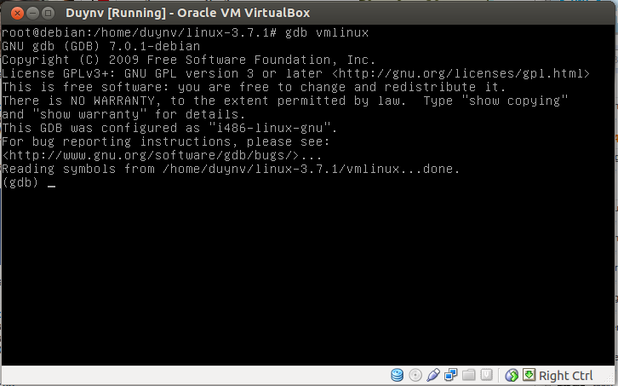
Figure 5.1.3-44 Connect to debug machine
Set remotebaud and target remote for gdb then we will connect with target machine. After that, we can remote debug kernel over serial port. In this version of kernel, KGDB over ethernet is not support in config option.
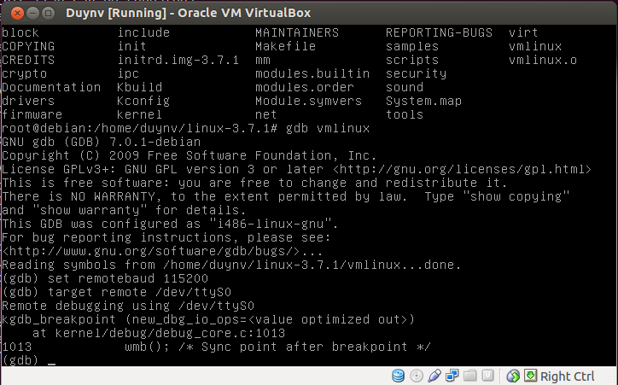
Figure 5.1.3-45 Connect success

Using KGDB on target board (CuBox)
KGDB is merged into Linux kernel version 2.6.26 or higher. To enable KGDB, we need to enable KGDB in kernel source code and recompile this.
To debug kernel running on target board (CuBox) by using KGDB, requires one Linux x86 PC which is installed CROSS_COMPILE SDK (gcc, gdb, …), and call that as DEV MACHINE.

Installing KGDB onto target board
1) Get kernel source code

$ git clone gitosis@debian.tsdv.com.vn:kernel/linux-tec
$ git checkout –b cubox-3.4.7-tsdv remotes/origin/cubox-3.4.7-tsdv

2) Enable KGDB

$ ARCH=arm CROSS_COMPILE=arm-skerlet-linux-gnueabi- make cubox_defconfig
$ ARCH=arm CROSS_COMPILE=arm-skerlet-linux-gnueabi- make menuconfig

Go to Kernel Hacking and Enable the following options:
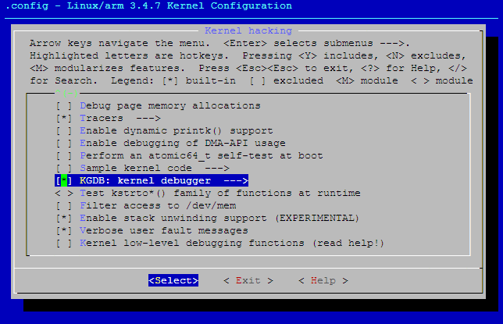
Figure 5.1.4-46 Enable KGDB

And in KGDB menuconfig:

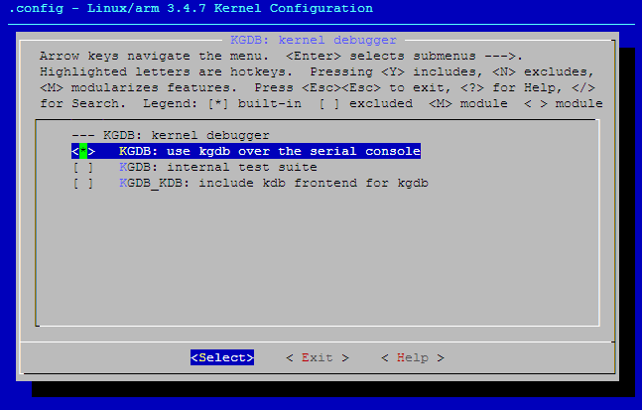
Figure 5.1.4-47 KGDB over serial

4) Compile kernel

$ ARCH=arm CROSS_COMPILE=arm-skerlet-linux-gnueabi- make uImage

After build success, we can see uImage in arch/arm/boot directory, and vmlinux in root directory (linux-tec).

5) Port uImage file into target board.

6) Setting up parameters for KGDB
Create file boot-script.txt

echo ============= Setting bootargs ==============
setenv bootargs 'kgdboc=ttyS0,115200 kgdbwait \
console=ttyS0,115200n8 vmalloc=384M \
root=/dev/mmcblk0p1 rw rhgb quiet crashkernel=128m@16M \
video=dovefb:lcd0:1920x1080-32@60-edid clcd.lcd0_enable=1 clcd.lcd1_enable=0'
echo ============= Loading kernel ... ==============
ext2load mmc 0:1 0x2000000 /boot/uImage
echo ============= Booting kernel ... ==============
bootm

Create file boot.scr

$ mkimage –A arm –O Linux –T script –C none –a 0x8000 –e 0x8000 –n "boot.scr" \ –d boot-script.txt boot.scr

7) Now boot the Kernel with those kernel parameters
NOTE: You can booting target board without 'kgdboc=ttyS0,115200 kgdbwait' parameters, and then enter to debug kernel mode in runtime, this will described in examble below.

8) On DEV MACHINE start gdb session

# arm-skerlet-linux-gnueabi-gdb vmlinux
(gdb)

NOTE: vmlinux is file which created when compile kernel for target board

9) Connect to target board with target command

(gdb) target remote /dev/ttyUSB0

10) This will stop your Kernel booting on target board and will give control to your "DEV MACHINE". Now, you can do Single-stepping or put breakpoints and etc.

11) Once your Kernel is running on target board and you want control over your running kernel from "DEVELOPMENT MACHINE", we can manualy configure KGDB on target board:

# echo ttyS0,115200 > /sys/module/kgdboc/parameters/kgdboc
# echo g > /proc/sysrq-trigger

Example
We create hello_world module and compile it within kernel source code.

File Add-hello_world-module.patch

From 85e54c9fe81f612dc8f4afc97b35199072539aa3 Mon Sep 17 00:00:00 2001
From: Vu Thanh Cong <congvt@tsdv.com.vn>
Date: Sat, 12 Nov 2016 12:50:42 +0700
Subject: [PATCH] Add hello_world module

Signed-off-by: Vu Thanh Cong <congvt@tsdv.com.vn>
---
drivers/misc/Makefile | 4 ++++
drivers/misc/hello_world.c | 53 ++++++++++++++++++++++++++++++++++++++++++++
2 files changed, 57 insertions(+)
create mode 100644 drivers/misc/hello_world.c

diff --git a/drivers/misc/Makefile b/drivers/misc/Makefile
index 2a60573..535e782 100644
--- a/drivers/misc/Makefile
+++ b/drivers/misc/Makefile
@@ -50,3 +50,7 @@ obj-$(CONFIG_USB_SWITCH_FSA9480) += fsa9480.o
obj-$(CONFIG_ALTERA_STAPL) +=altera-stapl/
obj-$(CONFIG_MAX8997_MUIC) += max8997-muic.o
obj-$(CONFIG_DOVE_MRVL_BMM) += bmm_drv.o
+#
+# TSDV
+#
+obj-y += hello_world.o
diff --git a/drivers/misc/hello_world.c b/drivers/misc/hello_world.c
new file mode 100644
index 0000000..b60eff1
--- /dev/null
+++ b/drivers/misc/hello_world.c
@@ -0,0 +1,53 @@
+/*
+ * hello_world.c
+ * Test KGDB
+ */
+#include <linux/fs.h>
+#include <linux/types.h>
+#include <linux/module.h>
+#include <linux/device.h>
+
+static ssize_t hello_read(struct file *fp, char __user *buf, size_t len, loff_t *pos)
+{
+ int i = 0;
+ for (i = 0; i < 10; i++)
+ printk(KERN_INFO "hello_read: %d\n", i);
+ return 0;
+}
+static struct class *hello_class;
+static struct device *hello_dev;
+static struct file_operations hello_fops = {
+ .read = hello_read,
+};
+static int __init hello_init(void)
+{
+ int ret = 0;
+ int major;
+ printk(KERN_INFO "Hello world\n");
+ major = register_chrdev(0, "hello", &hello_fops);
+ if (major < 0) {
+ printk("Can't register hello device driver\n");
+ return ret;
+ }
+ hello_class = class_create(THIS_MODULE, "hello");
+ if (IS_ERR(hello_class)) {
+ ret = PTR_ERR(hello_class);
+ unregister_chrdev(major, "hello");
+ return ret;
+ }
+ hello_dev = device_create(hello_class, NULL, MKDEV(major, 0), NULL, "%s", "hello");
+ if (IS_ERR(hello_class)) {
+ ret = PTR_ERR(hello_dev);
+ class_destroy(hello_class);
+ unregister_chrdev(major, "hello");
+ return ret;
+ }
+ return 0;
+}
+
+static void hello_exit(void)
+{
+ printk(KERN_INFO "Hello world: Exit\n");
+}
+module_init(hello_init);
+module_exit(hello_exit);
--
1.7.9.5

This is module is simple create /dev/hello in devfs, and print some message when read this device file
Apply above patch file into linux kernel source code

$ cd linux-tec
$ git apply Add-hello_world-module.patch

Recompile kernel

$ ARCH=arm CROSS_COMPILE=arm-skerlet-linux-gnueabi- make uImage

Booting kernel with bootargs "console=ttyS0,115200n8 vmalloc=384M root=/dev/mmcblk0p1 rw rhgb quiet crashkernel=128m@16M video=dovefb:lcd0:1920x1080-32@60-edid clcd.lcd0_enable=1 clcd.lcd1_enable=0"

At this point, we can set kernel into debug mode on target board:

# echo ttyS0,115200 > /sys/modules/kgdbboc/parameters/kgdbboc
# echo g > /proc/sysrq-trigger
SysRq : DEBUG
Entering KGDB

On DEV_MACHINE, we create two terminals:
- One terminal create SSH session to control target board

$ ssh root@TARGET_BOARD_IP
root@cubox:~#

- One terminal create GDB session to debug kernel running on target board

$ sudo arm-skerlet-linux-gnueabi-gdb vmlinux
(gdb) target remote /dev/ttyUSB0
Remote debugging using /dev/ttyUSB0
kgdb_breakpoint (key=20) at kernel/debug/debug_core.c:986
986 arch_kgdb_breakpoint();
(gdb)

Set breakpoint which point to hello_read() function

(gdb)b hello_read
Breakpoint 1 at 0xc0268ec4: file drivers/misc/hello_world.c, line 11.
(gdb) c
Continuing.

On SSH terminal, read /dev/hello device file

root@cubox:~# cat /dev/hello

Kernel will jump to hello_read() function, and waiting for commands from GDB client

(gdb)
Continuing.
Breakpoint 1, hello_read (fp=0xd16a34c0, buf=0x1a000 <Address 0x1a000 out of bounds>, len=32768, pos=0xd8571f80) at drivers/misc/hello_world.c:11
11 {
(gdb)

At this point, can using some GDB commands on GDB terminal such as: continue (c), next (n), print(p), … to debug our hello module.

Conclusion
KGDB is a kernel debugger in source level. It can debug linux kernel like an application. This has several advantages over kernel debugging with KGDB. It can be used on any kernel, without the patch required by KGDB. (Although it can only be used in a limited way if the kernel has not been compiled to include debugging information). Because it uses the on-chip debug hardware rather than a software debug agent, it can be used for post-mortem analysis. It does not require access to any peripherals (serial ports or Ethernet).

Kgtp

Overview
KGTP is a flexible, lightweight and realtime Linux debugger and tracer. It makes Linux Kernel supply a GDB remote debug interface. Then GDB in current machine or remote machine can debug and trace Linux kernel and user space program through GDB tracepoint and some other functions without stopping the Linux Kernel. And even if the board doesn't have GDB on it and doesn't have interface for remote debug. It can debug the Linux Kernel using offline debug

Preparatory work before use KGTP
If your system use the Linux kernel from distribution. You need install some Linux kernel package. If your system use the Linux kernel that is built by yourself. Your Linux kernel need enable some options.

Linux kernel
To use KGTP, your Linux kernel need open following options:
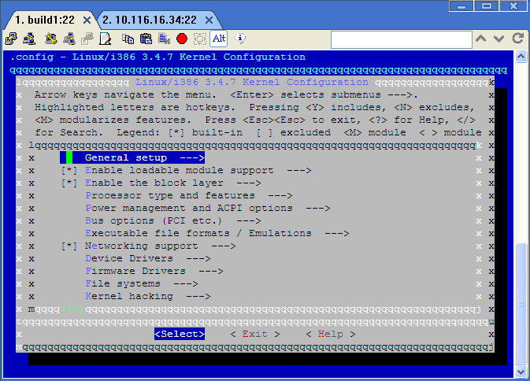
Figure 5.2.2-48 Select general setup
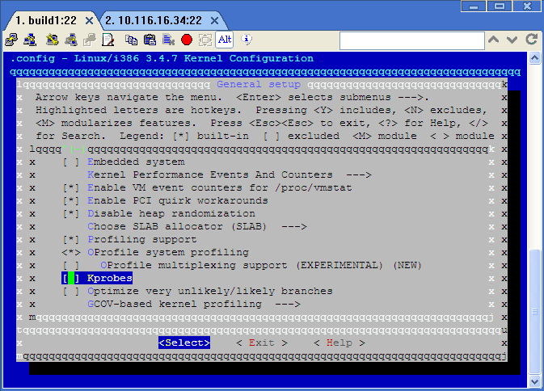
Figure 5.2.2-49 Enable Kprobes
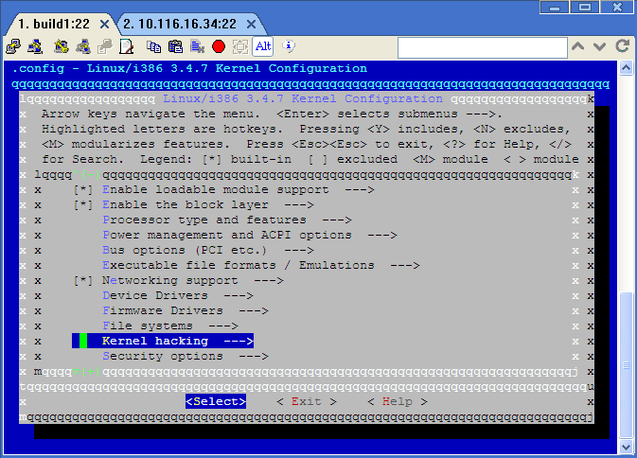
Figure 5.2.2-50 Select kernel hacking
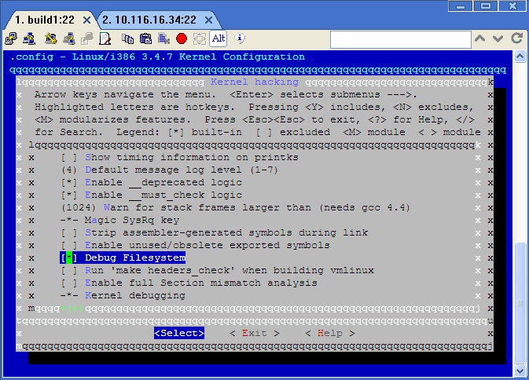
Figure 5.2.2-51 Enable debug file system
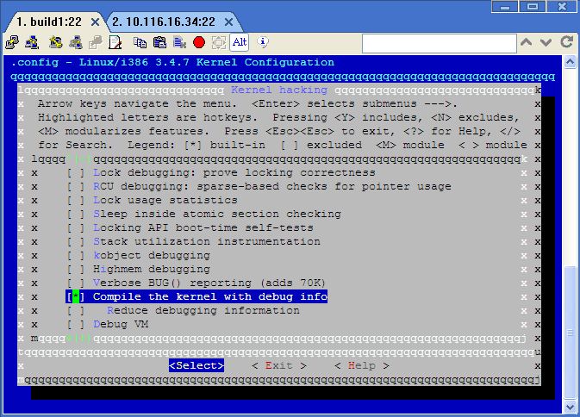
Figure 5.2.2-52 Compile kernel with debug info

Ubuntu
Add debug source to the sources list of Ubuntu.
Create an /etc/apt/sources.list.d/ddebs.list by running the following line at a terminal:
echo "deb http://ddebs.ubuntu.com $(lsb_release -cs) main restricted universe multiverse" | \
sudo tee -a /etc/apt/sources.list.d/ddebs.list
Stable releases (not alphas and betas) require three more lines adding to the same file, which is done by the following terminal command:
echo "deb http://ddebs.ubuntu.com $(lsb_release -cs)-updates main restricted universe multiverse
deb http://ddebs.ubuntu.com $(lsb_release -cs)-security main restricted universe multiverse
deb http://ddebs.ubuntu.com $(lsb_release -cs)-proposed main restricted universe multiverse" | \
sudo tee -a /etc/apt/sources.list.d/ddebs.list
Import the debug symbol archive signing key:
sudo apt-key adv --keyserver keyserver.ubuntu.com --recv-keys 428D7C01
Then run:
sudo apt-get update
Get Linux kernel debug image
sudo apt-get install linux-image-$(uname -r)-dbgsym
Then you can find Linux kernel debug image in "/usr/lib/debug/boot/vmlinux-$(uname -r)". Please note that this step Get Linux kernel debug image need do again when Linux kernel update.
Install the Linux kernel headers
sudo apt-get install linux-headers-generic
Install the Linux kernel source
Install the source package:
sudo apt-get install linux-source
Uncompress the source package:
sudo mkdir -p /build/buildd/
sudo tar vxjf /usr/src/linux-source-$(uname -r | sed 's/-.*//').tar.bz2 -C /build/buildd/
sudo rm -rf /build/buildd/linux-$(uname -r | sed 's/-.*//')
sudo mv /build/buildd/linux-source-$(uname -r | sed 's/-.*//') /build/buildd/linux-$(uname -r | sed 's/-.*//')

Fedora
Install the Linux kernel debug image
sudo yum --enablerepo=fedora-debuginfo install kernel-debuginfo
Then you can find Linux kernel debug image in "/usr/lib/debug/lib/modules/$(uname -r)/vmlinux".
Install the Linux kernel devel package
sudo yum install kernel-devel-$(uname -r)

Install Kgtp

Get Kgtp
Get KGTP through http
Please goto http://code.google.com/p/kgtp/downloads/list OR UPDATE to download the package.
Get KGTP through svn
Some people have trouble with access to KGTP website. You can access kgtp through svn:
svn checkout http://kgtp.googlecode.com/svn/ kgtp-read-only
kgtp-read-only/tags/ Present for each release of KGTP.
kgtp-read-only/trunk/ Present for the main trunk of KGTP.

Config Kgtp
Following part is the default config of KGTP inside the Makefile. With this config, KGTP will build together with current kernel that running on this machine.
KERNELDIR := /lib/modules/`uname -r`/build
CROSS_COMPILE :=
KERELDIR is set to the directory which holds the kernel you want to build for. By default, it is set to the kernel that you are running. Please note that this directory should be Linux kernel build directory or linux-headers directory but not the source directory but not the Linux kernel source directory. And the Linux kernel build directory should be used after build successful. CROSS_COMPILE is set to the prefix name of compiler that you want to build KGTP. Empty to compile with your default compiler. ARCH is the architecture. Or you can choose which kernel you want build with and which compiler you want use by change Makefile.
For example:
KERNELDIR := /home/teawater/kernel/bamd64
CROSS_COMPILE :=x86_64-glibc_std-
ARCH := x86_64
KERNELDIR is set to /home/teawater/kernel/bamd64. Compiler will use x86_64-glibc_std-gcc.

Compile kgtp
Normal compile
cd kgtp/
make
In some build environment (for example Android) will get some error with user space program getmod or getframe. Please ignore this error and use the gtp.ko in this directory.
Compile KGTP with some special config
Most of time, KGTP can auto select right options to build with Various versions of Linux kernel. But if you want config special options with yourself, you can read following part:
With this option, KGTP will not auto select any build options.
make AUTO=0
With this option, KGTP will use simple frame instead of KGTP ring buffer. The simple frame doesn't support gtpframe_pipe. It just for debug KGTP.
make AUTO=0 FRAME_SIMPLE=1
With this option, $clock will return rdtsc value instead of local_clock.
make AUTO=0 CLOCK_CYCLE=1
With this option, KGTP will use procfs instead of debugfs.
make AUTO=0 USE_PROC=1
The options can use together, for example:
make AUTO=0 FRAME_SIMPLE=1 CLOCK_CYCLE=1

Install and uninstall KGTP
KGTP don't need to be install because it can insmod directly inside its directory. But if you need, you can install it to your system.
Install:
cd kgtp/
sudo make install
Uninstall:
cd kgtp/
sudo make uninstall

Use Kgtp

Exec it
If you have installed KGTP in your system, you can:
sudo modprobe gtp
Or you can use the kgtp module in the directory.
cd kgtp/
sudo insmod gtp.ko

Make GDB connect to gtp
GDB on the current machine
sudo gdb ./vmlinux
(gdb) target remote /sys/kernel/debug/gtp
Remote debugging using /sys/kernel/debug/gtp
0x0000000000000000 in ?? ()
After that, you can begin to use GDB command trace and debug the Linux Kernel.
GDB on remote machine
#Open the KGTP interface in current machine.
sudo su
nc -l 1234 </sys/kernel/debug/gtp >/sys/kernel/debug/gtp
(nc -l -p 1234 </sys/kernel/debug/gtp >/sys/kernel/debug/gtp for old version netcat.)
#Let gdb connect to the port 1234
gdb ./vmlinux
(gdb) target remote xxx.xxx.xxx.xxx:1234

Comparing tools

Ftrace vs LTTng

Table 13 Compare Tracing tools
 | Ftrace | LTTng
Difference | Ftrace support tracing events and also fucntions | LTTng just only tracing events
Difference | Ftrace just only support tracing in kernel space | LTTng provides an integrated interface for both kernel and user-space tracing. A "tracing" group allows non-root users to control tracing and read the generated traces. It is multi-user aware, and allows multiple concurrent tracing sessions.  User can create tracepoint to dynamic tracing application
Difference | Ftrace is integrated into kernel source code, so it is easy to install | LTTng futures isn’t integrated into kernel upstream
Difference | All events of LTTng can be tracing with ftrace | Only support some events
Difference | Support kernel early boot tracing | does it support kernel early boot tracing
Difference | Allows dumping tracing buffers upon a kernel crash | Don't allows dumping tracing buffers upon a kernel crash
Advanced | + Ftrace's ability to show the events that lead up to a crash gives a better chance of finding exactly what caused it and can help the developer in creating the correct solution  + Built directly into the Linux kernel  + Allows dumping tracing buffers upon a kernel crash | + High-performance tracer with low overhead  + LTTng provides an integrated interface for both kernel and user-space tracing. A "tracing" group allows non-root users to control tracing and read the generated traces. It is multi-user aware, and allows multiple concurrent tracing sessions.  User can create tracepoint to dynamic tracing application
Disadvanced | + Main focus is on simplicity for kernel debugging use-cases, which means a single user, single tracing session, and single set of buffers  + Take much overhead if tracing function | + Doesn’t support kernel early boot tracing  + LTTng futures isn’t integrated into kernel upstream
Remark

Oprofile vs Perf
Table 14 Compare Profiling tools
 | Oprofile | Perf
Difference | + Support annotating source code in C language style, easy for reader | + Only support annotating source code in Assembly.
Advanced | + Support profiling source code which is useful for analyze bootneleck of performance.  + Support annotating source code to easy analyze source code performance. | + Support profiling source code which is useful for analyze bootneleck of performance.  + Support annotating source code to easy analyze source code performance.
Disadvanced |  | + Only support annotating source code in Assembly.
Remark

Memory leak tools
Beside the similar, each memory leak detect tools has a specific property. Below table shows comparation among those tools.
Table 15 Compare memory leak tools
Name | Different | Advantage | Disadvantage | Remarks
Valgrind | Combine many tools, detect common memory leak problems | Can show the reason of problem. No need link into application when compile. This tools usefull if deverlopers need to know the memory leak problems or some problems when access the memory. | Need to run and finish application to realse log file, read log to find problems
Mpatrol | It’s a library powerfull, replaces many funcitons of C/C++, show how the application works with memory | Link when compile, can detect almost the problems of memory | Not support from 2008, and large library, need to add mpatrol’s header file when coding
Efence | It’s a library that deverloper can link into their code when compile. Only show the message about two common types of programming | Link when compile, debug small program. Many incorrectly written programs to crash as soon as an error occurs. It is useful for debugging as the error location can be quickly determined using gdb. | Small library, Message is not complete.
Mtrace | Balance the malloc and free command | Usefull to debug program and funtions | Need to add header file when coding
Gperftools | Heap trace and profiling, it not about memory | Usefull when check program using heap. Tracking memory in whole program. If any memory not pointed to by objects that are still "live" at program-exit, it will find and generate message | Hard to use

